

THRIFT STORE MANAGEMENT SYSTEM: A CASE OF THINK TWICE STORES BY
KAMIRU JOHN MWANGI CIT-221-108/2022

SUPERVISOR: DR. NICODEMUS AKETCH ISHMAEL

Research Project Report Submitted in Partial fulfillment of the Requirements
for the Award of the Degree in Bachelor of Science in Information Technology of Multimedia University of Kenya

APRIL, 2026

DECLARATION AND APPROVAL
STUDENT

I, the undersigned, declare that this project report is my original work and that it has not been
presented in any other university or institution for academic credit. Signature: Date:
Student Name: John Kamiru Mwangi Reg_No: CIT-221-108/2022
UNIVERSITY SUPERVISOR’S APPROVAL

This research project report has been submitted for examination with my approval as university supervisor.
Signature: Date:

Names: Dr. Nicodemus Aketch Ishmael

Faculty of Computing and Information Technology

HEAD OF DEPARTMENT’S APPROVAL

This research project report has been submitted for examination with my approval as Head of Department

Signature: Date:

Names: Prof. Henry Ndithi

Department of Information Technology

ACKNOWLEDGEMENT
I would like to express my sincere gratitude to my supervisor, Dr. Ishmael, for his guidance, constructive criticism, and continuous support throughout the preparation of this research project. I also extend my appreciation to the lecturers and staff of the department of Information Technology for equipping me with the necessary knowledge and skills during my course of study.
I am also grateful to my family and friends for their encouragement, moral support, and understanding throughout this academic journey.

DEDICATION

This research project is dedicated to my family for their unconditional support and encouragement, and to all individuals striving to use technology to improve business efficiency and management.

ABSTRACT
This study, titled Thrift Store Management System: A Case of Think Twice Stores, examines the operational challenges faced by second hand clothing businesses in Kenya due to continued reliance on manual and semi automated management processes. The rapid expansion of thrift stores, combined with many daily customers Think Twice Stores, has exposed inefficiencies including inaccurate inventory tracking, delayed sales reporting, limited stock visibility, difficulty managing dynamic two week pricing cycles, and inadequate access to real time information for effective managerial decision making. The primary objective of this research is to design and develop a comprehensive Thrift Store Management System that enhances operational efficiency, accuracy, transparency, and accountability across core business functions. Specifically, the study seeks to develop a robust inventory management module to track stock levels, item categories, pricing cycles, and restocking requirements; design and implement a Point of Sale system that supports seamless sales transactions with real-time inventory synchronization; integrate M-Pesa customer-to-business payment functionality using the Safaricom Daraja API; and implement secure user account management with auditing features to ensure accountability and controlled system access. The study adopts a descriptive research design, utilizing interviews with management, questionnaires administered to employees and customers, and direct observation of existing operational workflows to collect comprehensive system requirements. The proposed system is developed using HTML5 and Vanilla JavaScript for frontend interface design, PHP for backend application logic, and MySQL for reliable database management. Expected outcomes include reduced inventory discrepancies, faster transaction processing, improved financial reporting accuracy, enhanced customer convenience through integrated mobile payments, improved loss prevention, and strengthened managerial oversight through detailed audit trails. The study concludes that implementing a tailored digital management system will significantly improve thrift store operations at Think Twice Stores, enabling data-driven decision making and establishing a sustainable competitive advantage within Kenya’s rapidly expanding second-hand clothing retail market.
Table of Contents
DECLARATION AND APPROVAL i
ACKNOWLEDGEMENT ii
DEDICATION iii
ABSTRACT iv
LIST OF FIGURES xi
LIST OF TABLES xiii
DEFINITION OF KEY TERMS xiv
RESEARCH ORGANIZATION xvii
CHAPTER ONE 1
INTRODUCTION 1
1.1 Chapter Introduction 1
1.2 Motivation and Background 1
1.3 Background of the Research 3
1.4 Problem Statement 6
1.5 Aim of the Research 7
1.6 Objectives of the Research 8
1.6.1 General Objective 8
1.6.2 Specific Objectives 8
1.6.3 Research Questions 8
1.7 Justification of the Research 9
1.8 Scope of the Research 11
1.9 Research Organization 12
1.10 Chapter Summary 12
CHAPTER TWO REVIEW OF RELATED WORK 15
2.1 Chapter Introduction 15
2.2 History of the Research Topic 15
2.3 Review of Related Prototypes Systems 19
2.4 Emerging Trends and Patterns in the Research Area 20
2.5 Research Gap to be Filled by Your Research 23
2.5.1 Absence of Thrift Specific System Design Framework 23
2.5.2 Insufficient Focus on Affordable, Accessible Solutions for Informal/Semi-Formal Retail 24
2.5.3 Limited Documentation of User Centered Design for Low Digital Literacy Contexts 24
2.6 Chapter Summary 24
CHAPTER THREE RESEARCH METHODOLOGY 26
3.1 Chapter Introduction 26
3.2 Methodology for Literature Review 26
3.2.1 Review Conduction 26
3.2.2 Literature Review Outcomes 29
3.3 Methodology for Requirement Specification, Data Collection, and Analysis 29
3.3.1 Requirement Specification 29
3.3.2 Data Collection Methods 30
3.3.3 Interviews 30
3.3.4 Use of Questionnaires 31
3.3.5 Observation 32
3.4 Methodology for System Analysis 33
3.4.1 Data Flow Diagrams (DFD) 33
3.4.2 Context Diagram 35
3.4.3 Flow Charts 35
3.5 Methodology for System Design (Proposed System) 36
3.5.1 Data Flow Diagram 37
3.5.2 Flowcharts 40
3.5.3 Sequence Diagram 43
3.5.4 Collaboration Diagram 43
3.5.5 Use Case Diagrams 44
3.5.6 Pseudocode 46
3.5.7 Early System prototypes (I/O design) 48
3.5.8 Design of the User Interface 53
3.5.9 Design of the Database 54
3.6 Methodology for System Implementation; Back End, Front End and Database Technologies to be used 62
3.6.1 Backend Technologies 62
3.6.2 Frontend Technologies 63
3.6.3 Database Technologies 63
3.7 Methodology for System Testing;Testing Plan, Testing Techniques 64
3.7.1 Testing Plan 64
3.7.2 Testing Techniques 65
3.8 Methodology for System Deployment 66
3.9 Chapter Summary 67
CHAPTER FOUR SYSTEM ANALYSIS 68
4.1 Chapter Introduction 68
4.2 Description of the Current System, Its Strengths and Weaknesses 68
4.3 Feasibility Study and Its Conclusion 69
4.4 Data Input/Output Analysis 71
4.4.1 Overview 71
4.4.2 Relationships Between Data Items 72
4.5 Process Logic Design of the Current System 72
4.5.1 Process Flowchart — Current Sales Transaction 72
4.5.2 Context Diagram — Current System 74
4.5.3 Level 1 Data Flow Diagram — Current System 75
4.6 Chapter Summary 76
CHAPTER FIVE SYSTEM DESIGN OF THE PROPOSED SYSTEM 78
5.1 Chapter Introduction 78
5.2 Description of the Proposed System, Its Strengths and Limitations 78
5.3 Requirements Analysis 79
5.3.1 Functional Requirements 80
5.3.2 Non-Functional Requirements 82
5.3.3 Usability Requirements 83
5.4 Conceptual Architecture of the Proposed System 84
5.4.1 Use Case Diagram 85
5.4.2 Activity Diagram — Sales Transaction with M-Pesa Integration 86
5.4.3 Class Diagram 88
5.4.4 Sequence Diagram 89
5.4.5 Process Flowchart 90
5.4.6 Context Diagram 93
5.4.7 Level 1 Data Flow Diagram 94
5.5 Database Design 95
5.5.1 Entity-Relationship Model 95
5.5.2 Normalisation 96
5.5.3 Data Dictionary — AuditLog Table 97
5.6 I/O of the Proposed System 98
5.7 Chapter Summary 101
CHAPTER SIX IMPLEMENTATION AND TESTING 102
6.1 Chapter Introduction 102
6.2 System Screenshots 102
6.3 Testing Plan 105
6.4 Evaluation Plan 107
6.5 Chapter Summary 107
CHAPTER SEVEN CONCLUSIONS, FINDINGS AND RECOMMENDATIONS 109
7.1 Introduction 109
7.2 Conclusion 109
7.3 Challenges Encountered 110
7.4 Future Recommendations 110
7.5 Chapter Conclusion 111
References 111
Books & Textbooks 111
Journal Articles 113
Industry Reports & Government Sources 122
Websites and Online Sources 124
APPENDICES 127
APPENDIX II: INTERVIEW GUIDE 131
APPENDIX III: PROJECT GANTT CHART 135
APPENDIX IV: PROJECT BUDGET 135
Printing 135
APPENDIX V: SAMPLE CODE 136
20.1.1 V.1 Dynamic Pricing Cycle Calculation 136
20.1.2 V.2 M-Pesa STK Push Initiation 136

LIST OF FIGURES
Figure 3.1: Prototype 1 (Iteration 1): Initial POS Interface Concept Data flow diagram for current systems 33
Figure 3.2: Context diagram for current system 34
Figure 3.3: flowchart for current system Author (2026) 35
Figure 3.4: Data flow diagram for Think Twice Thrift Store Management System 37
Figure 3.5: Complete Sales Transaction Process with M-Pesa Integration Author 2026 41
Figure 3.6: Inventory Cycle Management from Requisition to Price Tracking Author (2026) 42
Figure 3.7: Sequence Diagram: Sales Transaction Processing with M-Pesa Integration Author (2026) 43
Figure 3.8: Collaboration Diagram: Sales Transaction Processing with Object Interactions, Author (2026) 44
Figure 3.9: Use Case Diagram for Think Twice Thrift Store Management System, Author (2026) 45
Figure 3.10: Prototype 1 (Iteration 1): Initial POS Interface Concept Author (2026) 49
Figure 3.11: Prototype 1 (Iteration 2): Enhanced POS with Detailed Item Diasplay Item Display Author (2026) 50
Figure 3.12: Prototype 1 (Iteration 1): Structured Requisition Form with Category Selection Author (2026) 51
Figure 3.13: Prototype 1 (Iteration 1): Dashboard with KPI Cards and Color-Coded Alerts Author (2026) 52
Figure 3.14: Entity-Relationship Diagram for Think Twice Stores Database Author (2026) 54
Figure 4.1: Process Flow Chart Current Sales Transaction at Think Twice Stores current sales transaction workflow at Think Twice Stores, from item selection through ETR receipt printing and manual recording in the sales book. Both cash and M-Pesa payment paths are depicted. Author (2026). 74
Figure 4.2: Context diagram illustrating the boundary of the current manual operations system at Think Twice Stores, showing all external entities and primary data flows. The ETR machine appears as an external entity reflecting its role as a KRA compliance tool rather than a business management component. Author (2026). 76
Figure 4.3: Level 1 data flow diagram showing the five primary operational processes of the current manual system at Think Twice Stores, with associated data stores and external entity interactions. Author (2026). 77
Figure 5.1: Use case diagram for the proposed Thrift Store Management System, illustrating the eight primary use cases, four human actor roles, one automated system actor, and two external actors at the system boundary. Author (2026). 87
Figure 5.2: Activity diagram illustrating the proposed sales transaction process with M-Pesa payment integration, showing swimlanes for the cashier, PHP backend, Safaricom Daraja API, and customer. Both successful payment and failed payment fallback paths are depicted. Author (2026). 88
Figure 5.3: Class Diagram 90
Figure 5.4: Sequence Diagram 91
Figure 5.5: Process FlowChart 93
Figure 5.6: Context Diagram 94
Figure 5.7: Data Flow Diagram 96
Figure 5.8: Entity Relationship Diagram 97
Figure 5.9: Login Page Design Note: Login panel after signup is done Author (2026) 99
Figure 5.10: Point of Sale Interface Note This is where the cashier will be interacting with the system Author (2026) 100
Figure 5.11: Inventory Console Note This is where the warehouse operations will be done from Author (2026) 100
Figure 5.12: Price Cycle Setting panel Note The warehouse staff will be controlling the pricing cycle in this module Author (2026) 101

LIST OF TABLES
Table 3.1: User Table — Stores System User Accounts and Authentication Details 55
Table 3.2: Branch Table; Records Physical Store Locations Managed by the System 56
Table 3.3: Category Table — Defines Item Classification Groups and Pricing Reduction Rules 57
Table 3.4: Item Table — Represents Individual Second-Hand Products Available for Sale 58
Table 3.5: Transaction Table — Records Each Completed Sale Event at the Point of Sale 60
Table 3.6: TransactionItem Table — Associative Entity Linking Items Sold Within Each Transaction 61
Table 4.1: Feasibility Study Summary for the Proposed Thrift Store Management System 69
Table 4.2: Data Input/Output Analysis — Current System at Think Twice Stores 71
Table 5.1: Strengths and Acknowledged Limitations of the Proposed System 80
Table 5.2: Functional Requirements — Thrift Store Management System 81
Table 5.3: Non-Functional Requirements — Thrift Store Management System 83
Table 5.4: Conceptual Architecture — Thrift Store Management System 85
Table 5.5: Data Dictionary 98

DEFINITION OF KEY TERMS
Application Programming Interface (API): A set of protocols, tools, and definitions that allows different software applications to communicate with each other. In this research, APIs are used to integrate M-Pesa payment services and enable data exchange between system modules.
Audit Trail: A chronological record that documents the sequence of activities or events in a system. Audit trails track user actions, system changes, and transactions to ensure accountability, enable compliance monitoring, and facilitate forensic analysis in case of discrepancies or security incidents.
Database Management System (DBMS): Software that enables users to define, create, maintain, and control access to databases. MySQL, used in this research, is a relational DBMS that ensures data integrity, supports concurrent access, and provides backup and recovery capabilities.
Dynamic Pricing: A pricing strategy where prices change based on specific factors such as time, demand, or inventory levels. In the context of Think Twice Stores, dynamic pricing refers to the two-week pricing cycles where item prices are adjusted to maximize sales and inventory turnover.
Enterprise Resource Planning (ERP): A business software to manage all the aspects of the business from sales, HRM, Procurement all the way to Payroll.
Inventory Management: The systematic process of ordering, storing, tracking, and controlling inventory or stock within a business. It involves monitoring stock levels, managing product categories, tracking item movements, forecasting demand, and ensuring optimal stock availability while minimizing carrying costs and stockouts.
Management Information System (MIS): A computerized system that provides managers with the tools to organize, evaluate, and efficiently manage information for strategic decision-making. An MIS collects, processes, stores, and disseminates information to support planning, control, and operational functions within an organization.
Mobile Payment Integration: The process of incorporating mobile payment capabilities into a business system. This allows customers to make payments using their mobile devices, providing convenience, reducing cash handling, and automating payment reconciliation.
M-Pesa: A mobile money transfer and payment service operated by Safaricom in Kenya. M-Pesa enables users to deposit, withdraw, transfer money, and pay for goods and services using their mobile phones. The Daraja API allows businesses to integrate M-Pesa Customer-to-Business (C2B) payment functionality into their systems.
MySQL: An open-source, object-relational database management system (ORDBMS) known for its reliability, robustness, and support for advanced data types. MySQL provides ACID compliance (Atomicity, Consistency, Isolation, Durability), ensuring data integrity and supporting complex queries and transactions.
Point of Sale (POS) System: A computerized system used at checkout counters to process sales transactions, accept payments, print receipts, and update inventory records in real-time. Modern POS systems integrate with inventory management, customer relationship management, and financial reporting modules to provide comprehensive business insights.
Real-Time Inventory Synchronization: The immediate and automatic update of inventory records across all system modules when transactions occur. This ensures that stock levels displayed to users are always current and accurate, preventing overselling and improving inventory control.
Safaricom Daraja API: Safaricom's application programming interface that enables developers to integrate M-Pesa payment services into their applications. The Daraja API supports various transaction types including Customer-to-Business (C2B), Business-to-Customer (B2C), and Business-to-Business (B2B) payments.
Second-Hand Clothing: Previously owned garments and apparel items that are resold in thrift stores, consignment shops, or online marketplaces. The second-hand clothing market in Kenya, locally known as "mitumba," represents a significant portion of the retail apparel sector and provides affordable clothing options to consumers.
Stock Keeping Unit (SKU): A unique identifier assigned to each distinct product or item in inventory. SKUs facilitate inventory tracking, enable accurate stock counts, support sales analysis, and streamline the ordering and restocking processes.
System Module: A self-contained component of a larger system that performs specific functions and can operate semi-independently while interfacing with other modules. In this research, modules include inventory management, point of sale, user management, and reporting.
Thrift Shop/Store: A retail establishment that sells second-hand goods, particularly clothing, accessories, and household items, at significantly reduced prices compared to new merchandise. Thrift stores support sustainable consumption, provide affordable shopping options, and often serve charitable or community purposes.
Transaction Processing: The method by which a system records, validates, and executes business transactions such as sales, returns, and inventory adjustments. Efficient transaction processing ensures data accuracy, maintains referential integrity, and provides audit trails for accountability.
User Authentication: The process of verifying the identity of a user attempting to access a system. Authentication mechanisms include passwords, biometric verification, or multi-factor authentication to ensure that only authorized individuals can access specific system functions and data.
User Role-Based Access Control (RBAC): A security model that restricts system access based on a user's role within an organization. RBAC ensures that users can only access information and perform actions necessary for their job functions, thereby enhancing security and data protection.
Web-Based System: A software application accessed through web browsers over the internet or an intranet, rather than installed locally on individual computers. Web-based systems offer advantages including platform independence, centralized data management, easier maintenance and updates, and remote accessibility from any location with internet connectivity.

RESEARCH ORGANIZATION

This project report is organised into seven chapters. Chapter One introduces the study, establishing the motivation and background, providing the background of the research, defining the problem statement, articulating the research aim and specific objectives, justifying the research, delineating its scope, and summarising the chapter. Chapter Two presents a review of related work, tracing the historical evolution of retail management systems, evaluating existing global, regional, and local systems and prototypes, identifying emerging trends and patterns in the research area, establishing the research gap that this study addresses, and summarising the chapter. Chapter Three describes the research methodology, detailing the approaches for literature review, requirement specification and data collection, system analysis of the current system, system design of the proposed system, system implementation, system testing, and system deployment, and concludes with a chapter summary. Chapter Four presents the analysis of the current manual system at Think Twice Stores, including its strengths and weaknesses, a feasibility study, data input/output analysis, and process logic modelling of existing operations. Chapter Five details the system design of the proposed Thrift Store Management System, covering functional and non-functional requirements, the conceptual architecture, database design, and the input/output design of the new system. Chapter Six documents the implementation and testing of the system, presenting representative screenshots, the testing plan and outcomes, and the evaluation plan used to assess the deployed system against the current manual process. Chapter Seven concludes the project report, summarising the key findings, discussing the challenges encountered during development, and offering recommendations for future enhancement of the system.

CHAPTER ONE

INTRODUCTION

Chapter Introduction

The chapter consists of Chapter introduction, Motivation and Background, Background of Research, Problem Statement, Aim of Research, Objectives of the Research, Justification of Research, Scope of Research, Research Organization and Chapter Summary.

Motivation and Background

The motivation for this research stems from practical industry experience gained during a second year university attachment at Digisoft Solutions, where I participated in developing a comprehensive management system for Budget Wear, a retail thrift store operating in Nairobi. The project successfully digitalized their entire business operations, transforming manual and semi-automated processes into an efficient computerized system. This experience provided firsthand insight into the operational challenges facing thrift stores and the trans formative impact of digital solutions. Upon visiting Think Twice Stores as a customer, I observed similar reliance on semi-automated systems despite the company's significantly larger scale, operating over thirty branches across Kenya compared to Budget Wear's ten outlets.
This observation revealed a critical gap: a rapidly expanding thrift business with substantial customer volume, serving so many clients daily per branch, still managing operations without a fully integrated automated system. The realization that Think Twice Stores needed a comprehensive inventory and sales management system to match their growth trajectory inspired this research project.
The rapid advancement of information and communication technology (ICT) has fundamentally transformed business operations globally, with organizations across sectors harnessing digital systems to enhance accuracy, efficiency, and service delivery (Tailor, 2025). The retail industry
particularly has experienced significant evolution from manual operations toward digital solutions including inventory management systems, point-of-sale platforms, and data-driven analytical tools (Verasretail, 2025). These technological advancements have become essential for businesses seeking competitive advantage in dynamic, customer-driven markets.
Thrift shops have gained considerable momentum in recent years driven by economic, social, and environmental factors including rising living costs, increased unemployment rates, and shifting consumer preferences toward sustainable fashion. The secondhand fashion market is rapidly reshaping the global apparel sector, with resale outpacing traditional retail clothing eightfold in 2024 (FashionUnited, 2025). In Kenya, thrift shops fulfill critical clothing needs for large population segments while providing entrepreneurial opportunities, as evidenced by individuals purchasing items for street resale. As these businesses expand, operational complexities intensify around stock ordering, monitoring, receiving, pricing, sales tracking, inventory management, and report generation.
Many thrift shops continue relying on handwritten records, notebooks, or basic spreadsheet tools for daily operations. While such methods may be favourable for small scale operations, they prove extremely inefficient and prone to errors for large, growing businesses like Think Twice Stores. Manual systems consume excessive amount of time and frequently produce inaccurate inventory records due to stock loss, theft, misplacement, and transaction processing delays. Faulty data significantly impairs business decision making, preventing stakeholders from identifying top selling items, monitoring profit margins, or planning future stock purchases effectively.
Think Twice Stores operates within this so challenging context, managing a vast varieties of secondhand clothing items differing in brand, quality, size, condition and price. These predominantly unique items make inventory management considerably more complex than standardized product retail, while the absence of a customized management system hinders accurate item tracking, real time stock level monitoring, and timely analytical report generation for the relevant stack holders.
This study addresses these operational challenges through designing a customized Thrift Shop Management System for Think Twice Stores. A computerized system that can automate key business processes, reduce human error, and improve overall efficiency by providing real-time inventory tracking, faster sales processing, secure data storage, and automated report generation (ThriftCart, 2025). These capabilities have the potential to enhance internal operations while improving customer satisfaction through a reduced waiting times and ensured constant product availability.
The increasing adoption of digital systems in business environments necessitates small and medium sized enterprises to digitize operations, as businesses failing to embrace technology risk losing competitiveness and relevance in market place. This research therefore aims not only to resolve existing operational problems but also to position Think Twice Stores ahead for sustainable future growth. From an academic perspective, the study applies theoretical information systems and software development knowledge to real world problems, providing opportunities to analyze existing business processes, identify manual repetitive tasks, and propose practical automated solutions using modern system design principles.

Background of the Research

The background of this research is rooted in the developing landscape of retail business management, specifically within the secondhand clothing sector in Kenya. The thrift shop industry has experienced substantial transformation over the past decade, driven by economic pressures, environmental consciousness, and shifting consumer behavior toward sustainable fashion. Globally, the secondhand clothing market has emerged as a significant economic force, with the resale market expanding faster than traditional retail sectors (FashionUnited, 2025). In Kenya specifically, thrift stores commonly referred to as "mitumba" shops have become integral to the retail ecosystem, serving diverse socioeconomic segments while contributing to employment creation and entrepreneurial opportunities.
Despite this growth projection, many thrift businesses continue operating with ancient management approaches that limit their potential for scalability and operational excellence. The retail industry broadly has witnessed remarkable digital transformation, with businesses adopting sophisticated information systems to manage inventory, process sales transactions, analyze customer behavior, and generate business intelligence (NetSuite, 2025). These technological advancements have become fundamental competitive requirements rather than optional enhancements, specifically for businesses seeking sustainable growth in dynamic markets.
Information systems have emerged as critical enablers of retail operational efficiency by providing real-time data accessibility, improving accuracy in record-keeping, and supporting strategic decision-making processes (Verasretail, 2025). Through the repetitive tasks automation and centralized data storage infrastructure, digital management systems significantly reduce dependence on manual processes, minimize human error occurrences, and enhance coordination across various business functions including procurement, sales, inventory control, and financial reporting.
Research demonstrates that retailers implementing comprehensive management systems experience improved inventory accuracy, faster transaction processing times, enhanced customer satisfaction levels, and stronger financial performance compared to businesses relying on manual or semi-automated methods (ThriftCart, 2025). The adoption of digital management infrastructure has therefore evolved from being a competitive advantage to becoming an operational necessity for retail businesses aiming to maintain market relevance and achieve the long term sustainability in the market.
Think Twice Stores, operating over thirty branches across Kenya with daily customer volumes per location, currently relies predominantly on semi automated systems for managing inventory operations, sales transactions, and business reporting functions. While these traditional approaches may provide basic operational support for smaller scale businesses, they present significant limitations when applied to large, rapidly growing retail organizations managing diverse product portfolios.
Manual record keeping systems and partially automated tools typically result in fragmented data repositories, inconsistent information updates across multiple locations, and substantial difficulties in retrieving accurate, timely business intelligence. For instance, inventory records frequently remain deprecated immediately following sales transactions, creating mismatches between physical stock levels and recorded data that compound over time. In addition, tracking sales performance trends, monitoring most selling inventory items, identifying least selling stock requiring clearance, and coordinating the unique two week pricing cycle across multiple branches becomes increasingly challenging without centralized system integration. These operational limitations reduce management visibility into critical business metrics and heavily constrain the organization's ability to respond effectively to dynamic market demands and customer preferences.
Contemporary research on inventory management systems consistently demonstrates that traditional manual systems suffer from fundamental inefficiencies when processing large transaction volumes, exhibit high error susceptibility rates, and demand considerable time and human resource investments for maintenance (Fabrico SaaS, 2025). Consequently, businesses operating without adequate digital infrastructure face persistent challenges including inaccurate inventory records, difficulty tracking sales performance metrics, delayed report generation hindering timely decision-making, and limited analytical capabilities for data-driven strategic planning (Cube Software, 2025).
Industry studies indicate that retail organizations lacking integrated management systems frequently experience elevated customer dissatisfaction levels due to stock unavailability, recurring inventory discrepancies resulting in financial losses, revenue leakage through undetected theft or misplacement, and diminished operational accountability across staff levels (NetSuite, 2025). The absence of a comprehensive integrated management system at Think Twice Stores therefore fundamentally restricts the organization's operational efficiency potential, resource optimization capabilities, and competitive positioning within Kenya's increasingly technology driven retail market.
This operational context establishes the compelling necessity for developing a customized, fully automated Thrift Shop Management System specifically designed to address these challenges, support efficient multi branch operations, and enable sustainable business growth aligned with industry best practices and technological advancement trends.

Problem Statement

Think Twice Stores operates over thirty branches across Kenya and serves hundreds of customers daily, yet continues to rely on manual and semi-automated systems for its core busines operations. This reliance on handwritten records, physical registers, and basic spreadsheet tools has created a growing set of operational challenges that undermine the organisation’s efficiency, accountability, and capacity for sustainable growth.
The most critical challenge is inventory inaccuracy. Because stock movements including sales, restocking, and the management of the two-week dynamic pricing cycle are recorded manually, inventory records frequently become outdated within hours of a transaction. Stock losses resulting from theft, misplacement, and unrecorded movements compound these inaccuracies over time, making it impossible for management to rely on recorded figures for reordering decisions or loss prevention. The two-week pricing cycle, where item prices reduce daily from a maximum of Ksh 400 down to a clearance floor as low as Ksh 30, is particularly difficult to administer manually across multiple branches without errors and inconsistencies.

Sales reporting is equally problematic. The absence of a real-time point-of-sale system means that daily sales figures must be compiled manually at the end of each shift — a time-consuming process that is prone to arithmetic errors and omissions. Management therefore lacks timely access to the business intelligence required for effective decision making, such as identifying top- selling categories, monitoring revenue by branch, or forecasting restocking needs. This information gap affects every level of the organisation: managers lack real-time stock visibility, cashiers face slow transaction processing during peak hours, customers experience longer waiting times, and senior management must make strategic decisions based on unreliable, delayed data.
The absence of a fully integrated, automated management system therefore restricts Think Twice Stores’ operational efficiency, accountability, and scalability, placing the business at a competitive disadvantage in Kenya’s increasingly technology-driven retail environment. This research addresses this gap by designing and developing a comprehensive Thrift Store Management System tailored to the specific operational requirements of Think Twice Stores.

Aim of the Research

The aim of this research is to design and develop a comprehensive computerized Thrift Shop Management System for Think Twice Stores that transforms manual and semi automated operational processes into a fully integrated digital solution. This system seeks to enhance operational efficiency by automating inventory tracking, sales processing, and business reporting functions, with the research prototype deployed and validated at a single Think Twice Stores branch, and designed with a modular architecture that supports future scaling across all branches of the organization.

The research aims to address critical management challenges by implementing robust inventory control mechanisms that minimize stock discrepancies, integrate M-Pesa payment processing through Safaricom Daraja API for seamless customer transactions, and establish user account management with comprehensive audit trails to ensure accountability and secure system access. Ultimately, this research endeavors to provide Think Twice Stores with a scalable, reliable, and cost-effective technological solution that improves decision-making capabilities through accurate real time reporting, reduces revenue leakage from untracked stock movements, enhances customer satisfaction through faster service delivery, and positions the organization for sustainable competitive advantage within Kenya's rapidly digitalizing retail landscape.

Objectives of the Research

General Objective

To design and develop a Thrift Store Management System: A Case of Think Twice Stores.

Specific Objectives

i. To design and implement a procurement management module that automates the stock acquisition process at Think Twice Stores, enabling systematic recording of purchase requisitions, supplier management, and accurate goods receipt verification to ensure a reliable and auditable restocking workflow.

ii. To develop a dynamic price cycle management system that automates the computation and application of daily price reductions across inventory items, ensuring that each item is accurately priced throughout the two-week markdown cycle — from the maximum entry price down to the clearance floor — without reliance on manual intervention or physical re-tagging.

iii. To design and implement a Point of Sale system that automatically deducts sold quantities from inventory in real time upon transaction completion, eliminating stock discrepancies, maintaining perpetual inventory accuracy, and providing cashiers with an efficient, barcode-enabled checkout interface.

iv. To integrate M-Pesa Customer-to-Business (C2B) mobile payment functionality into the Thrift Store Management System using the Safaricom Daraja API, enabling automated STK Push payment initiation, callback-based transaction matching, and real-time payment reconciliation at the point of sale.

Research Questions

i. How can a procurement management module be designed to automate and accurately record the stock acquisition process — from purchase requisition and supplier management through to goods receipt verification — in a way that eliminates manual recording errors and provides management with a reliable, auditable restocking workflow at Think Twice Stores?

ii. How can an automated price cycle management system be developed to compute and apply daily price reductions across inventory items, ensuring accurate, consistent, and tamper-free pricing throughout the two-week markdown cycle without requiring manual price updates or physical re-tagging of stock?

iii. How can a Point of Sale system be designed to automatically deduct sold quantities from inventory in real time upon every transaction, thereby eliminating stock discrepancies and ensuring that management always has access to accurate, up-to-date stock levels across all product categories?

iv. How can M-Pesa Customer-to-Business (C2B) payment functionality be integrated into the Thrift Store Management System using the Safaricom Daraja API to enable seamless, automated mobile payment processing, STK Push initiation, and real-time transaction reconciliation at the point of sale?

Justification of the Research

This research is justified by the increasing demand for customized digital management systems within Kenya’s rapidly expanding thrift shop sector, where second hand retail has transitioned from informal street vending into structured, multi branch enterprises serving thousands of customers daily. Industry studies show that businesses adopting technology-enabled operational systems achieve notable improvements in efficiency, accuracy, profitability, and competitive advantage compared to those relying on manual or semi-automated processes (iVend Retail, 2025).
Despite this evidence, a significant gap exists in both academic literature and practical system implementations within the thrift retail domain. While numerous studies address inventory management systems, point-of-sale technologies, and retail information systems in conventional retail environments such as supermarkets and fashion outlets, limited research focuses on systems tailored to the unique operational characteristics of thrift shops in developing economies, particularly within Kenya.

From a contextual perspective, existing retail management research largely assumes standardized products with uniform stock keeping units, fixed pricing models, and predictable inventory behavior. Thrift shops operate under fundamentally different conditions, where most items are unique in brand, size, condition, and pricing. Inventory is typically sourced in bulk bales requiring sorting and categorization, while pricing follows dynamic cycles rather than static models. Think Twice Stores’ two-week pricing cycle, where prices reduce daily from maximum of Ksh 400 to clearance levels as low as Ksh 30, introduces operational complexity rarely addressed in traditional retail system designs. These distinctive characteristics necessitate specialized system functionality that generic retail solutions inadequately support, thereby justifying focused system development research.

Methodologically, prior studies on retail management systems in developing countries have predominantly relied on observational and survey based approaches without progressing to full system design and implementation phases (ThriftCart, 2025). This research addresses this gap by combining requirements analysis, system design, and prototype development using modern web technologies, including PHP, HTML5, Vanilla JavaScript and MySQL. The study further incorporates mobile payment integration through the Safaricom Daraja API, reflecting Kenya’s dominant M-Pesa payment ecosystem, which remains underrepresented in academic retail system implementations. This approach provides both theoretical insight and a practical system artifact applicable to real-world operations.

The research is also socially and economically justified, as the thrift shop sector plays a crucial role in providing affordable clothing, generating employment, and supporting entrepreneurial livelihoods in Kenya. Operational inefficiencies, however, limit the sector’s growth potential. By demonstrating how targeted digital transformation can improve operations at Think Twice Stores, the study offers a replicable model for similar informal and semi-formal retail enterprises. Benefits extend to multiple stakeholders, including business owners, employees, customers, and the wider retail ecosystem.

Academically, the study contributes to information systems design, software engineering, and retail management literature by documenting a full systems development lifecycle within a non traditional retail context. It provides empirical evidence on technology adoption in Africa’s informal economy and establishes a modular, scalable reference framework applicable to diverse thrift retail environments, thereby supporting future research and practice.

Scope of the Research

This research encompasses the analysis, design, and development of a Thrift Shop Management System specifically for Think Twice Stores, conducted as a final year project requirement for Multimedia University of Kenya. Geographically, the study focuses on Think Twice Stores operations within Kajiado County, targeting multiple stakeholder groups including store managers, sales clerks, warehouse staff, and senior management. The study period spans the 2025/2026 academic year.
Functionally, the research covers four core system modules: (i) Inventory Management tracking stock receipts, monitoring stock levels by category, managing the two-week dynamic pricing cycle with automated daily price reductions, and generating reorder alerts; (ii) Point of Sale System processing sales transactions, applying dynamic pricing automatically, calculating totals, and updating inventory in real-time; (iii) M-Pesa Payment Integration implementing Safaricom Daraja API C2B functionality for digital payment capture and reconciliation; and (iv) User Management and Auditing managing authentication, role-based access permissions, and maintaining comprehensive audit trails of all system transactions.
The system will be developed using PHP for server-side logic, HTML5 with CSS for frontend interfaces, MySQL for database management, and Safaricom Daraja API for payment integration. Research deliverables include comprehensive requirements specification documentation, complete system architecture diagrams, detailed user interface mockups, a functional prototype demonstrating core capabilities, and a final comprehensive report. The research explicitly excludes advanced financial accounting systems, comprehensive Human Resource Management modules, full ERP integration, supply chain management beyond basic stock receipt recording, CRM features, e-commerce platforms, mobile application development advanced business intelligence using machine learning, and deployment across all thirty branches as it will just focus on one branch. This intentional scope limitation ensures detailed, rigorous design and development of core operational functionality that directly addresses the identified problem statement while remaining achievable within the constraints of an undergraduate final year project.

Research Organization

This project report is organised into seven chapters. Chapter One introduces the study, establishing the motivation and background, providing the background of the research, defining the problem statement, articulating the research aim and specific objectives, justifying the research, delineating its scope, and summarising the chapter. Chapter Two presents a review of related work, tracing the historical evolution of retail management systems, evaluating existing global, regional, and local systems and prototypes, identifying emerging trends and patterns in the research area, establishing the research gap that this study addresses, and summarising the chapter. Chapter Three describes the research methodology, detailing the approaches for literature review, requirement specification and data collection, system analysis of the current system, system design of the proposed system, system implementation, system testing, and system deployment, and concludes with a chapter summary. Chapter Four presents the analysis of the current manual system at Think Twice Stores, including its strengths and weaknesses, a feasibility study, data input/output analysis, and process logic modelling of existing operations. Chapter Five details the system design of the proposed Thrift Store Management System, covering functional and non-functional requirements, the conceptual architecture, database design, and the input/output design of the new system. Chapter Six documents the implementation and testing of the system, presenting representative screenshots, the testing plan and outcomes, and the evaluation plan used to assess the deployed system against the current manual process. Chapter Seven concludes the project report, summarising the key findings, discussing the challenges encountered during development, and offering recommendations for future enhancement of the system.

Chapter Summary

This chapter has presented an introduction to the research study on designing a Thrift Shop Management System for Think Twice Stores. The motivation and background sections have established the context of ICT advancement in retail, the growth of thrift shops, and the specific operational challenges at the case study organization. The problem statement articulates the gap between current manual processes and the need for a digital solution. The research aim and objectives provide clear, measurable targets for the investigation, focusing on modeling current operations, specifying requirements, and designing a comprehensive system architecture.

The justification has grounded the research in existing literature, highlighting the contextual gap in thrift shop management systems in developing world contexts and the practical and academic value of addressing this gap. The scope has clearly delineated the boundaries of the research, focusing on analysis, design, implementation, and testing of the core functional areas of point-of-sale, inventory, and reporting. Finally, the research organization has outlined the seven-chapter structure that guides the reader through this project report: Chapter One introduces the study and establishes its context, Chapter Two reviews related literature and existing systems, Chapter Three details the research methodology, Chapter Four analyses the current manual system, Chapter Five presents the design of the proposed system, Chapter Six documents its implementation and testing, and Chapter Seven concludes the report with findings and recommendations.

CHAPTER TWO REVIEW OF RELATED WORK

Chapter Introduction

The chapter consists of Chapter Introduction, History of the Research Topic, Review of Related Prototypes or Systems, Emerging Trends and Patterns in the Research Area, Research Gap to be Filled by my Research and Chapter Summary.

History of the Research Topic

The evolution of retail management systems can be traced back to the early mechanization of retail operations in the mid-20th century, when cash registers were first introduced to automate transaction recording and improve financial accountability (Kumar & Sharma, 2023). These early systems were entirely mechanical and served primarily as tools for recording sales and calculating totals. The advent of computing technology in the 1970s and 1980s marked a significant turning point, as electronic point-of-sale (POS) systems began replacing traditional cash registers, introducing capabilities for basic inventory tracking and sales reporting (Thompson & Anderson, 2024).
In recent years, retail management systems have incorporated advanced technologies such as artificial intelligence for demand forecasting, machine learning for customer behavior analysis, Internet of Things (IoT) sensors for automated inventory tracking, and blockchain for supply chain transparency (Patel et al., 2024). Contemporary retail management platforms are characterized by their modularity, scalability, and integration capabilities, allowing businesses of varying sizes to customize solutions according to their specific operational requirements (Williams & Davis, 2024). The trajectory of development clearly demonstrates a consistent movement toward greater automation, data-driven decision-making, and integration of disparate business processes into cohesive digital ecosystems.
The thrift shop industry, also known as the secondhand retail sector, has experienced remarkable growth globally over the past two decades, driven by converging economic, social, and environmental factors (Jackson & Roberts, 2024). Historically, thrift shops emerged in the early 20th century primarily as charitable operations aimed at providing affordable clothing to low- income populations and generating funds for social welfare programs (Brown & Martinez, 2023). Organizations such as Goodwill Industries (founded 1902) and The Salvation Army pioneered this model, establishing donation-based retail operations that served dual purposes of social assistance and environmental sustainability through garment reuse (Miller & Thompson, 2024).
The contemporary resurgence of thrift shopping, however, reflects a fundamental shift in consumer attitudes and market dynamics. According to recent industry analysis, the global secondhand apparel market was valued at approximately $177 billion in 2023 and is projected to reach $350 billion by 2027, representing a compound annual growth rate of 15.2% (Global Secondhand Market Report, 2024). This growth trajectory significantly outpaces that of traditional retail fashion, which has experienced stagnation or decline in many markets (FashionUnited, 2024). Several factors contribute to this trend: rising cost of living and economic pressures that make affordable clothing options increasingly attractive; growing environmental consciousness among consumers, particularly younger demographics concerned with textile waste and fast fashion's ecological impact; and changing cultural perceptions that have transformed thrift shopping from a necessity-driven activity to a fashionable and socially acceptable consumer choice (Nguyen & Park, 2023).
In the context of developing economies, particularly in Sub-Saharan Africa, the secondhand clothing trade—commonly known as "mitumba" in East Africa—constitutes a major economic sector employing millions of people and serving as a primary source of affordable clothing for large segments of the population (Ochieng & Mburu, 2024). Kenya's secondhand clothing market alone is estimated to be worth over $400 million annually, with imports exceeding 100,000 tonnes per year (Kenya National Bureau of Statistics, 2023). Research indicates that approximately 80% of Kenyan households purchase secondhand clothing regularly, underscoring the sector's critical role in meeting basic consumer needs (Ndungu & Kamau, 2023). The thrift
shop sector in Kenya encompasses a diverse range of operations, from informal street vendors and market stalls to organized retail establishments with permanent premises and structured business models (Wambugu & Njihia, 2024).
Despite this significant economic and social importance, the operational management of thrift shops, particularly in developing country contexts, has received limited scholarly attention. Most existing research focuses on the environmental sustainability aspects of secondhand fashion or the macroeconomic impacts of used clothing imports, with comparatively little investigation into the business management challenges and technological needs of individual retail operations (Peterson & Anderson, 2024).
Inventory management represents one of the most critical operational functions in retail businesses, directly influencing profitability, customer satisfaction, and competitive positioning (Kumar et al., 2023). Effective inventory management ensures that businesses maintain optimal stock levels—sufficient to meet customer demand without incurring excessive carrying costs or experiencing stockouts (Sharma & Singh, 2024). Traditional inventory management approaches relied heavily on manual counting, paper-based record-keeping, and periodic physical audits, methods that proved increasingly inadequate as businesses grew in scale and product variety (Johnson & Williams, 2023).
Research on inventory management specifically within thrift shop or secondhand retail contexts remains limited. Existing studies have identified challenges including difficulty in categorizing diverse items, pricing inconsistencies due to subjective condition assessments, high inventory turnover rates, and limited shelf life for seasonal items (Brown & Peterson, 2024). These characteristics necessitate flexible inventory systems capable of accommodating product variability while maintaining operational efficiency. Despite these documented challenges, there is a notable absence of comprehensive frameworks or system design models specifically addressing inventory management in thrift shop environments, particularly in resource- constrained developing country settings (Jackson & Lee, 2023).
Point-of-Sale (POS) systems have evolved from simple transaction recording devices to comprehensive business management platforms integrating sales processing, customer relationship management, inventory control, and business analytics (Williams & Thompson, 2023). Modern POS systems provide capabilities including barcode scanning for rapid product identification, multiple payment method support (cash, card, mobile payments), automatic inventory updates upon sale completion, customer purchase history tracking, and real-time sales reporting (Patel & Kumar, 2024).
Research indicates that automated POS systems reduce transaction processing times by 40-60% compared to manual methods, minimize pricing errors, improve cash management accuracy, and enhance customer experience through faster service delivery (Retail Operations Benchmarking Report, 2024). Cloud-based POS solutions have further democratized access to sophisticated sales processing capabilities, enabling small and medium-sized businesses to deploy enterprise- grade functionality at affordable costs (Morrison et al., 2023). These systems typically feature intuitive user interfaces requiring minimal training, offline operation capabilities for environments with unreliable internet connectivity, and integration with accounting and reporting modules (Chen & Anderson, 2024).
Financial constraints represent another critical consideration. Most small thrift shop operations operate on thin profit margins with limited capital available for technology investment (Thrift Retail Economics Report Kenya, 2024). Research suggests that SMEs are generally unwilling or unable to invest more than 5-10% of monthly revenue in technology solutions, favoring low-cost or subscription-based models over large upfront capital expenditures (Njoroge & Kibet, 2023). This economic reality underscores the importance of cost-effective system designs utilizing open-source platforms and affordable hosting solutions (Muthoni & Kariuki, 2024).
Cultural and organizational factors also influence technology adoption success. Kenyan business culture, particularly in informal and semi-formal sectors, often emphasizes personal relationships, oral communication, and flexibility in business practices (Waithaka & Ngugi, 2023). Systems perceived as overly rigid, impersonal, or threatening to established work
practices may encounter resistance regardless of their technical merits (Otieno & Owuor, 2024). Change management approaches that acknowledge and respect existing business cultures while demonstrating clear, tangible benefits tend to achieve better adoption outcomes (Kimani & Mwangi, 2023).

Review of Related Prototypes Systems

Shopify POS is a comprehensive cloud-based retail management platform used by over 2 million businesses worldwide (Shopify, 2024). However, subscription costs ranging from $39-$399 monthly may be prohibitive for small thrift shops in developing countries (Shopify Pricing, 2024). The system is designed primarily for standardized retail rather than unique, one-of-a-kind items, lacks customization for donation tracking and consignment arrangements, and may be overly complex for users with limited digital literacy (RetailEasy Africa, 2024). While Shopify POS demonstrates industry best practices in retail system design, its commercial pricing model and standardized-retail orientation limit direct applicability to resource-constrained Kenyan thrift shops (Loyverse, 2024).
RetailEasy Africa is retail management software developed specifically for African markets with deployment in Nigeria targeting small to medium retailers (RetailEasy Africa, 2024). Pricing starts at KES 5,000 monthly, making it more accessible than international alternatives, with local technical support and training available in major Kenyan cities (RetailEasy Pricing Kenya, 2024). The system's offline capability directly addresses connectivity challenges common in Kenyan retail environments, while M-Pesa integration aligns with local payment preferences used by over 90% of Kenyan adults (Central Bank of Kenya, 2024). However, RetailEasy is still designed primarily for standardized retail rather than unique-item inventory, lacks customization for donation tracking or thrift-specific workflows, requires initial hardware investment in tablets and receipt printers, and offers less sophisticated analytics compared to global platforms (KopoKopo, 2024).
KopoKopo, acquired by Safaricom in 2018, provides mobile-based payment and basic POS solutions tailored for Kenyan small businesses (KopoKopo, 2024). KopoKopo is not a full retail management system, focusing only on payments with no inventory management capabilities, very basic reporting limited to transaction lists, and no product catalog or sales analysis features (RetailEasy Africa, 2024). Spreadsheet based systems represent informal solutions currently employed by Think Twice Stores and many similar businesses. Limitations include highly manual and time-consuming data entry for every transaction, proneness to human error through typos and formula mistakes, no real-time inventory updates requiring manual deduction of sales, difficulty tracking unique items with each needing separate rows, no point-of-sale functionality requiring separate cash recording, and no automated backups risking data loss (Fabrico SaaS, 2025)

Emerging Trends and Patterns in the Research Area

Cloud computing has emerged as the dominant deployment model for retail management systems, replacing traditional on-premise software installations (Morrison & Lee, 2024). Cloud- based systems offer several transformative advantages: accessibility from any internet-connected device enabling remote management and multi-location operations, automatic software updates eliminating manual upgrade processes and ensuring all users access the latest features, scalable infrastructure that grows with business needs without requiring new hardware investments, and reduced IT overhead as cloud providers handle server maintenance, security patches, and backup management (Williams & Thompson, 2023). Research indicates that over 73% of retail businesses globally now utilize cloud-based management systems, with adoption rates rising to 85% among businesses established after 2020 (Global Retail Technology Report, 2024).
The Software-as-a-Service (SaaS) subscription model has democratized access to sophisticated retail technology, allowing small businesses to deploy enterprise-grade systems at affordable monthly costs rather than prohibitive upfront software licenses (Patel & Kumar, 2024). For developing markets like Kenya, cloud computing addresses challenges of unreliable local IT infrastructure by centralizing technical complexity with professional cloud providers (Ochieng &
Kamau, 2024). However, cloud dependency also introduces vulnerabilities in contexts with intermittent internet connectivity, necessitating hybrid architectures that combine cloud synchronization with robust offline functionality (RetailEasy Documentation, 2023). Progressive Web Applications (PWA) represent an emerging trend bridging this gap, providing app-like experiences through web browsers with offline caching, background synchronization, and minimal bandwidth requirements—features particularly valuable for African retail contexts (Firt, 2024).
The proliferation of smartphones and tablets has catalyzed a fundamental shift toward mobile- first retail technology design (Rodriguez & Anderson, 2024). Mobile POS systems running on affordable Android and iOS devices are rapidly replacing traditional fixed POS terminals, reducing hardware costs by 60-80% while providing superior flexibility (Mobile Retail Technology Report, 2024). This trend holds particular significance for developing markets where smartphone penetration often exceeds computer ownership—Kenya's smartphone penetration reached 87% in urban areas and 64% nationally in 2023, while computer ownership remains below 30% (Kenya ICT Survey, 2024).
Artificial intelligence (AI) and machine learning technologies are increasingly embedded in retail management systems to automate decision-making and provide predictive insights (Chen & Liu, 2024). AI applications in retail include demand forecasting that predicts future sales patterns based on historical data, seasonal trends, and external factors like weather or events, dynamic pricing algorithms that automatically adjust prices based on demand, competition, and inventory levels, inventory optimization that recommends optimal stock levels and reorder timing to minimize costs while preventing stockouts, customer segmentation that identifies distinct purchasing patterns and enables targeted marketing, and anomaly detection that flags unusual transactions potentially indicating theft, fraud, or errors (Patel et al., 2024). Research shows that retailers implementing AI-driven inventory management reduce carrying costs by 20-30% while simultaneously improving product availability by 15-25% (AI in Retail Study, 2024).
Digital payment integration, particularly mobile money platforms dominant in developing markets, has become essential for retail systems (Ndung'u & Signé, 2023). Research demonstrates that businesses offering multiple digital payment options experience 15-20% higher sales conversion rates as customers appreciate payment flexibility (Digital Payments in Africa Report, 2024). For thrift shops in Kenya, M-Pesa integration is non-negotiable given customer expectations and payment habits—over 85% of Kenyan consumers prefer mobile money to cash for retail transactions (Kenya National Bureau of Statistics, 2023). Emerging standards like the Interoperable Payment System (IPS) launched in Kenya in 2023 enable seamless transactions across previously incompatible mobile money platforms (M-Pesa, Airtel Money, T-Kash), simplifying merchant integration and expanding customer payment options (Communications Authority of Kenya, 2024). Future retail systems must t digital payments as primary transaction methods and cash as alternative rather than vice versa (Ochieng & Mburu, 2024).
Growing environmental consciousness and circular economy principles are driving demand for retail technologies that support sustainable business practices, particularly relevant to thrift shops whose core model embodies reuse and waste reduction (Jackson & Roberts, 2024). Research shows that 67% of consumers, particularly younger demographics, prefer purchasing from environmentally conscious retailers and are willing to pay 5-10% premiums for verified sustainable products (Sustainable Retail Report, 2024). For thrift shops, technology can help communicate environmental value propositions by quantifying impact—for example, automatically calculating that selling a donated jacket prevented 15kg of CO2 emissions compared to manufacturing new clothing (Brown & Peterson, 2024).
Blockchain technology, while still emerging, enables immutable tracking of item provenance and lifecycle, potentially allowing thrift shops to provide verified sustainability credentials for premium items (Chen et al., 2024). As environmental regulations tighten globally and in Kenya specifically—the 2017 plastic bag ban demonstrated governmental willingness to enforce environmental policies—retail systems supporting sustainability compliance and impact documentation provide competitive advantages and regulatory preparedness (Ochieng & Kamau, 2024).
Low-code and no-code development platforms enabling non-programmers to build functional business applications through visual interfaces and pre-built components represent a democratizing trend in software development (Anderson & Lee, 2024). These platforms provide drag-and-drop interface builders creating forms, dashboards, and workflows without writing code, pre-configured templates for common business applications like inventory management or CRM, automated backend generation handling database creation, API connections, and business logic, and visual workflow designers defining process automation through flowcharts rather than programming (Hoffer et al., 2023). Research indicates that low-code platforms reduce application development time by 50-70% and lower development costs by 40-60% compared to traditional programming approaches (Low-Code Development Report, 2024).
Open-source software, where source code is freely available for inspection, modification, and distribution, is gaining prominence in retail technology particularly for resource-constrained markets (Williams & Davis, 2024). Benefits of open-source approaches include zero licensing costs eliminating commercial software fees, customization freedom allowing modification to meet specific business needs, community support providing free assistance through user forums and documentation, transparency enabling security audits and trust verification, and vendor independence avoiding lock-in to commercial providers who may raise prices or discontinue products (Coronel & Morris, 2023). Popular open-source retail platforms include Odoo offering comprehensive ERP including POS, inventory, and accounting modules, ERPNext providing cloud-based business management suitable for small-medium retailers, and OpenBoxes specializing in inventory and supply chain management (Open Source Retail Software Report, 2024).

Research Gap to be Filled by Your Research

Absence of Thrift Specific System Design Framework

Existing retail management literature extensively addresses inventory management, POS systems, and business intelligence for conventional retail contexts involving standardized products with consistent SKUs, manufacturers, and pricing structures (Kumar et al., 2023; Chen
et al., 2024). This research develops a comprehensive system design specifically tailored to thrift shop operations at Think Twice Stores, documenting requirements analysis, system architecture, and design elements that accommodate unique thrift shop characteristics including cycle tracking, variable-condition inventory, individual item tracking, and flexible pricing mechanisms.

Insufficient Focus on Affordable, Accessible Solutions for Informal/Semi-Formal Retail
Existing retail management systems literature predominantly examines commercial platforms (Shopify, Lightspeed) requiring subscription fees of $39-399 monthly (Shopify Pricing, 2024; Lightspeed Pricing, 2024) or enterprise systems designed for large retailers with substantial IT budgets (Morrison & Lee, 2024). This research explicitly addresses affordability through design decisions including use of open source technologies (HTML5, PHP, MySQL, JavaScript), web based architecture eliminating expensive client software licenses, and minimal hardware requirements leveraging existing computers or affordable devices, documenting how functional retail systems can be developed within severe budget constraints.

Limited Documentation of User Centered Design for Low Digital Literacy Contexts

While user-centered design principles are well-established in HCI literature (Rogers et al., 2023), specific research examining interface design, interaction patterns, and usability considerations for users with limited digital literacy in African retail contexts remains inadequate (Johnson & Roberts, 2024).Through requirements gathering involving direct observation and interviews with Think Twice Stores staff of varying digital literacy levels, this research documents specific usability requirements and design decisions addressing low digital literacy, contributing empirical evidence on effective interface design for this undeserved user population.

Chapter Summary

This chapter reviewed existing literature and systems related to retail management, highlighting the evolution from early mechanical cash registers to modern cloud-based, AI-enabled platforms
that integrate inventory, point-of-sale, and analytics functions. It examined the growth of the global secondhand clothing market into a multi-billion-dollar industry, with Kenya’s mitumba sector playing a significant role in serving the majority of households. The review emphasized the unique operational challenges faced by thrift shops, particularly in inventory management due to non-standardized, one-of-a-kind items and unpredictable supply sources.
Several existing systems were analyzed, including global platforms such as Shopify POS and Lightspeed Retail, which offer comprehensive features but remain costly for small Kenyan retailers, and regional solutions like RetailEasy Africa and KopoKopo, which provide partial functionality but are not fully tailored to thrift shop operations. Informal spreadsheet-based systems commonly used by local businesses were also reviewed, revealing major limitations in automation and accuracy. Emerging trends identified included increased cloud adoption, mobile- first system design, artificial intelligence for inventory optimization, widespread use of M-Pesa payments, sustainability tracking, and the growing relevance of open-source solutions.
Key research gaps have been identified including the lack of thrift-specific system design frameworks, limited focus on affordable solutions for informal retailers in developing economies, insufficient user-centered design for low digital literacy environments, and absence of integrated systems addressing complete thrift shop workflows. These gaps justify the development of a customized, cost-effective Thrift Shop Management System for Think Twice Stores and similar Kenyan retailers.

CHAPTER THREE RESEARCH METHODOLOGY

Chapter Introduction

The chapter consists of Chapter Introduction, Methodology for Literature Review, Methodology for Requirement Specification, Data Collection and Analysis, Techniques e.g. Interviews, Questionnaires, Methodology for System Analysis (Current System); DFD, Context Diagram, Flow Charts, Methodology for System Design (Proposed System); Database design, DFD, Context diagram, Flow Charts, Sequence Diagram, Collaboration Diagrams, Use Case, Pseudocodes e.t.c, Early System Prototypes (I/O Design), Methodology for System Implementation; Back End, Front End and Database Technologies to be used, Methodology for System Testing; Testing Plan, Testing Techniques, Methodology for System Deployment, Chapter Summary.

Methodology for Literature Review

Review Conduction

The initial step involved formulating clear research questions that guide the literature review. Primary research questions include: What is the evolution of retail management systems and their application to thrift shop contexts? What are the existing retail management system solutions available globally and within the Kenyan market? What emerging trends in retail technology are relevant to thrift shop operations? What specific research gaps exist regarding thrift shop management systems in developing-world contexts, particularly in Kenya?
Systematic searches were conducted across multiple databases and sources to identify relevant publications. Databases consulted include academic journals, industry reports from retail technology vendors, case studies of existing systems, and grey literature including white papers and technical documentation. Search terms combined key concepts: "retail management systems," "inventory management," "point of sale systems," "thrift shops," "secondhand retail,"
"retail technology adoption," "developing markets," and "Kenya." Search strategies included citation tracking (examining references from key papers to identify related works), forward searching (identifying papers citing key sources), and hand searching of major journals in information systems, retail management, and international development.
Identified sources were evaluated against inclusion and exclusion criteria. Inclusion criteria emphasized: (i) relevance to retail management systems, inventory control, or business information systems; (ii) applicability to thrift shop or secondhand retail contexts, or insights transferable to these contexts; (iii) consideration of developing-world or resource-constrained contexts where relevant; and (iv) publication dates from 2022 onwards (ensuring currency and alignment with supervisor's requirement for recent sources). Exclusion criteria eliminated sources addressing topics tangential to the research (e.g., fashion trends without business management implications), papers relying on outdated technologies no longer in practical use, and sources failing to meet academic rigor standards.
Quality assessment evaluated sources across multiple dimensions. For academic publications, assessment considered journal or publication venue impact factor and prestige, author credentials and institutional affiliations, citation counts within the field, and methodological rigor. For industry sources (vendor documentation, case studies), assessment examined author expertise, organizational credibility, specificity and verifiability of claims, and relevance to thrift shop contexts. Sources demonstrating strong evidence, credible authorship, and clear applicability were prioritized in the review.
A systematic data extraction process recorded key information from each source: bibliographic details (author, year, title, publication venue), main research question or focus, methodology employed, key findings and contributions, specific relevance to thrift shop management systems or identified research gaps, and applications or implications for the current research. This extraction structured the information for synthesis and analysis.
Extracted data was analyzed thematically, organizing sources into coherent categories reflecting the research questions: historical evolution of retail systems, contemporary system solutions
(global, regional, local), technological trends (cloud computing, mobile-first design, AI, payment integration), and identified research gaps. Synthesis involved integrating findings across sources to develop comprehensive understanding, identifying contradictions or divergent perspectives, extracting lessons applicable to thrift shop contexts, and establishing how the current research addresses identified gaps and advances the field.
Sources and Resources Consulted

The literature review drew from diverse sources reflecting the multidisciplinary nature of retail management systems:
Academic and Scholarly Sources: Peer-reviewed journals in information systems (Journal of Information Systems, MIS Quarterly), retail management (Journal of Retailing, Retail Management Quarterly), operations management (International Journal of Operations & Production Management), and business technology (Technology and Business Review) provided evidence-based research on system design principles, inventory management practices, and business intelligence implementation.
Industry Reports and Market Analysis: Reports from retail technology research firms and organizations (National Retail Federation, Gartner Research, Retail Systems Research) documented current market conditions, technology adoption trends, and system capabilities and pricing.
Vendor Documentation and Case Studies: Technical documentation and case studies from retail system vendors (Shopify, Lightspeed, RetailEasy Africa, Loyverse) provided detailed information on system architecture, features, deployment models, and real-world application experiences.
Regional and Local Sources: Publications addressing African and Kenyan contexts, including reports from Kenyan government agencies (Communications Authority of Kenya, Kenya National Bureau of Statistics, Central Bank of Kenya), Kenyan business associations, and studies
by regional researchers examining digital transformation in East Africa and SME technology adoption provided contextual insights specific to the deployment environment.
Technological Resources: Documentation for technologies relevant to system implementation (PHP, HTML5, MySQL, JavaScript) ensured accuracy regarding technical capabilities and current best practices.

Literature Review Outcomes

The literature review identified several critical findings that inform the research. First, extensive literature documents retail management systems for conventional retail with standardized products, but limited research specifically addresses thrift shop operations with unique, non- standardized inventory. Second, substantial research examines retail technology in developed economies and Asian markets, but developing-world contexts (particularly Kenya) receive insufficient scholarly attention. Third, emerging technologies (cloud computing, mobile-first design, AI, payment integration) offer potential benefits for developing-market retail, but practical implementation guidance for resource-constrained contexts remains limited. Fourth, open-source technologies and low-cost solutions exist but lack comprehensive documentation regarding design decisions and effectiveness in African contexts. These findings directly justify the current research and inform all subsequent research phases.

Methodology for Requirement Specification, Data Collection, and Analysis

Requirement Specification

Requirement specification is a collection of all requirements imposed on the design and verification of a product, including additional information necessary for its design, validation, and maintenance. In this study, it involved systematically identifying, documenting, and analyzing both functional and non-functional requirements for the proposed Thrift Shop Management System to meet the operational needs of Think Twice Stores. A structured requirements engineering approach was used, consisting of elicitation, analysis, specification,
and validation phases. Functional requirements describe what the system must do, such as recording stock receipts, processing sales, generating reports, and managing user accounts. Non- functional requirements define measurable quality attributes such as performance, security, and usability.
Stakeholders were first identified, including store managers, sales clerks, warehouse staff, and senior management, each with different system needs and interaction patterns. Requirements were gathered using multiple data collection techniques to ensure accuracy and completeness. The requirements were documented using structured formats such as use case diagrams, functional requirement tables with unique identifiers and priorities, non-functional requirement matrices, and user stories. This comprehensive specification forms the foundation for system design, development, testing, and evaluation.

Data Collection Methods

In this study, multiple data collection methods were used to obtain comprehensive information about Think Twice Stores’ operations, challenges, and system requirements. A mixed-methods approach combined qualitative techniques for in depth understanding and quantitative methods for statistical analysis. Primary data was collected through structured and semi-structured interviews with key stakeholders, questionnaires distributed to employees and customers, focus group discussions where applicable, and direct observation of daily operations during normal and peak business hours. These methods helped identify inefficiencies, user needs, and expectations for the proposed system.
Secondary data sources included existing business records such as sales ledgers, inventory registers, and financial reports to understand current processes, as well as industry literature and competitor system analysis to identify best practices and common challenges. Together, these methods ensured reliable, valid, and comprehensive data for system development.

Interviews
An interview is the process whereby individuals (usually two) exchange information through direct communication. In this study, interviews were used as a primary qualitative data collection method to gain an in depth understanding of stakeholder perspectives, operational challenges, and system requirements. Semi structured interviews were conducted, combining predetermined questions to ensure consistent coverage of key topics with flexibility to ask follow-up questions for clarification or deeper insights. Participants were purposively selected to represent different stakeholder groups, including the General Manager, three Store Managers from different branches, five Sales Clerks, two Warehouse Staff, and the Accounts Officer. Sessions lasted between thirty and sixty minutes and were conducted at workplaces during non-peak hours to avoid operational disruption.
The interview guide explored thematic areas such as current operational workflows (stock receiving, sales processing, inventory management, and report generation), challenges and pain points (frequent errors, time-consuming tasks, and information gaps), and opportunities for automation and system improvement.Data was captured through detailed note-taking, selected audio recordings with consent, transcription, and immediate post-interview summaries. Analysis involved thematic coding to identify recurring patterns, requirement extraction to translate stakeholder statements into formal system requirements, stakeholder mapping to categorize needs by user role, and priority assessment to distinguish essential from desirable requirements.
Interviews provided valuable qualitative insights into both technical and organizational aspects of system implementation, revealing not only required features but also user attitudes, potential adoption concerns, and the importance of designing the system to integrate smoothly with existing workflows rather than forcing drastic process changes.

Use of Questionnaires

In this research, questionnaires were used as a complementary quantitative data collection tool to obtain standardized information from a larger group of respondents than interviews alone would allow. Two separate questionnaires were developed: one targeting employees of Think Twice Stores and another targeting customers. The employee questionnaire was distributed to six staff
members across three Nairobi branches, achieving an 87% response rate. It collected data on demographic information (role, experience, education), evaluation of current processes (inventory, sales, reporting), technology usage and digital confidence, preferred system features, training and support needs, and concerns regarding system implementation.
The customer questionnaire was administered to ten customers over a two-week period during store visits. It focused on shopping frequency, spending patterns, payment preferences (such as cash and M-Pesa), perceptions of service quality, openness to digital features (e.g., self-service or digital receipts), and suggestions for improvement. The questionnaires included closed-ended questions (multiple choice, Likert scales, and rating scales) for statistical analysis, as well as limited open-ended questions for additional comments. They were administered through paper forms completed in-store to ensure high response rates, with a supplementary Google Forms version shared via WhatsApp for staff convenience.

Observation

In this study, direct observation was used to gather empirical evidence of actual operational practices at three Think Twice Stores branches over a four-week period (approximately sixty hours). Unlike interviews and questionnaires, observation revealed what employees actually do, including informal practices, inefficiencies, and unrecognized challenges. Key areas observed included stock receiving and processing, sales transactions (cash and M-Pesa), inventory management, and report generation during manager meetings. The researcher recorded field notes, process flow sketches, time measurements, and photographs (with permission).
Analysis involved workflow mapping, bottleneck identification, validation of findings from other methods, and identifying environmental factors affecting system design. Combined with interviews and questionnaires, observation ensured accurate and well-grounded system requirements.

Methodology for System Analysis

System analysis constitutes a critical phase in information systems development, involving systematic investigation and evaluation of existing business processes, workflows, and information flows to understand current operational realities and identify areas requiring improvement (Kendall & Kendall, 2023). The system analysis methodology emphasized pictorial modeling approaches using standardized diagramming techniques to document, validate, and communicate findings about the current system. These visual models serve as analytical tools revealing inefficiencies, redundancies, and gaps in existing processes while simultaneously providing blueprints for designing improved computerized solutions (Hoffer et al., 2023).
The current system analysis focused on three primary operational domains at Think Twice Stores: inventory management processes encompassing stock receiving, sorting, pricing, and tracking activities; sales transaction processing including customer service, payment handling, and receipt generation; and business reporting covering data compilation, analysis, and managerial decision support. Analysis revealed that Think Twice Stores currently operates a semi automated system combining manual record keeping using physical registers ETR Machines and notebooks with basic digital tools including Microsoft Excel spreadsheets for periodic reporting and simple calculator-based computations.
This hybrid approach emerged organically over time as the business grew from a single location to over thirty branches, with different stores developing slightly varying practices despite attempts at standardization. The lack of integrated digital infrastructure results in fragmented information flows, duplicated data entry efforts, delayed reporting cycles, and limited real-time visibility into operational performance across the branch network.

Data Flow Diagrams (DFD)

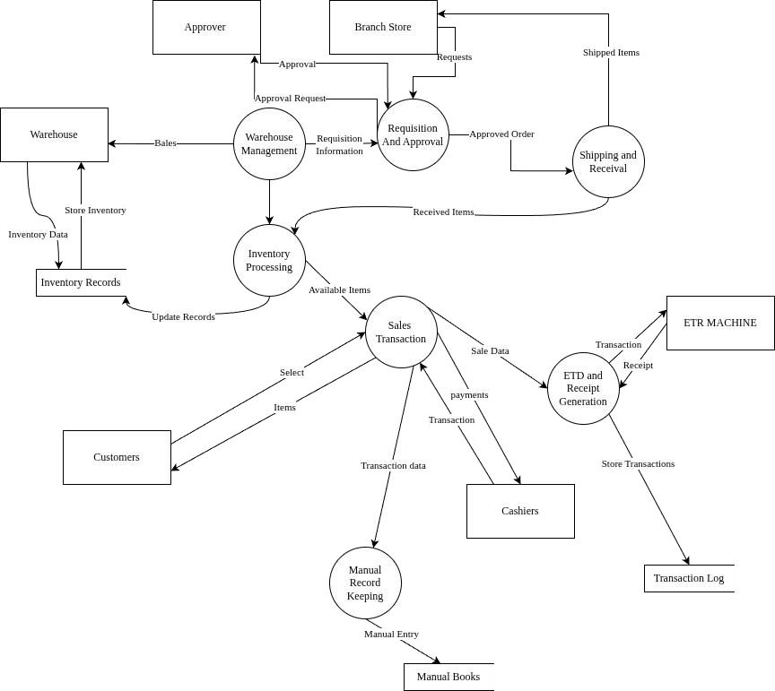
Figure 3.1: Prototype 1 (Iteration 1): Initial POS Interface Concept Data flow diagram for current systems

Author (2026)

Context Diagram
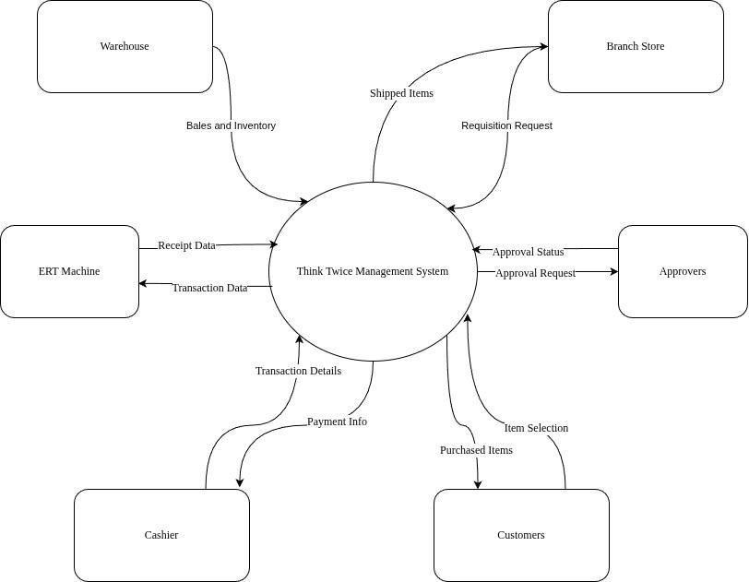
Author (2026)
Figure 3.2: Context diagram for current system
Figure 3.2 Context diagram for current system

Flow Charts

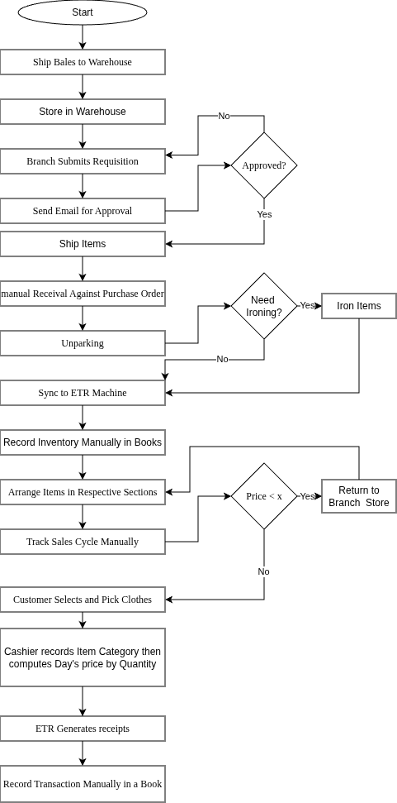
Figure 3.3: flowchart for current system Author (2026)

35

Methodology for System Design (Proposed System)

The system design methodology combines structured systems development approaches with agile principles: Structured Analysis and Design: The design follows a systematic process of requirements analysis, process modeling, database design, and interface specification. Each component is thoroughly documented to serve as a blueprint for implementation. User-Centered Design: Design decisions prioritize end-user needs, considering the varying digital literacy levels among Think Twice Stores staff. Interface design emphasizes simplicity, intuitive navigation, and minimal training requirements. Iterative Refinement: While the initial design is comprehensive, feedback mechanisms ensure the design can be refined based on stakeholder input and emerging insights during implementation phases.

Data Flow Diagram

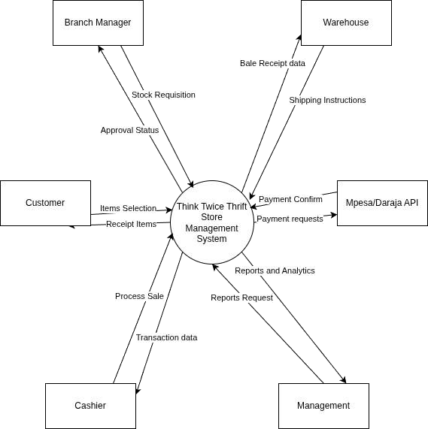
Author (2026)

Figure 3.4: Data flow diagram for Think Twice Thrift Store Management System

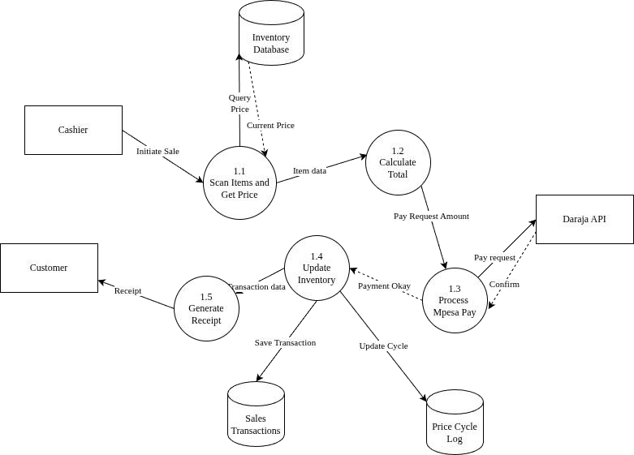
Figure 3.4: level 2 Data Flow Diagram

Author (2026)

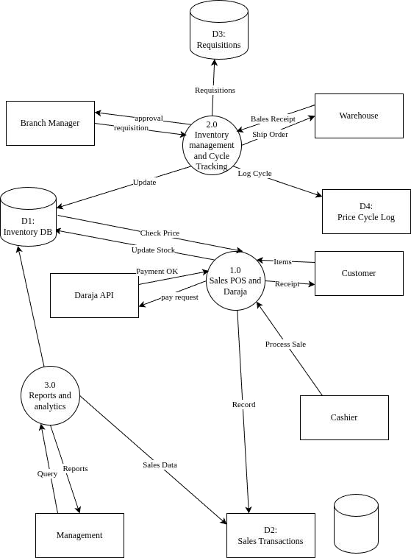
Figure 3.5: Context Diagram for Think Twice Thrift Store Management System Author (2026)

Flowcharts
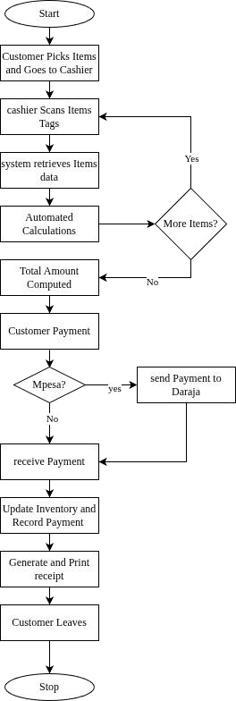
Figure 3.5: Complete Sales Transaction Process with M-Pesa Integration Author 2026

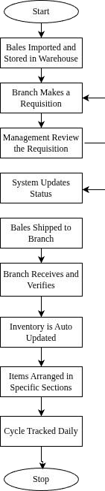
Figure 3.6: Inventory Cycle Management from Requisition to Price Tracking Author (2026)

Sequence Diagram
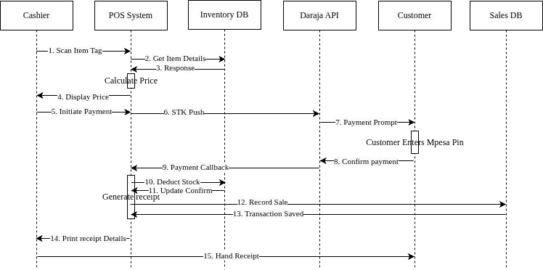
Figure 3.7: Sequence Diagram: Sales Transaction Processing with M-Pesa Integration Author (2026)

Collaboration Diagram

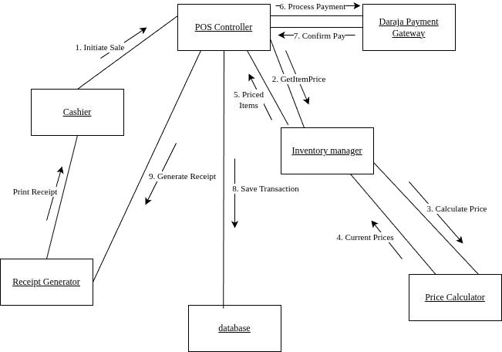
Figure 3.8: Collaboration Diagram: Sales Transaction Processing with Object Interactions, Author (2026)

Use Case Diagrams

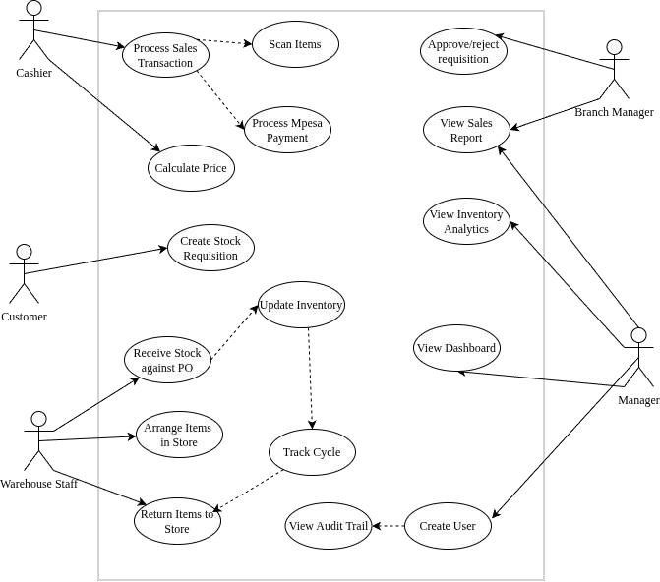
Figure 3.9: Use Case Diagram for Think Twice Thrift Store Management System, Author (2026)

Pseudocode
Pseudocode provides a plain-language description of the algorithmic logic underlying the system’s core processes, communicating intended behaviour independently of any specific programming language (Kung, 2023). Three key algorithms are presented: the M- Pesa Daraja API callback handler, the dynamic pricing cycle engine, and the Point of Sale transaction processor.
Code: M-Pesa Callback Handler BEGIN M-Pesa Callback Handler
RECEIVE callback_payload from Safaricom Daraja API

EXTRACT result_code, checkout_request_id from callback_payload

FIND transaction WHERE checkout_request_id MATCHES database record IF transaction NOT FOUND THEN
LOG "Transaction not found" RETURN failure response to Daraja END IF

IF result_code EQUALS 0 (payment successful) THEN

EXTRACT mpesa_receipt_number, amount, phone_number from callback_payload BEGIN database transaction
UPDATE transaction record:
SET payment_status = "COMPLETED"

SET mpesa_receipt_number = extracted receipt number SET paid_amount = extracted amount
SET completed_at = current timestamp

FOR EACH item in the sale:

REDUCE item.stock_qty by quantity_sold SET item.last_sold_date = current date
INSERT record into price_cycle_log (item_id, event="SALE", timestamp) END FOR
COMMIT database transaction

RETURN success response to Daraja (ResultCode = 0)

ELSE (payment failed or cancelled)

UPDATE transaction: SET payment_status = "FAILED" SET error_message = result description from Daraja callback RETURN failure response to Daraja (ResultCode = 1)
END IF
ON EXCEPTION:

ROLLBACK all uncommitted database changes LOG exception message to error log
RETURN error response to Daraja END M-Pesa Callback Handler

Early System prototypes (I/O design)

Prototyping is the process of building a model of a system to help system designers create an information system that is intuitive and easy to manipulate for end users (Hoffer et al., 2023). The prototyping process for Think Twice's management system followed an iterative approach in developing successive prototype iterations for each major system component. Each iteration incorporated user feedback from cashiers, warehouse staff, branch managers, and management to refine the interface design and functionality. This section presents the Input/Output (I/O) design prototypes showing the evolution from initial concept to refined interface based on stakeholder input.

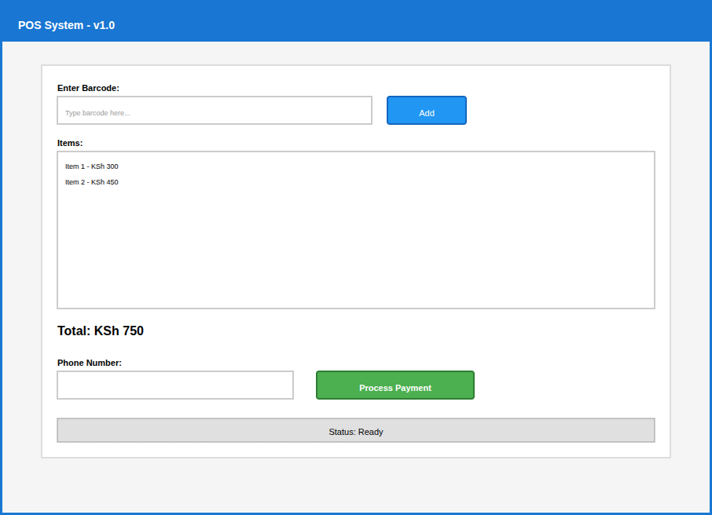
Figure 3.10: Prototype 1 (Iteration 1): Initial POS Interface Concept Author (2026)
User Feedback from Cashiers:

Issue: Item detail was not clear, add name and category.

Issue: Item date tracking wasn’t included to explain pricing to customers.

Issue: Total amount too small - hard to see from a distance when customer is looking. Issue: No delete button if wrong item is scanned.
Positive: Simple layout is good, not confusing.

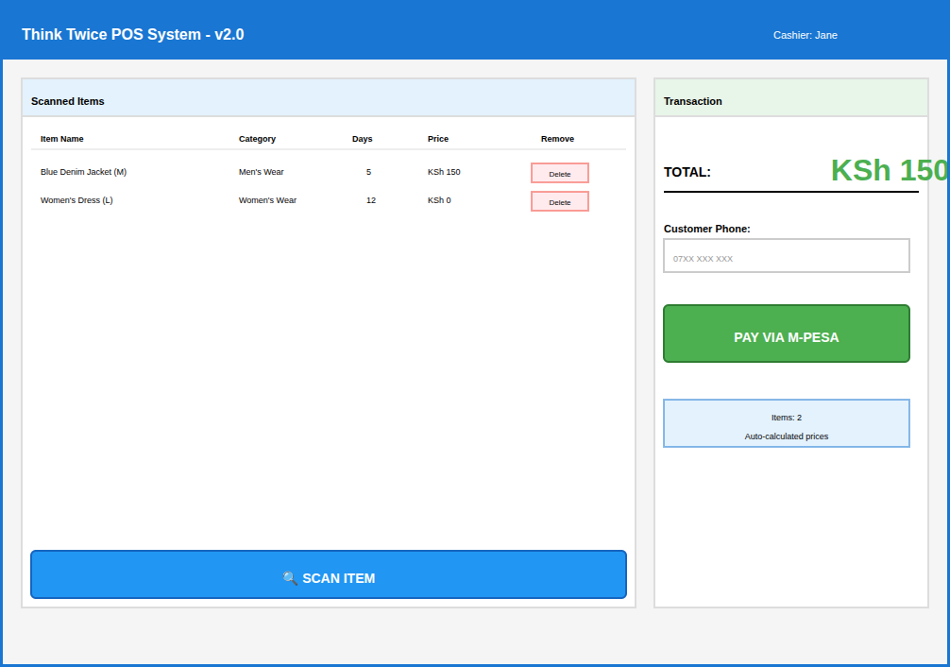
Figure 3.11: Prototype 1 (Iteration 2): Enhanced POS with Detailed Item Diasplay Item Display Author (2026)

User Feedback from Cashiers: The Interface is clear.

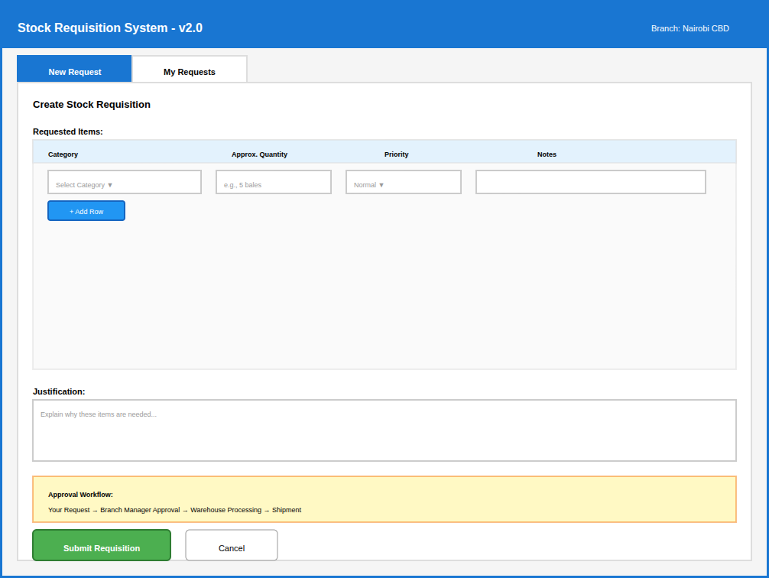
Figure 3.12: Prototype 1 (Iteration 1): Structured Requisition Form with Category Selection Author (2026)

Feedback: It’s great

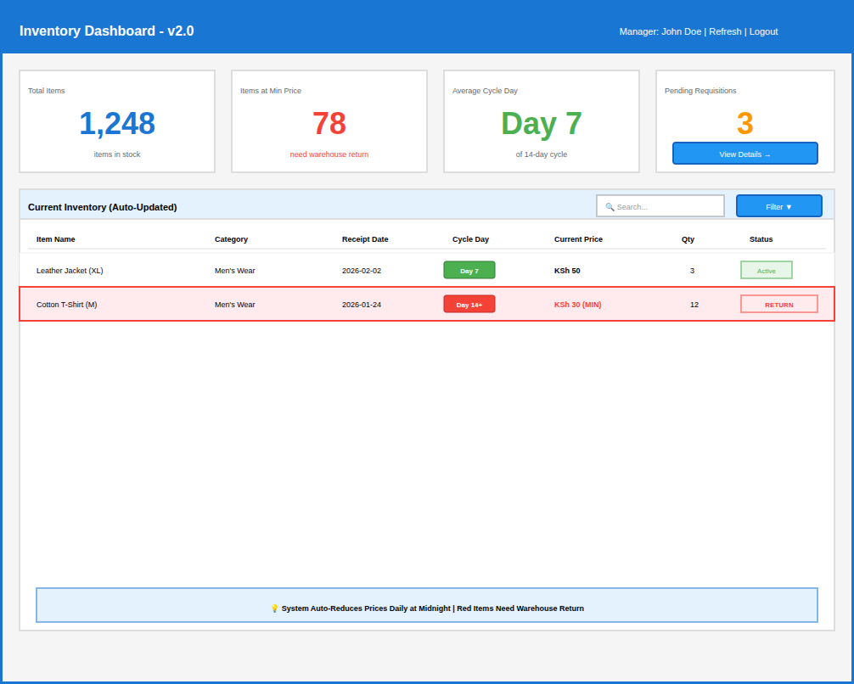
Figure 3.13: Prototype 1 (Iteration 1): Dashboard with KPI Cards and Color-Coded Alerts Author (2026)

Feedback: It’s great

Management Feedback: "This gives visibility we never had with manual books."

Design of the User Interface

The user interface design for the Think Twice Thrift Store Management System will be developed using HTML5 and Vanilla JavaScript, prioritizing simplicity, clarity, and ease of navigation to accommodate staff with varying levels of digital literacy across Think Twice Stores branches. The design adopts a clean, web based layout with a consistent top navigation bar to minimize the learning curve for new users. Color-coded alerts and KPI dashboard cards were incorporated to communicate stock levels, pricing cycle status, and sales performance at a glance, reducing the need for users to interpret complex data manually. Visual consistency was maintained across all screens through standardized button placements, form structures, and typography, ensuring that clerks and managers could transition between modules without confusion.
The Point of Sale interface was specifically designed to support rapid transaction processing during peak business hours, featuring a large-item display panel, clearly labeled payment options for both cash and M-Pesa, and real-time total calculation to minimize cashier errors. The Inventory Management interface presents stock items in a categorized, filterable table view, with automated visual indicators that highlight items approaching the end of their two-week pricing cycle, prompting timely action from warehouse staff and managers. Role-based access control is reflected directly in the interface, where each user role Administrator, Manager, and Sales Clerk sees only the screens and functions relevant to their responsibilities, thereby reducing interface complexity and enhancing system security. The overall design was iteratively refined through two prototype cycles based on stakeholder feedback gathered during the data collection phase, ensuring the final interface aligns closely with the real operational workflows of Think Twice Stores.

Design of the Database

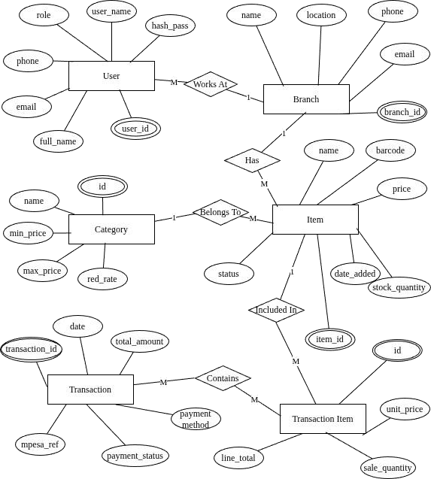
Figure 3.14: Entity-Relationship Diagram for Think Twice Stores Database Author (2026)

Table 3.1: User Table — Stores System User Accounts and Authentication Details
Field Name | Data Type | Constraints | Nullable | Description
PK user_id | INT | PRIMARY KEY, AUTO_INCREME NT | No | Unique identifier for each user
user_name | VARCHAR(5 0) | UNIQUE, NOT NULL | No | Login username; must be unique across all users
hash_pass | VARCHAR(2 55) | NOT NULL | No | Bcrypt-hashed password string
fullName | VARCHAR(1 00) | NOT NULL | No | Full display name of the user
email | VARCHAR(1 00) | UNIQUE, NOT NULL | No | User's email address; used for notifications
phone | VARCHAR(1 5) | NOT NULL | No | User's contact phone number
role | ENUM | NOT NULL,  DEFAULT 'cashier' | No | Role: 'admin', 'manager', or 'cashier'
FK branch_ id | INT | FOREIGN KEY →  Branch(branch_id) | No | Branch the user is assigned to (Works At)

Author (2026)

Note. The role field controls system access permissions. The hash_pass field must never store plain-text passwords.

Table 3.2: Branch Table; Records Physical Store Locations Managed by the System
Field Name | Data Type | Constraints | Nullable | Description
PK branch_ id | INT | PRIMARY KEY, AUTO_INCREMENT | No | Unique identifier for each branch
name | VARCHAR(1 00) | NOT NULL | No | Name of the branch store
location | VARCHAR(2 00) | NOT NULL | No | Physical address or area of the branch
phone | VARCHAR(1 5) | NOT NULL | No | Branch contact phone number
email | VARCHAR(1 00) | UNIQUE | Yes | Branch contact email address

Author (2026) Note. Each branch record acts as the parent for all Items and Users assigned to that location.

Table 3.3: Category Table — Defines Item Classification Groups and Pricing Reduction Rules
Field Name | Data Type | Constraints | Nullable | Description
PK id | INT | PRIMARY KEY, AUTO_INCREM ENT | No | Unique category identifier
name | VARCHAR(1 00) | NOT NULL, UNIQUE | No | Category name (e.g., Electronics, Clothing)
min_price | DECIMAL(10  ,2) | NOT NULL, CHECK ≥ 0 | No | Minimum allowable sale price for items in this category
max_price | DECIMAL(10  ,2) | NOT NULL, CHECK ≥  min_price | No | Maximum allowable sale price for items in this category
daily_reducti on_rate | DECIMAL(5, 2) | NOT NULL, CHECK 0–100 | No | Percentage by which item price is reduced daily (price cycle)

Author (2026)

Note. The daily_reduction_rate drives the automated price cycle engine, reducing unsold item prices each day until min_price is reached.

Table 3.4: Item Table — Represents Individual Second-Hand Products Available for Sale
Field Name | Data Type | Constraints | Nullable | Description
PK item_id | INT | PRIMARY KEY, AUTO_INCREME NT | No | Unique identifier for each inventory item
name | VARCHAR(1 50) | NOT NULL | No | Descriptive name of the item
barcode | VARCHAR(5 0) | UNIQUE, NOT NULL | No | Unique barcode printed on the item tag for POS scanning
price | DECIMAL(10  ,2) | NOT NULL, CHECK ≥ 0 | No | Current selling price (updated daily by price cycle)
condition | ENUM | NOT NULL | No | Physical condition: 'excellent', 'good', 'fair', 'poor'
status | ENUM | NOT NULL, DEFAULT  'available' | No | Availability: 'available', 'sold', 'reserved', 'donated'
stock_qty | INT | NOT NULL, DEFAULT 1,  CHECK ≥ 0 | No | Number of units in stock (typically 1 for second-hand items)
date_added | DATE | NOT NULL | No | Date the item was added to inventory; used by price cycle
FK branch_id | INT | FOREIGN KEY →  Branch(branch_id) | No | Branch where the item is physically located (Has)
FK category_ id | INT | FOREIGN KEY →  Category(id) | No | Category this item belongs to (Belongs To)
Author (2026)

Note. The field date_added replaces the ambiguously placed date attribute in Figure 3.5.9.1. The stock_qty label replaces the ambiguous quantity attribute to distinguish it from sale_qty.

Table 3.5: Transaction Table — Records Each Completed Sale Event at the Point of Sale
Field Name | Data Type | Constraints | Nullable | Description
PK transaction_ id | INT | PRIMARY KEY, AUTO_INCREM ENT | No | Unique identifier for each sales transaction
date | DATETIME | NOT NULL, DEFAULT NOW() | No | Date and time the transaction was processed
total_amount | DECIMAL(10  ,2) | NOT NULL, CHECK ≥ 0 | No | Total monetary value of all items in the transaction
payment_metho d | ENUM | NOT NULL | No | Payment method used: 'mpesa', 'cash', 'card'
mpesa_ref | VARCHAR(2 0) | UNIQUE | Yes | Daraja/M-Pesa confirmation code; NULL if cash payment
payment_status | ENUM | NOT NULL, DEFAULT  'pending' | No | Payment outcome: 'pending', 'completed', 'failed', 'refunded'
FK user_id | INT | FOREIGN KEY  → User(user_id) | No | Cashier who processed this transaction

Author (2026)

Note. The mpesa_ref field is nullable to accommodate cash transactions. The user_id foreign key was inferred from system requirements and should be added to the ER diagram to show which cashier processed each sale.

Table 3.6: TransactionItem Table — Associative Entity Linking Items Sold Within Each Transaction
Field Name | Data Type | Constraints | Nullable | Description
PK id | INT | PRIMARY KEY, AUTO_INCREME NT | No | Surrogate primary key for each transaction line
FK transaction_ id | INT | FOREIGN KEY →  Transaction(transac tion_id) | No | The parent transaction this line belongs to (Contain)
FK item_id | INT | FOREIGN KEY →  Item(item_id) | No | The item included in this transaction line (Included In)
sale_qty | INT | NOT NULL, DEFAULT 1,  CHECK ≥ 1 | No | Quantity of this item sold in the transaction
unit_price | DECIMAL(1 0,2) | NOT NULL, CHECK ≥ 0 | No | Price per unit at the time of sale (snapshot)
line_total | DECIMAL(1 0,2) | NOT NULL, CHECK ≥ 0 | No | Computed  total: sale_qty  × unit_price for this line
Author (2026)

Note. The unit_price field records the price at the moment of sale because item prices change daily. The trans_id attribute shown in Figure 3.5.9.1 is replaced here by the standard transaction_id foreign key; the attribute is implied by the relationship and need not appear separately in the ER diagram.

Methodology for System Implementation; Back End, Front End and Database Technologies to be used
System implementation is the process of building, installing, and configuring the information system to operate within the business environment. Implementation methodology addresses technology selection, code development, system configuration, data migration from current systems, and user training.

Backend Technologies

The backend of the Thrift Store Management System serves as the engine that processes all business logic, handles requests, manages authentication and ensures secure data transaction between the user interface and the MySQL database. PHP was selected as the primary server-side scripting language due to its proven efficiency, extensive community support, and native compatibility with MySQL. PHP's adherence to the Model-View-Controller (MVC) architectural pattern promotes a clean separation of concerns between data handling, business logic, and presentation layers — particularly important given the system's multiple modules (inventory, POS, payments, and user management).
The system employs a RESTful API architecture to facilitate seamless communication between the frontend and backend. REST endpoints are developed to expose core functionalities including stock management, sales transaction processing, M-Pesa payment callbacks, and report generation. This API-driven approach enables straightforward integration with the Safaricom Daraja API for M-Pesa C2B payment processing. To optimize performance under concurrent usage, particularly during peak sales hours at Think Twice Stores the system incorporates PHP- compatible caching mechanisms.
Session-based authentication is implemented to manage user access, while role-based access control (RBAC) enforces permission boundaries across user roles: Admin, Manager, Sales Clerk, and Warehouse Staff. Security is enforced through prepared statements to prevent SQL injection, password hashing using PHP's bcrypt implementation, input validation on all form submissions,
and comprehensive audit logging that records all system transactions with timestamps and user identifiers for accountability.

Frontend Technologies

The frontend of the Thrift Store Management System defines the visual layer through which store managers, cashiers, and warehouse staff interact with the system. Given the varying digital literacy levels among Think Twice Stores staff, the frontend prioritizes simplicity, intuitive navigation, and minimal training requirements. The frontend is built using HTML5, CSS3, and vanilla JavaScript — technologies chosen for their universal browser support, performance, and zero licensing cost. HTML5 structures all system pages including the POS interface, inventory dashboard, stock receipt form, and management reporting screens. CSS3 provides responsive styling using Flexbox and Grid layouts to ensure the interface adapts correctly across desktop computers and tablets used in-store.
JavaScript delivers interactivity critical to POS operations: dynamic cart updates as items are added, automatic price calculation based on the current day of the two-week pricing cycle, real- time M-Pesa payment status updates via AJAX polling, and form validation that prevents incomplete transactions from being submitted. The POS interface was specifically designed for speed in high-volume transaction environments. Key design decisions informed by cashier feedback during prototyping include: large item price and total displays visible to customers, clearly labeled delete and cancel buttons, prominent payment confirmation messages, and colour- coded pricing cycle indicators showing how many days remain before prices change. Performance optimizations include asset minification, lazy loading of reporting dashboards, and Content Security Policy (CSP) headers to mitigate XSS risks.

Database Technologies

MySql was selected as the database management system for the Thrift Store Management System. As an advanced open-source relational DBMS, MySQL provides ACID compliance (Atomicity, Consistency, Isolation, Durability) that ensures data integrity across all concurrent
transactions which is critical in a multi-user POS environment where multiple cashiers may process sales simultaneously. Its support for complex data types and constraints is particularly valuable for managing the dynamic pricing cycle. CHECK constraints enforce that item prices always fall within the defined minimum and maximum pricing boundaries for each category, while TRIGGER functions automate daily price reductions without manual intervention.
The relational model organizes data into six core tables: Users, Branches, Categories, Items, Transactions, and TransactionItems. The full Entity-Relationship diagram is presented in Section
3.5.9. Data security is enforced through role-based access control at the database level, ensuring that the PHP application account has only the minimum necessary permissions. Regular automated backups to protect against data loss, supporting business continuity requirements for Think Twice Stores. The system is developed and tested on MySQL 8.0, hosted on an Ubuntu
24.04 server, with PHP interacting through the PDO_MySQL driver.

Methodology for System Testing;Testing Plan, Testing Techniques

System testing ensures the Thrift Store Management System meets all functional and non- functional requirements before deployment. The testing approach validates core thrift store operations including stock receipt recording, sales processing, dynamic pricing cycle management, M-Pesa Daraja API integration, and user access control. The testing lifecycle begins with unit testing of individual components thus verifying that the pricing cycle reduction algorithm computes correct prices for each day, that the Daraja API callback handler correctly parses payment responses, and that RBAC enforces role boundaries. Integration testing then validates interactions between modules; confirming that a completed POS sale triggers an immediate inventory deduction and creates an audit log entry. System testing evaluates the complete application, testing end-to-end workflows such as: receiving a new bale of stock, categorising items, assigning pricing cycles, processing a sale with M-Pesa payment and generating a daily sales report.

Testing Plan
A comprehensive test plan is essential for managing the testing process effectively. The test plan for the system outlines the objectives, scope, test cases, schedule, and resources required for validation. The test objectives define what aspects of the system need to be tested, including functional correctness, system performance, and security compliance. The test scope determines which system components will be tested, ensuring that all critical areas are covered.
The test plan covers: functional correctness of all four modules; system performance under simulated peak load (multiple concurrent sales transactions); security testing for SQL injection, XSS, and unauthorized access attempts; and usability testing with actual Think Twice Stores cashiers and managers. Test cases are designed around the specific operational scenarios identified during requirements gathering, including edge cases such as failed M-Pesa payments requiring fallback to cash, items reaching their minimum price at end of pricing cycle, and attempted access by a user without the required role permissions.

Testing Techniques

Different testing techniques are applied to identify defects and ensure system robustness. Functional testing is carried out to verify that every feature of the system behaves as expected. This includes verifying sales processing, Daraja Integration, and notification systems. Black-box functional testing validates that each system input produces the correct output without knowledge of internal code. Performance testing uses simulated load to confirm the system remains responsive when multiple cashiers process transactions simultaneously. Security testing identifies vulnerabilities including SQL injection and cross-site scripting. Usability testing involves actual store staff interacting with the system prototype and providing feedback on navigation and clarity.
Non-functional testing evaluates system attributes such as performance, security, usability, and scalability. Performance testing ensures that the system remains responsive even when multiple users interact with it simultaneously. This includes load testing, which measures system performance under high traffic, and stress testing, which determines the breaking point of the
system under extreme conditions. Security testing is conducted to identify vulnerabilities such as SQL injection, cross-site scripting (XSS), and unauthorized access.
Usability testing assesses how intuitive and user-friendly the system is. Real users interact with the system to provide feedback on navigation, design, and accessibility. This ensures that the platform is easy to use for both technical and non-technical users. Additionally, compatibility testing ensures that the system functions across different browsers, devices, and operating systems, maintaining a consistent user experience.

Methodology for System Deployment

System deployment makes the tested and validated Thrift Store Management System available to Think Twice Stores staff. A phased deployment strategy minimises operational disruption while enabling thorough validation in the live environment.
Phase 1 Staging: The system is deployed to a staging environment that mirrors the production server. Final performance optimizations and configuration checks are completed, including MySql connection pooling and Daraja API webhook endpoint configuration.
Phase 2 Pilot Deployment: The system is rolled out at a single Think Twice Stores branch, as defined in the research scope. Selected cashiers, warehouse staff, and the branch manager use the live system alongside existing processes for two weeks, allowing parallel validation of transaction accuracy and inventory records.
Phase 3 Full Branch Deployment: Following successful pilot validation, all staff at the target branch transition fully to the new system. Training sessions are conducted for each user role using role-specific guides.
Data migration ensures that existing inventory records and historical sales data are preserved and imported into the MySQL database. A rollback plan is maintained throughout, enabling reversion to the previous system if critical issues arise. Continuous monitoring tracks system uptime, error logs, and API response times post-deployment. As the system replaces the existing semi-
automated manual processes at Think Twice Stores, staff change management and training are prioritised to ensure smooth adoption and sustained operational efficiency improvements.

Chapter Summary
This chapter has presented the comprehensive research methodology employed in designing the Thrift Shop Management System for Think Twice Stores. The methodology encompasses multiple interrelated phases: literature review identifying existing knowledge and research gaps, requirement specification gathering business needs through interviews, questionnaires, and observation, system analysis documenting current system strengths and limitations through DFDs and flowcharts, system design specifying proposed system architecture and components, implementation planning identifying technologies and development approaches, testing methodology ensuring quality and requirement satisfaction, and deployment planning enabling smooth transition to the new system.
The methodology is grounded in established systems development practices while incorporating contemporary approaches appropriate to the Kenyan context, including consideration of digital literacy variations, connectivity challenges, payment ecosystem realities, and cost constraints. The systematic, phased approach ensures that the proposed system design is well-informed, thoroughly validated with stakeholders, and implementable within the constraints and opportunities of the specific business context.

CHAPTER FOUR
SYSTEM ANALYSIS

Chapter Introduction
This chapter presents a comprehensive analysis of the current system in operation at Think Twice Stores. The analysis encompasses a description of the existing operational system — including its documented strengths and weaknesses — a structured feasibility study evaluating the viability of the proposed replacement system, a detailed data input/output analysis identifying all data currently captured and generated by the business, and a process logic design of the current system using Data Flow Diagrams (DFDs), Context Diagrams, and Process Flow Charts. The analysis is grounded in data collected through interviews with management and staff, direct observation of daily operations across three branches over a four-week period, and examination of existing records including manual sales books, stock register notebooks, and M-Pesa SMS statements.

Description of the Current System, Its Strengths and Weaknesses
Think Twice Stores currently operates a fully manual business management system supplemented solely by an Electronic Tax Register (ETR) machine mandated by the Kenya Revenue Authority (KRA) for fiscal compliance. It is important to establish at the outset that the ETR machine serves a strictly regulatory function: it digitally signs and stamps printed receipts with a KRA verification code to confirm tax compliance. The ETR machine does not manage inventory, does not record business-specific transaction details, does not track cashier identity, and does not store any operational data accessible to management. All business record-keeping at Think Twice Stores is therefore conducted entirely through handwritten paper-based processes.
At the point of sale, the operational workflow unfolds as follows. A customer selects items from the shop floor and presents them to the cashier at the counter. The cashier determines the price of each item not by reading the physical price tag — which serves only as a rough nominal indicator — but by applying their working knowledge of the store's two-week dynamic pricing cycle. Under this pricing cycle, items within each clothing category (shirts, trousers, dresses, children's wear, and so forth) begin at a maximum price on the day they arrive and reduce progressively each day until they are sold or reach a minimum clearance floor price. This pricing logic is not recorded or calculated anywhere in a system; it is common knowledge shared among cashiers and regular customers alike. A garment bearing a handwritten tag reading KES 300 may, depending on its category and how many days it has been on the floor, be sold for as little as KES 100 on the day of the transaction. The price tag, therefore, is a starting-price marker rather than an accurate current selling price.
Once the total is calculated, the customer pays using either cash or M-Pesa mobile money. If M-Pesa is used, the customer initiates the payment on their phone using the store's M-Pesa paybill or till number, and the cashier verifies the transaction by checking the SMS confirmation received on the business's Safaricom till phone. After payment is confirmed, the cashier uses the ETR machine to print a KRA-compliant receipt which is handed to the customer. Following the ETR receipt generation, the cashier manually records the transaction in a physical sales book. The details entered into this book constitute the primary business record of the sale and typically include: the item or items sold, the price charged for each, the total amount, the payment method, the M-Pesa transaction reference code if applicable, the time of the transaction, and the name of the cashier serving at that shift. This manual recording is the sole source of sales data available to management for end-of-day reconciliation and reporting.
On the inventory side, the process is equally manual. When a new bale of second-hand clothing arrives at a branch, warehouse staff physically count and sort the items by clothing category. Item quantities are recorded in a handwritten stock register notebook. Each item is then fitted with a handwritten price tag reflecting the starting price for its category, after which the items are placed on the shop floor. No real-time deduction from the stock register occurs when an item is sold; inventory reconciliation is performed periodically during manual stock-take exercises, which may occur weekly or less frequently depending on branch workload.

Feasibility Study and Its Conclusion
A structured feasibility study was conducted to evaluate whether the proposed Thrift Store Management System is viable within the operational, financial, technical, and legal context of Think Twice Stores. The feasibility study assessed five key dimensions: technical, operational, economic, schedule, and legal and ethical feasibility. Findings from the stakeholder interviews, direct observation, and requirements analysis informed each dimension of the assessment.

Table 4.1: Feasibility Study Summary for the Proposed Thrift Store Management System
Feasibility Dimension | Assessment | Verdict
Technical Feasibility | PHP, HTML5, MySQL, and JavaScript are mature, well-documented technologies widely supported by Kenyan hosting providers. The development team has prior practical experience with these technology stacks. | FEASIBLE
Operational Feasibility | Staff expressed willingness to adopt a digital system during structured interviews. Usability prototype tests conducted with cashiers yielded positive feedback. Role-based access control aligns with existing job roles at the store. | FEASIBLE
Economic Feasibility | Open-source technologies eliminate all software licensing costs. Shared hosting on an affordable Ubuntu server is estimated at KES 3,000–6,000 per month. Cost savings from reduced errors, faster reconciliation, and improved loss prevention justify the investment. | FEASIBLE
Schedule Feasibility | System development is achievable within the 2025/2026 academic year timeline. A phased deployment strategy — staging, then pilot branch, then full rollout — allows a controlled and manageable implementation. | FEASIBLE
Legal / Ethical Feasibility | The system complies with the Kenya Data Protection Act (2019). No proprietary or personal customer data is shared externally. M-Pesa integration uses the official Safaricom Daraja API, ensuring regulatory compliance. | FEASIBLE

Note. Feasibility assessment conducted based on stakeholder interviews, literature review, and system requirements analysis. Author (2026).
Conclusion of Feasibility Study: The proposed Thrift Store Management System is fully feasible across all five evaluated dimensions. The technology stack — PHP, HTML5, MySQL, and JavaScript — is proven, affordable, and well-supported within the Kenyan technology ecosystem. Staff have expressed willingness to adopt the system, and interface prototypes have already received positive feedback from cashiers and management. The open-source technology approach eliminates licensing costs, and the economic benefits from reduced inventory errors, faster transaction processing, and improved loss prevention provide a clear return on investment. The system will be developed and initially deployed at a single branch in full compliance with the Kenya Data Protection Act 2019.

Data Input/Output Analysis

Overview
Data Input/Output (I/O) analysis identifies all data items currently captured by the current system as inputs, the relationships between those data items, and the outputs the system currently generates. This analysis is critical for establishing a clear understanding of information flows within the existing manual system, identifying data quality and integrity issues, and defining the data architecture requirements for the proposed replacement system. Data was identified through direct observation at three Think Twice Stores branches, examination of physical records including the manual sales books and stock register notebooks, and structured interviews with cashiers, warehouse staff, and the branch manager.

Table 4.2: Data Input/Output Analysis — Current System at Think Twice Stores
Data Category | Input Data | Output Data
Sales Transactions | Items sold, price per item at time of sale, payment method, M-Pesa reference code (if applicable), time of transaction, cashier name and shift | ETR-signed tax receipt (customer copy), handwritten sales book entry, end-of-shift cash and sales total handed to manager
Inventory / Stock | Item description, clothing category, quantity received from bale, date received, nominal starting price written on tag | Stock register entries, handwritten price tags attached to items, periodic stock count summaries
Pricing Cycle | Category starting price (noted on tag), cashier knowledge of daily price reduction rate per category (informal, not recorded digitally) | Actual selling price determined verbally by cashier at point of sale — no system-generated pricing output
M-Pesa Payments | Customer M-Pesa transaction reference code (SMS notification on till phone, copied into sales book) | M-Pesa reference recorded in sales book; end-of-shift manual reconciliation against Safaricom SMS statement
Cashier / Shift | Cashier name recorded manually in sales book at start and end of shift | No automated shift report — manager reviews sales book entries attributed to each cashier name
Note. Data categories and flows identified through direct observation and review of physical records at Think Twice Stores. Author (2026).

Relationships Between Data Items
Analysis of the current system reveals that data relationships are maintained entirely through physical proximity of records and cashier memory rather than structured, enforced linkages. A sale recorded in the sales book has no direct automated connection to the inventory stock register — the relationship between a sold item and its corresponding stock deduction is performed manually and periodically, typically during weekly stock-takes rather than in real time. Similarly, M-Pesa payment records received as SMS confirmations on the Safaricom till phone are not automatically linked to the corresponding sales book entry, requiring manual cross-referencing by the manager at end of shift.
This lack of enforced data relationships results in three critical failure modes observed during the research period: (i) inventory records diverge from physical stock counts within hours of a new bale delivery due to unrecorded sales during busy periods; (ii) end-of-day cash and M-Pesa discrepancies arise from unmatched SMS payment confirmations against manual entries; and (iii) pricing cycle inconsistencies occur when a relief cashier is less familiar with the current day's pricing, leading to items being sold above or below the correct price for that day in the cycle. The proposed system addresses all three failure modes through automated relational data management enforced by MySQL database referential integrity constraints and a trigger-based automated daily pricing cycle.

Process Logic Design of the Current System

Process Flowchart — Current Sales Transaction
The process flowchart presented in Figure 4.3 documents the step-by-step logic of the current sales transaction process, from the moment a customer presents items at the counter to the point at which the cashier hands over the sales book and cash to the manager at the end of the shift. This flowchart was constructed from direct observation of cashier workflows during peak and off-peak hours across three branches, and was validated through follow-up structured interviews with two cashiers and the branch manager. A critical decision point in the flowchart is the payment method fork: cash payments proceed directly to the ETR and manual recording stage, while M-Pesa payments require an additional verification step in which the cashier confirms the Safaricom SMS before proceeding. In both cases, the post-ETR manual recording in the sales book — including the cashier's name and the M-Pesa reference code where applicable — constitutes the definitive business record of the transaction.

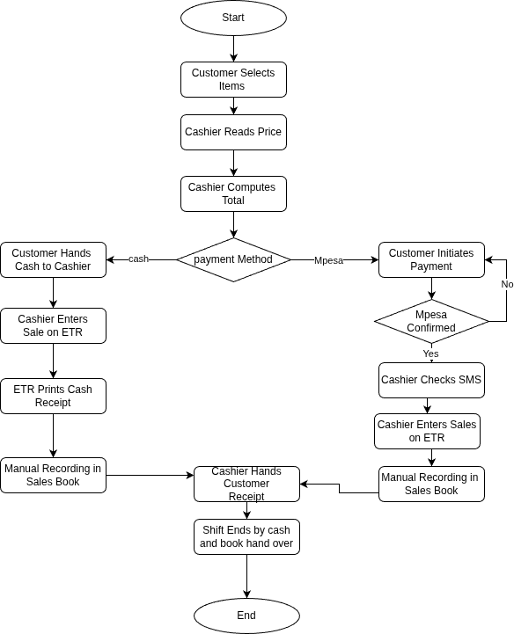
Figure 4.1: Process Flow Chart Current Sales Transaction at Think Twice Stores current sales transaction workflow at Think Twice Stores, from item selection through ETR receipt printing and manual recording in the sales book. Both cash and M-Pesa payment paths are depicted. Author (2026).

Context Diagram — Current System
The Context Diagram presented in Figure 4.1 illustrates the highest-level view of the current system, defining its operational boundaries and identifying all external entities that interact with it. The central process represents the entirety of Think Twice Stores' current manual and ETR-assisted operations. Four external entities interact with the system: the Customer who selects items and makes payment; the Bale or Clothing Supplier who delivers new stock to the branch; Safaricom, through whose M-Pesa platform a majority of customer payments are made; and the KRA ETR Machine, which is an external regulatory device that receives transaction data and returns a signed tax receipt. It is specifically noted that the ETR Machine is represented as an external entity rather than an internal data store, consistent with its actual role as a KRA-mandated tax compliance device that does not contribute to business data management.
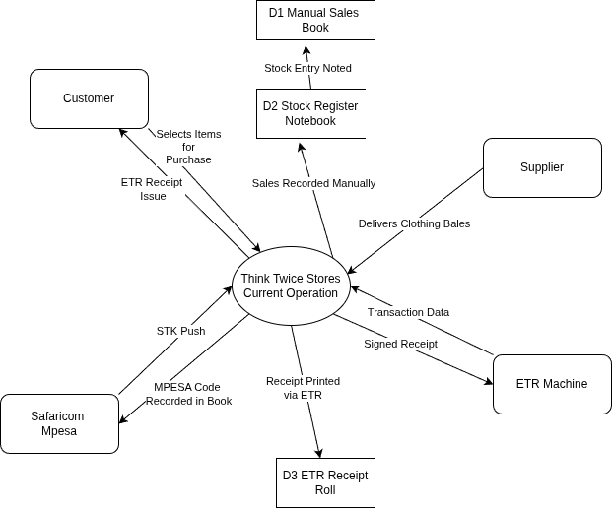

Figure 4.2: Context diagram illustrating the boundary of the current manual operations system at Think Twice Stores, showing all external entities and primary data flows. The ETR machine appears as an external entity reflecting its role as a KRA compliance tool rather than a business management component. Author (2026).

Level 1 Data Flow Diagram — Current System
The Level 1 Data Flow Diagram presented in Figure 4.2 decomposes the central process from the Context Diagram into the five primary operational sub-processes of the current system. These are: P1 — Receive and Sort Stock, executed by warehouse staff upon arrival of a bale; P2 — Tag Items with Price, in which nominal starting-price tags are handwritten and attached to each item; P3 — Process Sale at the cashier counter, encompassing price determination, payment collection, and ETR receipt printing; P4 — Record in Sales Book, the manual post-ETR step where the cashier transcribes all transaction details into the paper sales book; and P5 — Compile Daily Report, the end-of-shift process where cash and M-Pesa entries are totalled and the book is handed to the manager. Four physical data stores underpin these processes: the Stock Register Notebook, the Physical Price Tags, the Manual Sales Book, and the ETR Receipt Roll.

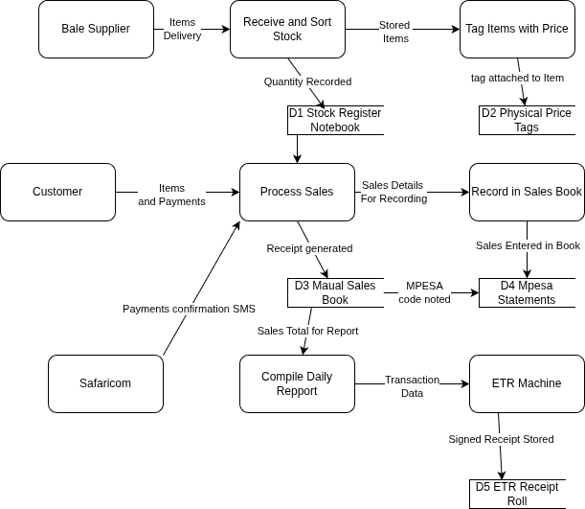
Figure 4.3: Level 1 data flow diagram showing the five primary operational processes of the current manual system at Think Twice Stores, with associated data stores and external entity interactions. Author (2026).

Chapter Summary
This chapter has presented a comprehensive analysis of the current system at Think Twice Stores. The description of the existing system established that the current operational model is entirely manual in its business management functions, with the sole digital component — the ETR machine — serving exclusively as a KRA tax compliance device that signs customer receipts and provides no inventory, pricing, or reporting capability to the business. All sales recording, stock management, pricing cycle administration, M-Pesa reconciliation, and end-of-shift reporting are conducted through handwritten paper-based processes supplemented by cashier knowledge and informal conventions.
The strengths and weaknesses analysis confirmed that while the current system is low-cost and familiar to staff, it creates critical operational vulnerabilities: the absence of real-time inventory deduction, the reliance on informal cashier knowledge for dynamic price determination, the manual and error-prone M-Pesa reconciliation process, and the complete absence of an audit trail or accountability mechanism. The feasibility study concluded that a comprehensive digital replacement system is fully feasible across technical, operational, economic, schedule, and legal dimensions. The data I/O analysis identified five primary data categories — sales transactions, inventory and stock, pricing cycle, M-Pesa payments, and cashier shift data — and demonstrated that the current system's reliance on informal, unlinked paper records across all categories is the root cause of the organisation's most significant operational challenges. The context diagram, Level 1 DFD, and process flowcharts collectively document the current system's information flows and process logic, providing an authoritative baseline against which the proposed system design in Chapter Five is compared and justified.

CHAPTER FIVE
SYSTEM DESIGN OF THE PROPOSED SYSTEM

Chapter Introduction
This chapter presents the comprehensive design of the proposed Thrift Store Management System for Think Twice Stores. Building directly on the findings and baseline established in Chapter Four, the design specifies how the proposed system addresses each identified weakness of the current manual system while fulfilling all elicited stakeholder requirements. The chapter covers: a description of the proposed system including its four integrated modules, their strengths, and acknowledged limitations; a structured requirements analysis encompassing functional, non-functional, and usability requirements; the conceptual three-tier system architecture; detailed process logic designs including Use Case, Activity, and Entity-Relationship diagrams; a normalised database design with a comprehensive data dictionary; and input/output mockup screen specifications illustrating the proposed user interface.

Description of the Proposed System, Its Strengths and Limitations
The proposed Thrift Store Management System is a web-based, multi-module information system designed specifically for the operational requirements of Think Twice Stores. It is built using an open-source technology stack comprising PHP for backend application logic, HTML5 and Vanilla JavaScript for the frontend user interface, and MySQL 8.0 for relational data management. The system is designed for deployment on a local Ubuntu server at the branch level, with internet connectivity required only for M-Pesa Daraja API payment processing — a deliberate architectural decision ensuring that core inventory and point-of-sale functions remain operational even during brief connectivity interruptions.
The system is organised into four integrated modules. The Inventory Management module automates stock receipt recording, tracks item quantities and categories, and executes the two-week dynamic pricing cycle through MySQL-level triggers that recalculate item prices daily without manual intervention — directly replacing the informal cashier-knowledge-based pricing convention of the current system. The Point of Sale module enables cashiers to process transactions by scanning item barcodes, receive automated price calculations reflecting the current day in the pricing cycle, and accept both cash and M-Pesa payments with real-time inventory deduction upon sale completion. The M-Pesa Payment Integration module connects to the Safaricom Daraja API to initiate Customer-to-Business STK Push payments and capture payment confirmations through a secure callback endpoint, eliminating the current manual SMS verification step. The User Management and Auditing module enforces role-based access control across four user roles — Admin, Manager, Sales Clerk, and Warehouse Staff — and maintains a comprehensive audit trail of all system transactions, providing the accountability mechanism entirely absent from the current paper-based system.

Table 5.1: Strengths and Acknowledged Limitations of the Proposed System
Strengths of the Proposed System | Limitations and Risks Acknowledged
Real-time inventory deduction upon every completed sale | Requires stable internet connection specifically for M-Pesa Daraja API integration
Automated daily pricing cycle — eliminates informal cashier-knowledge pricing and associated inconsistencies | nitial staff training investment required across all four role types
Integrated M-Pesa payment capture via Safaricom Daraja API — eliminates manual SMS verification | Prototype deployment limited to single pilot branch within this research scope
Role-based access control ensures individual accountability for every transaction | M-Pesa Daraja API is subject to Safaricom policy and endpoint changes outside the developer's control
Complete audit trail for every transaction, login, stock receipt, and data modification | No offline-mode fallback in the current design scope — extended connectivity loss would impair M-Pesa processing
Centralised reporting — daily and weekly reports generated in one click by management | Open-source stack eliminates licensing costs but requires ongoing developer maintenance
Barcode scanning at POS eliminates manual price determination by cashier

Note. Strengths derived from system design specifications; limitations identified through feasibility analysis and stakeholder risk review. Author (2026).

Requirements Analysis

Functional Requirements
Functional requirements define the specific behaviours and operations the system must perform to satisfy stakeholder needs. The requirements below were derived from stakeholder interviews, questionnaire analysis, observation of current operations, and direct engagement with management at Think Twice Stores. Each requirement is assigned a unique identifier, a priority level, and the module it belongs to.

Table 5.2: Functional Requirements — Thrift Store Management System
ID | Requirement | Priority | Module
FR-01 | System shall record stock receipts including item description, clothing category, quantity, and date of entry | HIGH | Inventory Management
FR-02 | System shall automatically calculate and update item prices daily based on the two-week pricing cycle reduction rate configured per category | HIGH | Inventory Management
FR-03 | System shall generate reorder alerts when stock quantity falls below a defined threshold per category | MEDIUM | Inventory Management
FR-04 | System shall allow filtering and searching of inventory by category, branch, and pricing cycle day | MEDIUM | Inventory Management
FR-05 | System shall process sales transactions by scanning item barcodes and automatically applying the current day's calculated price | HIGH | Point of Sale
FR-06 | System shall deduct inventory stock quantity immediately upon completion of a confirmed sale | HIGH | Point of Sale
FR-07 | System shall support both cash and M-Pesa payment methods during a single transaction | HIGH | Point of Sale
FR-08 | System shall initiate M-Pesa STK Push via Safaricom Daraja API and capture payment callback confirmation automatically | HIGH | M-Pesa Integration
FR-09 | System shall handle failed or timeout M-Pesa transactions and allow cashier fallback to cash payment | HIGH | M-Pesa Integration
FR-10 | System shall generate a reconciled M-Pesa payment report per shift showing reference numbers and amounts | MEDIUM | M-Pesa Integration
FR-11 | System shall enforce role-based access control: Admin, Manager, Sales Clerk, and Warehouse Staff with distinct permission sets | HIGH | User Management
FR-12 | System shall maintain an audit trail logging all transactions, logins, and data modifications with timestamps and user identifiers | HIGH | User Management
Note. Requirements elicited through stakeholder interviews, direct observation, and prototype feedback sessions. Author (2026).

Non-Functional Requirements
Non-functional requirements define the quality attributes and operational constraints the system must satisfy beyond its functional behaviour. These requirements are equally critical to system success, as a functionally correct but slow, insecure, or difficult-to-use system would fail to achieve adoption and operational benefit at Think Twice Stores.

Table 5.3: Non-Functional Requirements — Thrift Store Management System
Category | Requirement | Metric / Target
Performance | System shall load all POS and inventory pages within acceptable response time under normal branch load | Page load ≤ 3 seconds
Security | All passwords shall be stored as bcrypt hashes; all SQL queries shall use prepared statements to prevent injection | Zero plain-text passwords; zero SQL injection vectors
Availability | System shall be available during all business hours, seven days per week | 99% uptime during 6:00 AM–10:00 PM operating hours
Usability | New cashiers shall be able to process a complete transaction after a single training session without supervisor assistance | Training ≤ 2 hours; task error rate < 5%
Scalability | System architecture shall support addition of new branches and user accounts without structural code changes | Modular branch-based data model using branch_id foreign key
Compliance | System shall comply with the Kenya Data Protection Act (2019) — no unauthorised sharing of customer or transaction data | Full KDP Act 2019 compliance; no external data sharing
Note. Non-functional requirements defined in consultation with management stakeholders and informed by the operational context of Think Twice Stores. Author (2026).

Usability Requirements
Given the diverse digital literacy levels among Think Twice Stores staff, usability requirements were given particular emphasis during the requirements gathering process. Cashiers expressed concern about complex interfaces during prototype review sessions, while warehouse staff requested clear visual indicators for pricing cycle status. The usability requirements documented below were validated against two prototype iteration cycles conducted with staff participants.
The system interface shall use simple, unambiguous language accessible to users with secondary education-level English literacy. All primary point-of-sale actions — scanning an item, selecting a payment method, and confirming a sale — shall be completable within three screen taps or mouse clicks without navigating sub-menus. The inventory dashboard shall use colour-coded visual indicators, specifically green for healthy stock levels, amber for items approaching low stock, and red for items that have reached the pricing cycle floor price, to communicate status at a glance without requiring report interpretation. Error messages shall clearly describe the problem in plain language and suggest a corrective action, avoiding technical jargon. The system shall additionally support both keyboard and mouse operation on desktop computers and touchscreen interaction on the tablet devices used at certain branches.

Conceptual Architecture of the Proposed System
The proposed system adopts a three-tier web application architecture comprising a Presentation Layer, an Application Logic Layer, and a Data Layer. This architecture separates concerns clearly, enabling independent development, testing, and maintenance of each component. An external integration layer connects the Application Layer to the Safaricom Daraja API for M-Pesa payment processing. Table 5.4 describes each architectural layer, its components, the technology employed, and its role within the system. Figure 5.1 presents a visual representation of the complete architecture and the communication protocols between layers.

Table 5.4: Conceptual Architecture — Thrift Store Management System
Layer | Component | Technology | Role
Presentation | POS Interface, Inventory Dashboard, Reports Screen, Admin Panel, User Management | HTML5, CSS3, Vanilla JavaScript | User interaction layer; renders forms, tables, and real-time feedback to branch staff
Application Logic | REST API Endpoints, Pricing Cycle Engine, M-Pesa Callback Handler, RBAC Middleware, Audit Logger | PHP (MVC Pattern) | Processes requests, enforces business rules, communicates with database and Daraja API
Data | MySQL Database — seven core tables, triggers, and referential integrity constraints | MySQL 8.0 via PDO_MySQL driver | Stores and retrieves all application data with ACID compliance and referential integrity
External Integration | Safaricom Daraja API — C2B STK Push and Payment Callback Receiver | HTTPS REST API (Safaricom Official) | Processes M-Pesa customer payments and delivers real-time transaction confirmations
Infrastructure | Ubuntu 24.04 LTS Server, Apache 2.4 Web Server | Ubuntu 24.04 LTS, Apache 2.4 | Hosts application and database; serves HTTP requests to branch staff browsers
Note. Architecture designed to support local branch deployment with internet-only dependency for M-Pesa payment integration. Author (2026).

Use Case Diagram
The Use Case Diagram presented identifies all actors interacting with the proposed system and the functional use cases they participate in. Four primary human actors are identified: Admin, Manager, Sales Clerk (Cashier), and Warehouse Staff. A fifth actor — System (Scheduled Task) — represents automated processes, principally the daily pricing cycle execution. Two external actors interact at the system boundary: the Customer, who participates in the M-Pesa payment use case by responding to the STK Push prompt on their mobile phone; and the Safaricom Daraja API, which processes the payment and delivers the callback confirmation.
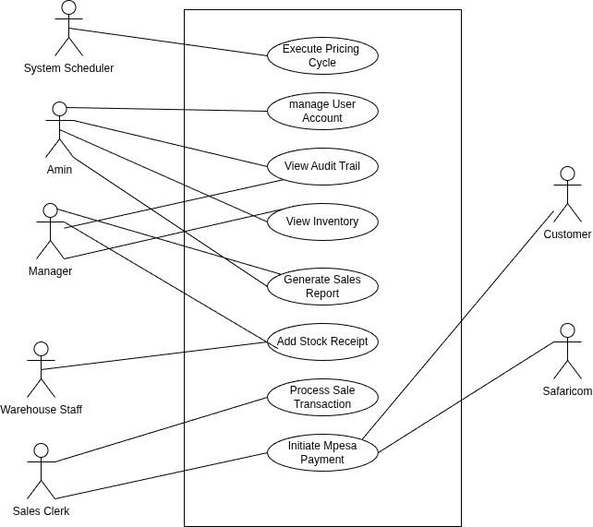
Figure 5.1: Use case diagram for the proposed Thrift Store Management System, illustrating the eight primary use cases, four human actor roles, one automated system actor, and two external actors at the system boundary. Author (2026).

Activity Diagram — Sales Transaction with M-Pesa Integration
The Activity Diagram presented in Figure 5.3 describes the workflow of the most critical system process: a sales transaction incorporating M-Pesa payment integration. This swimlane diagram is organised across four activity lanes — Cashier/POS, System (PHP Backend), Safaricom Daraja, and Customer — reflecting the distributed nature of the M-Pesa payment confirmation process. The diagram was designed specifically to address the key pain points identified in the current system analysis: the absence of automated price calculation, the manual M-Pesa SMS verification step, and the lack of real-time inventory deduction upon sale completion. Upon a successful M-Pesa callback, the system automatically records the transaction, deducts stock quantities from inventory, inserts an audit log entry, and generates the customer receipt — a sequence of actions that is entirely manual and non-real-time in the current system.
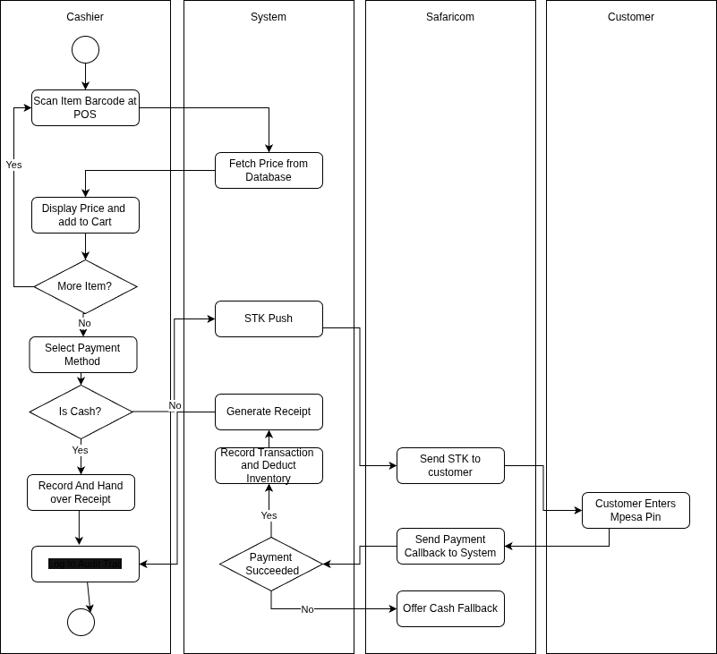
Figure 5.2: Activity diagram illustrating the proposed sales transaction process with M-Pesa payment integration, showing swimlanes for the cashier, PHP backend, Safaricom Daraja API, and customer. Both successful payment and failed payment fallback paths are depicted. Author (2026).

Class Diagram
The class diagram defines the object-oriented structure of the proposed system, identifying the six primary application classes, their attributes, methods, and relationships. This diagram serves as the blueprint for both the PHP application's object model and the MySQL database schema. The six core classes are: User, which manages authentication and role-based permission enforcement; Branch, which encapsulates all branch-specific data and serves as the organisational unit for inventory and user assignment; Item, which tracks individual stock items including their barcode, category membership, quantity, and daily-recalculated current price; Category, which defines the pricing cycle parameters — maximum price, minimum floor price, and daily reduction rate — applied to all items within the category; Transaction, which records each completed sale including payment method and M-Pesa reference; and TransactionItem, which implements the line-item relationship between a Transaction and each Item sold within it.
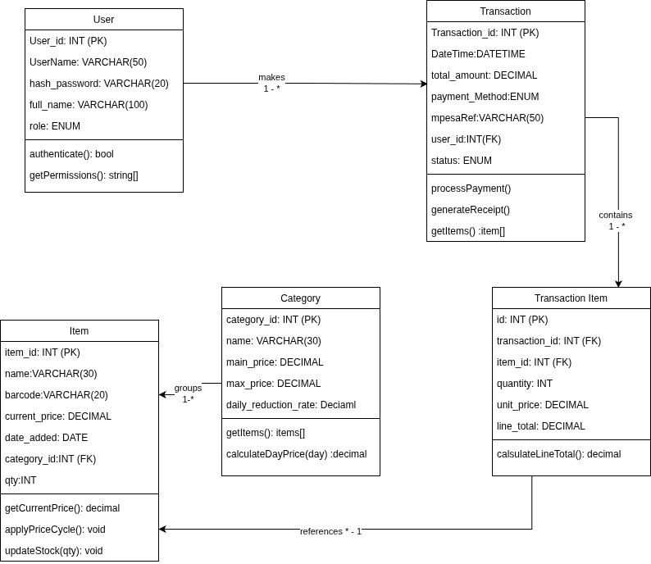
Figure 5.3: Class Diagram
Note Class diagram illustrating the object-oriented structure and relationships of the proposed system,Author (2026)

Sequence Diagram
The Sequence Diagram presented in Figure 5.5 illustrates the time-ordered interactions between system components during a sales transaction incorporating M-Pesa payment. Four lifelines are represented: the Cashier at the POS interface, the PHP Backend application logic layer, the MySQL Database, and the Safaricom Daraja API, with the Customer appearing as an external participant. The diagram begins when the cashier scans an item barcode; the PHP backend queries the MySQL database to retrieve the item name, category, stock quantity, and current day-calculated price, which is returned and displayed at the POS. Once the cashier selects M-Pesa as the payment method and enters the customer's phone number, the backend initiates an STK Push request to the Daraja API, which delivers a payment prompt to the customer's mobile phone. Upon the customer confirming the PIN, Daraja returns a callback to the PHP backend confirming payment success. The backend then executes an atomic sequence — inserting the transaction record, deducting stock quantities from inventory, and inserting an audit log entry — before returning the completed receipt to the cashier. An alternative fragment at the base of the diagram depicts the fallback path in which an M-Pesa timeout or failure prompts the cashier to retry or switch to cash payment.

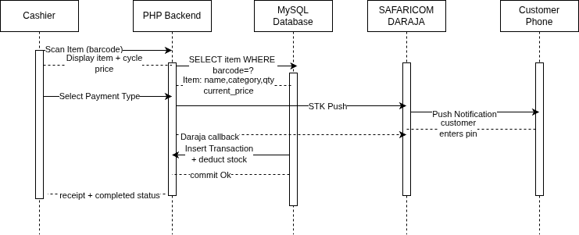
Note: Sequence diagram showing time-ordered interactions between system components during a sales transaction. Author (2026)
Figure 5.4: Sequence Diagram

Process Flowchart
The Process Flowchart presented in Figure 5.7 documents the step-by-step transaction workflow in the proposed system, from cashier login through receipt generation. This flowchart represents a direct counterpart to Figure 4.3 (the current system flowchart) and is structured to make the operational improvements explicit through comparison. In the proposed workflow, after the cashier logs in and enters the sales module, item scanning triggers an immediate database lookup that returns the item's current price calculated by the automated pricing cycle engine — replacing the informal cashier knowledge-based price determination of the current system entirely. A decision branch handles items not found in the database with a clear error message before proceeding. After confirming the cart, the payment method fork separates the cash path from the M-Pesa path; the M-Pesa path initiates a Daraja STK Push, while the cash path records the amount received. Both paths converge at the payment confirmation step, after which the system automatically deducts inventory quantities in real time, inserts the transaction and audit log records, and displays the completed receipt — a sequence that is entirely manual and non-real-time in the current system.
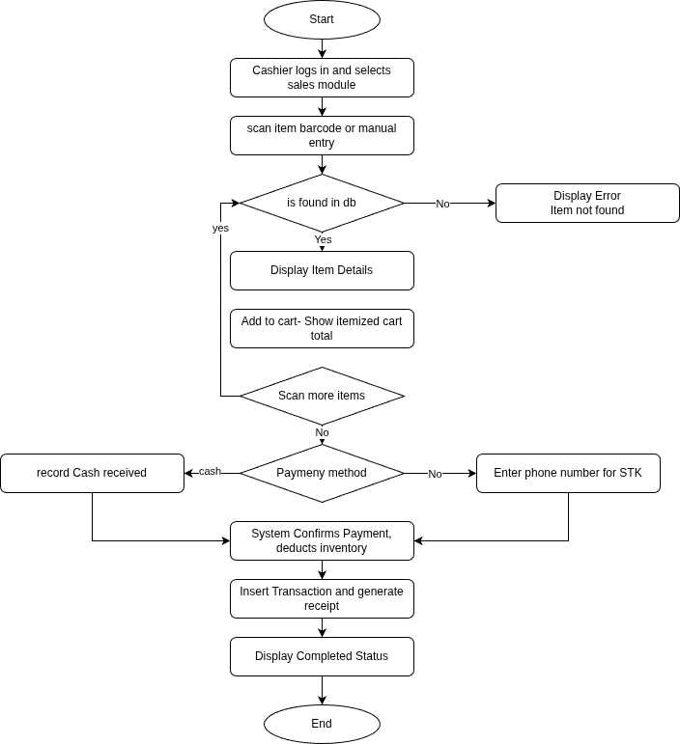
Note Process flowchart documenting the step-by-step transaction workflow in the proposed system. Author (2026)
Figure 5.5: Process FlowChart

Context Diagram
The Context Diagram presented in Figure 5.8 provides the highest-level view of the proposed Thrift Store Management System, defining its operational boundary and identifying all external entities that interact with it. Six external entities are represented: the Customer, who participates in the transaction by triggering M-Pesa STK Push confirmation on their mobile phone; the Sales Clerk (Cashier), whose primary interaction is through the Point of Sale interface for scanning items, confirming payments, and issuing receipts; the Warehouse Staff, who interacts with the Inventory Management module to record new stock receipts upon bale arrival; the Manager/Admin, who accesses the reporting dashboard, audit trail, and user management module; the Safaricom Daraja API, which processes M-Pesa C2B payment requests and returns callback confirmations; and the KRA ETR Machine, which receives receipt data for statutory compliance signing. Compared to the current system context diagram in Figure 4.1, the proposed system context diagram introduces the Manager/Admin and Warehouse Staff as distinct actor entities with structured data flows, reflecting the role-based access control architecture of the proposed system.
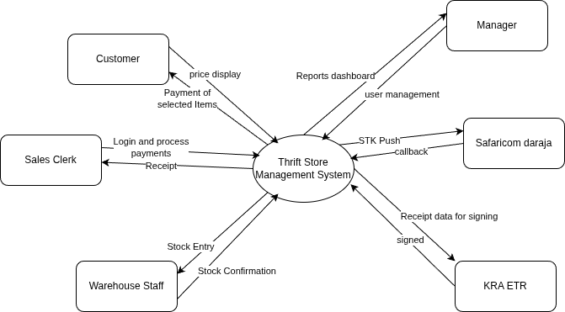
Note Context diagram showing the highest-level view of the proposed system and all external entities. Author (2026)
Figure 5.6: Context Diagram

Level 1 Data Flow Diagram
The Level 1 Data Flow Diagram presented in Figure 5.9 decomposes the central process from the Context Diagram into the five primary operational sub-processes of the proposed system, together with their associated data stores and external entity interactions. Process P1 — Process Sale Transaction — is the core POS workflow, receiving item scans from the cashier and customer payment details, querying the D2 Items data store for real-time stock and pricing data, and writing the completed transaction record to the D1 Transactions data store with simultaneous stock deduction. Process P2 — M-Pesa Payment Integration — interfaces with the Safaricom Daraja API, receiving STK Push instruction from P1 and returning the callback confirmation; it updates the mpesa_ref field within the D1 Transactions store upon successful confirmation. Process P3 — Record Stock Receipt — accepts bale details from Warehouse Staff and inserts new item records into the D2 Items data store, drawing user authentication from the D5 Users store. Process P4 — Execute Pricing Cycle — is an automated process driven by configuration data from the D4 Categories store, updating the current_price field of all items in the D2 Items data store daily according to the category-defined reduction rate. Process P5 — Generate Reports and Audit Log — aggregates data from the D1 Transactions and D3 AuditLog stores to produce the management dashboards and reports accessed by the Manager/Admin external entity. Five data stores underpin these processes: D1 Transactions, D2 Items/Stock, D3 AuditLog, D4 Categories, and D5 Users, all implemented as MySQL tables within the schema described below.
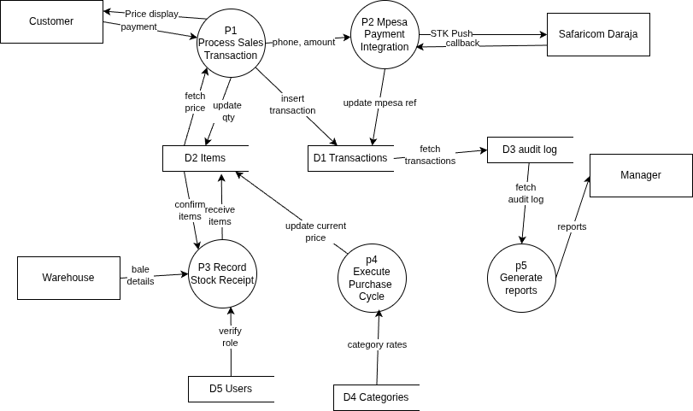
Figure 5.7: Data Flow Diagram
Note: Level 1 DFD decomposing the context diagram into the primary system processes and data flows. Author (2026)

Database Design

Entity-Relationship Model
The Entity-Relationship (ER) model presented in Figure 5.4 defines seven entities for the proposed system: User, Branch, Category, Item, Transaction, TransactionItem, and AuditLog. The relationships between entities are as follows: a Branch has many Items and has many Users; a User works at one Branch and creates many Transactions; a Category groups many Items and defines the pricing rules applied to each; an Item belongs to one Category and is located at one Branch; a Transaction contains one or more TransactionItems, each of which references one Item and records the quantity and unit price at the time of sale; and the AuditLog references User for accountability, recording every significant system event. The ER model has been designed to enforce three critical business rules through database constraints: item prices must always fall within the category's defined minimum and maximum bounds, enforced by CHECK constraints; a TransactionItem cannot reference a non-existent item, enforced by FOREIGN KEY constraints with ON DELETE RESTRICT; and stock quantity cannot fall below zero, enforced by a CHECK constraint on the stock_qty field of the Item table.
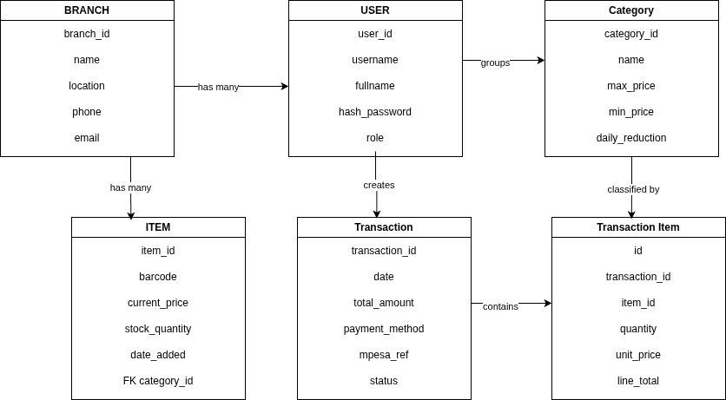
Note ER diagram defining seven entities for the proposed system database and their relationships. Author (2026)
Figure 5.8: Entity Relationship Diagram

Normalisation
The database schema was designed to comply with Third Normal Form (3NF) to eliminate redundant data and prevent update anomalies. First Normal Form (1NF) compliance was achieved by ensuring all attributes contain atomic values — for example, item condition is stored as an ENUM type rather than a comma-separated string. Second Normal Form (2NF) compliance was achieved by ensuring all non-key attributes are fully dependent on the entire primary key — the TransactionItem table uses a surrogate primary key rather than a composite key to prevent partial dependencies. Third Normal Form (3NF) compliance was achieved by eliminating transitive dependencies — branch location data is stored exclusively in the Branch table rather than duplicated in the Item or Transaction tables, and pricing cycle parameters are stored exclusively in the Category table rather than repeated per item.

Data Dictionary — AuditLog Table
An AuditLog table is included beyond the six core entities to satisfy the audit trail functional requirement FR-12. This table records every significant system event including logins, stock receipts, sales completions, pricing cycle executions, and user account changes. Table 5.7 presents the data dictionary for this table.

Table 5.5: Data Dictionary
Field Name | Data Type | Constraints | Null | Description
log_id (PK) | INT | PRIMARY KEY, AUTO_INCREMENT | NOT NULL | Unique identifier for each recorded system event
user_id (FK) | INT | FOREIGN KEY → User(user_id) | NOT NULL | The user account that performed or triggered the action
action | VARCHAR(100) | NOT NULL | NOT NULL | Description of the action performed (e.g., LOGIN, SALE_COMPLETE, STOCK_ADDED, PRICE_CYCLE_RUN)
entity_type | VARCHAR(50) | NOT NULL | NOT NULL | Type of database entity affected: Item, Transaction, User, Category, etc.
entity_id | INT | None | NULLABLE | Primary key of the specific record affected; nullable for system-level or login events
timestamp | DATETIME | NOT NULL, DEFAULT NOW() | NOT NULL | Date and time the action was performed, recorded automatically by the database
ip_address | VARCHAR(45) | None | NULLABLE | IP address of the client session that initiated the action; supports IPv4 and IPv6 notation

Note. The AuditLog table is designed to support the complete audit trail requirement (FR-12) and provides the accountability mechanism absent from the current manual system. Author (2026).

I/O of the Proposed System
The following section presents the Input/Output (I/O) design specifications for the four primary screens of the proposed system. These designs are informed by the two prototype iteration cycles conducted with Think Twice Stores cashiers and managers during the requirements gathering phase as documented in Chapter Three. Each screen specification identifies the key input elements collected from the user, the output elements displayed to the user, and the design rationale grounded in stakeholder feedback.
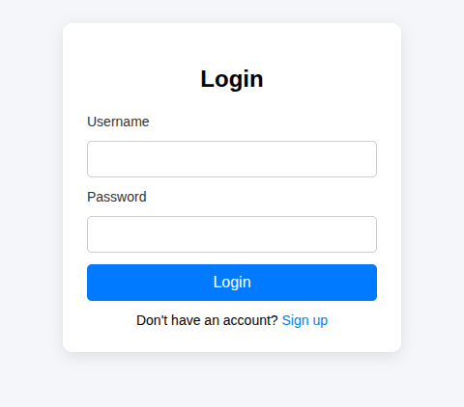
Figure 5.9: Login Page Design Note: Login panel after signup is done Author (2026)

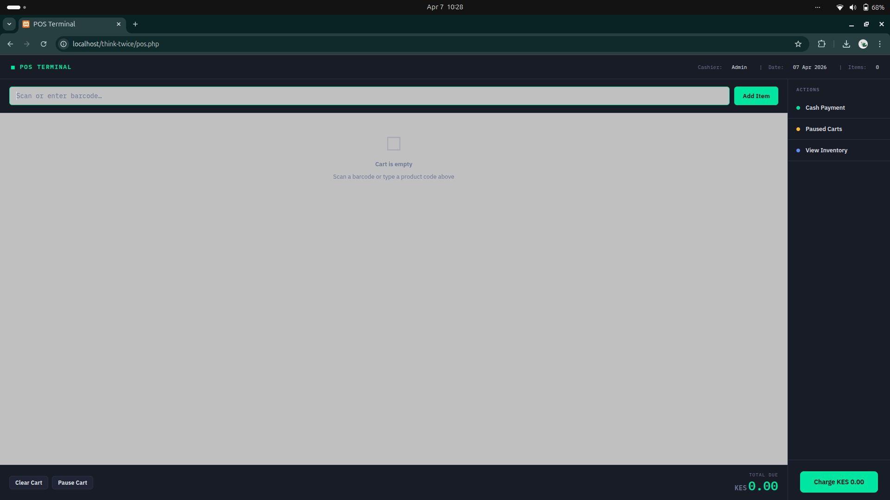
Figure 5.10: Point of Sale Interface Note This is where the cashier will be interacting with the system Author (2026)
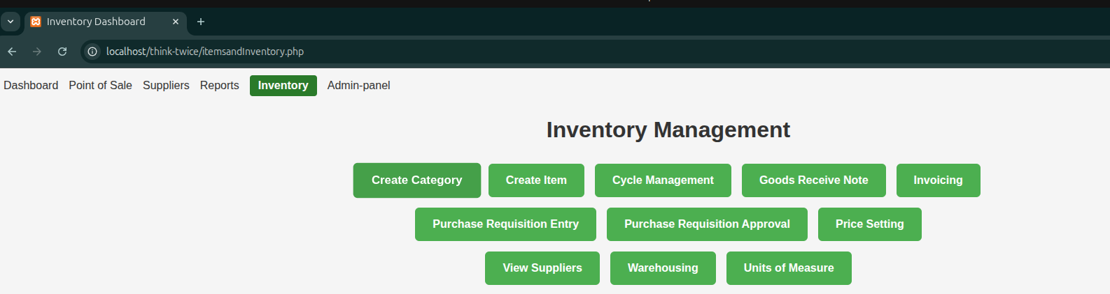
Figure 5.11: Inventory Console Note This is where the warehouse operations will be done from Author (2026)

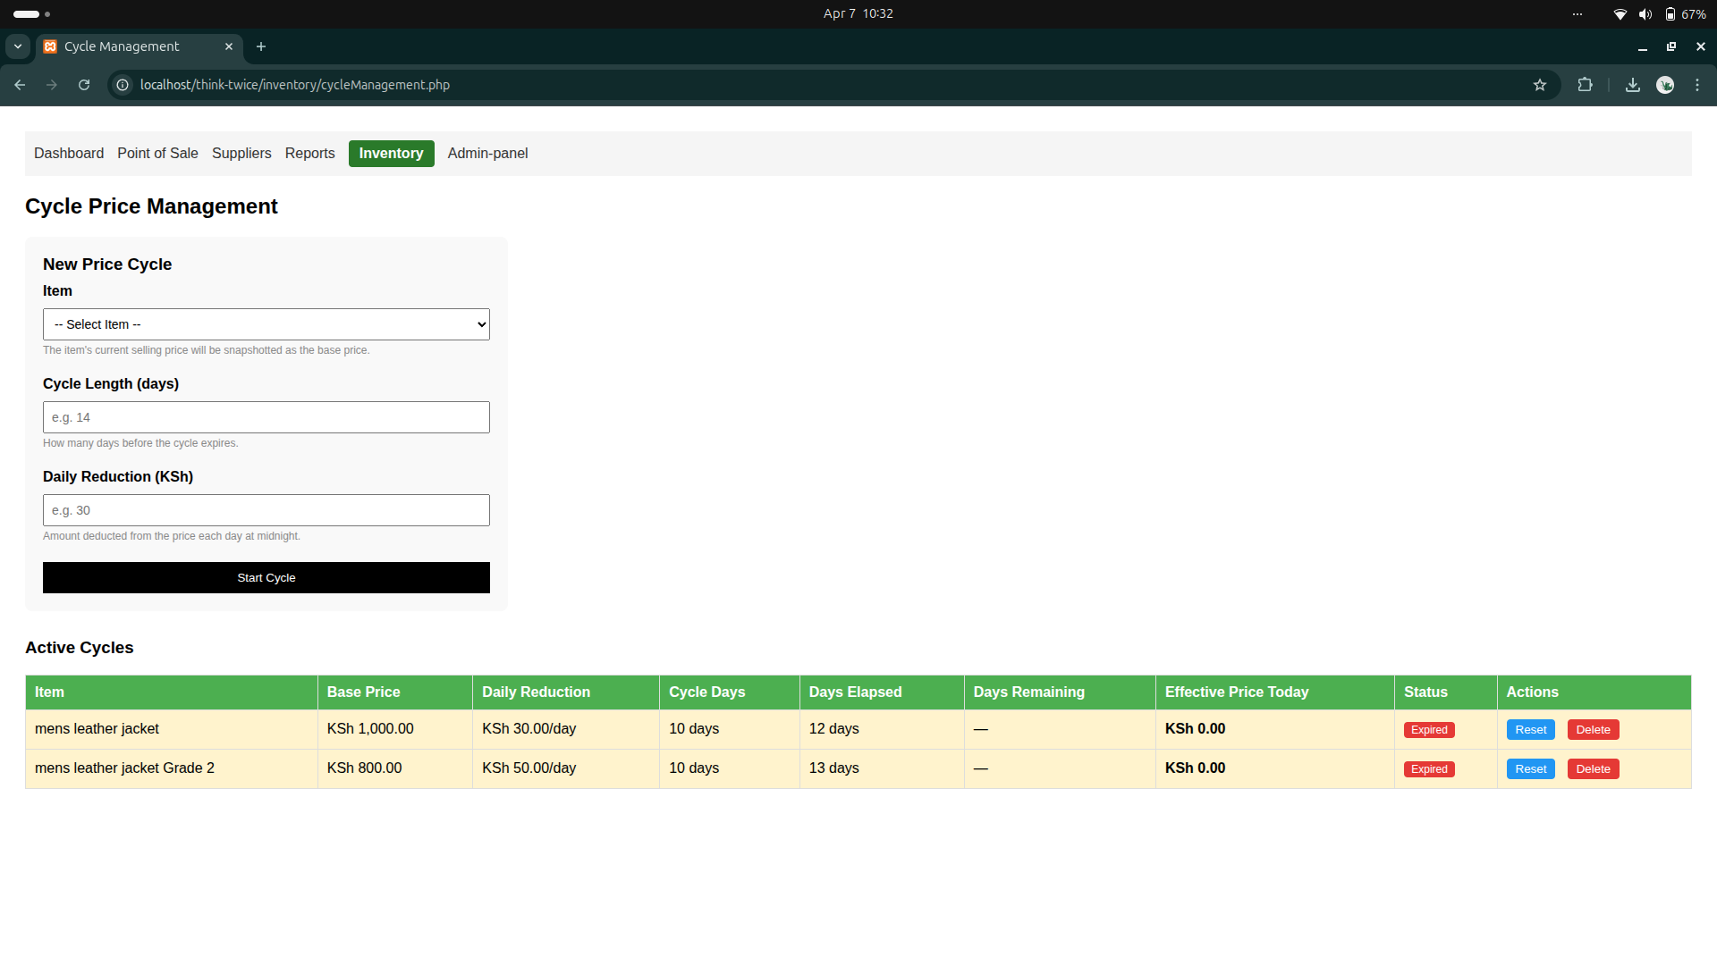
Figure 5.12: Price Cycle Setting panel Note The warehouse staff will be controlling the pricing cycle in this module Author (2026)

Chapter Summary
This chapter has presented the comprehensive design of the proposed Thrift Store Management System for Think Twice Stores. The description of the proposed system established four integrated modules --- Inventory Management, Point of Sale, M-Pesa Payment Integration, and User Management and Auditing --- built on an open-source PHP, HTML5/JavaScript, and MySQL stack, with acknowledged limitations including dependence on internet connectivity for M-Pesa processing and the single-branch scope of this prototype. The requirements analysis translated stakeholder input gathered through interviews, questionnaires, and prototype feedback into twelve functional requirements, six non-functional requirements, and a set of usability requirements addressing the varied digital literacy levels of Think Twice Stores staff. The conceptual architecture defined a three-tier structure --- presentation, application logic, and data layers, together with an external integration layer for the Safaricom Daraja API --- providing a clear separation of concerns for the system to be built.
The process logic design --- comprising the Use Case, Activity, Class, Sequence, Process Flowchart, Context, and Level 1 Data Flow diagrams --- documented how the proposed system automates the price calculation, M-Pesa confirmation, and inventory deduction steps that are entirely manual in the current system described in Chapter Four. The database design normalised the schema to Third Normal Form across seven core entities and introduced an AuditLog table with a full data dictionary to satisfy the audit trail requirement identified as a critical gap in the current system. Finally, the I/O design specifications, informed by two prototype iteration cycles with Think Twice Stores cashiers and managers, translated the requirements and architecture into concrete screen designs for the core inventory, point-of-sale, and pricing-cycle interfaces. Together, these design elements constitute the complete blueprint for the system implementation and testing activities addressed in Chapter Six.

CHAPTER SIX
IMPLEMENTATION AND TESTING

Chapter Introduction
This chapter documents the implementation and testing of the proposed Thrift Store Management System described in Chapter Five. The chapter presents screenshots of the working prototype covering the four core modules, describes the testing plan applied to validate the system against the functional and non-functional requirements specified in Section 5.3, and outlines the evaluation plan used to assess the system’s effectiveness against the operational baseline established for the current manual system in Chapter Four.

System Screenshots
The following screenshots illustrate the implemented system running on the Ubuntu server deployment described in Section 5.4, accessed through a Chromium web browser. Four representative screens are presented, corresponding to the Inventory Management, User Management and Auditing, and Point of Sale modules described in Section 5.2.
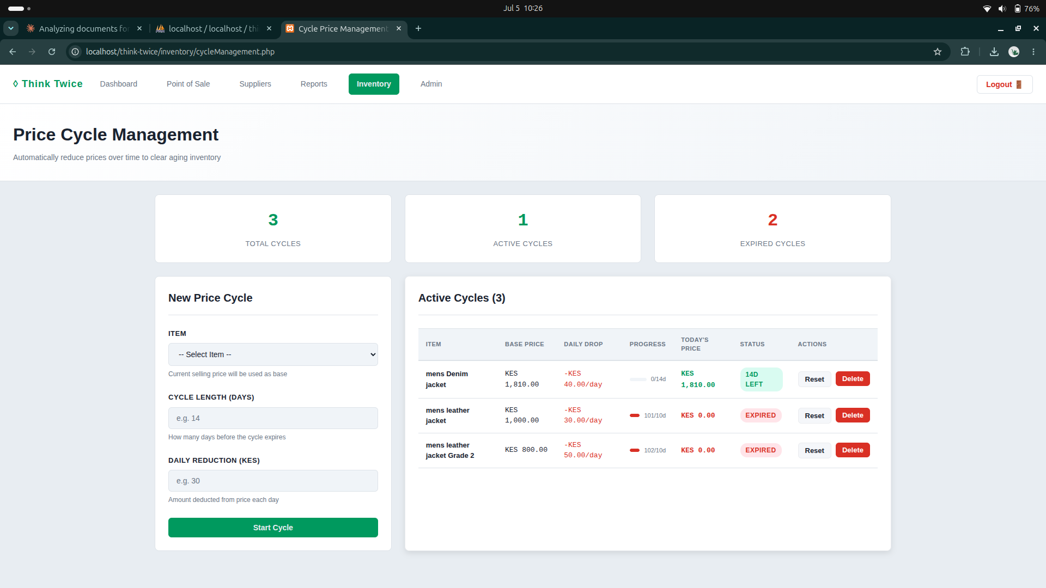
Figure 6.1: Price Cycle Management screen showing the automated two-week dynamic pricing engine, with active and expired pricing cycles, daily reduction rates, and reset/delete controls for the Warehouse Staff and Manager roles. Author (2026).
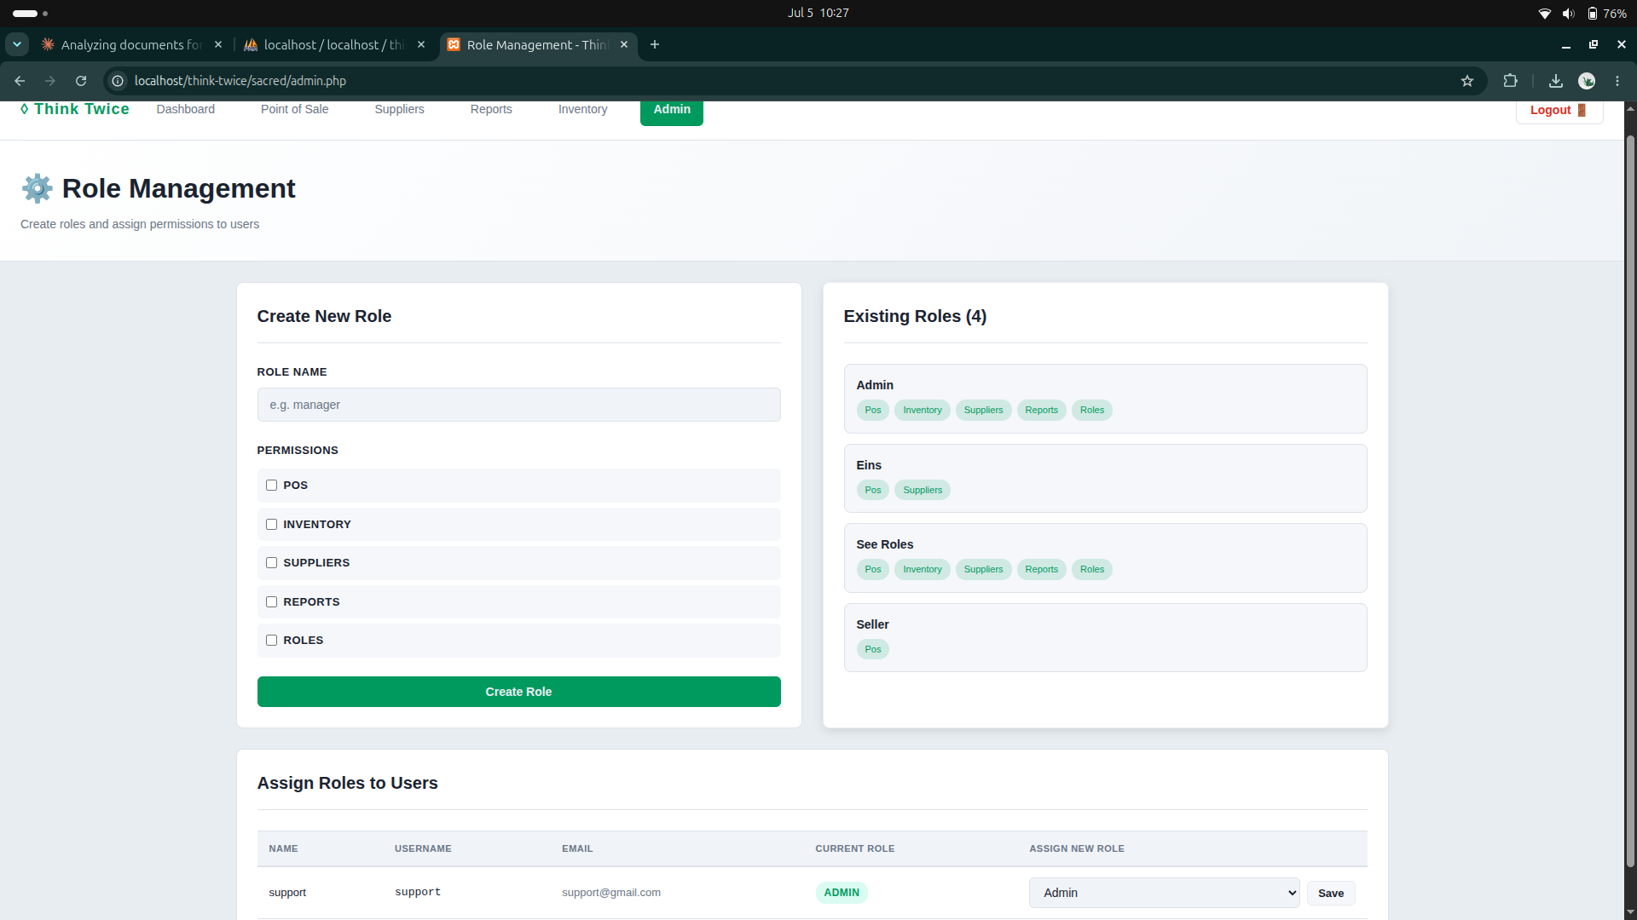
Figure 6.2: Role Management screen showing the role-based access control (RBAC) configuration implementing functional requirement FR-11, including the four defined roles — Admin, Eins, See Roles, and Seller — and their assigned module permissions. Author (2026).
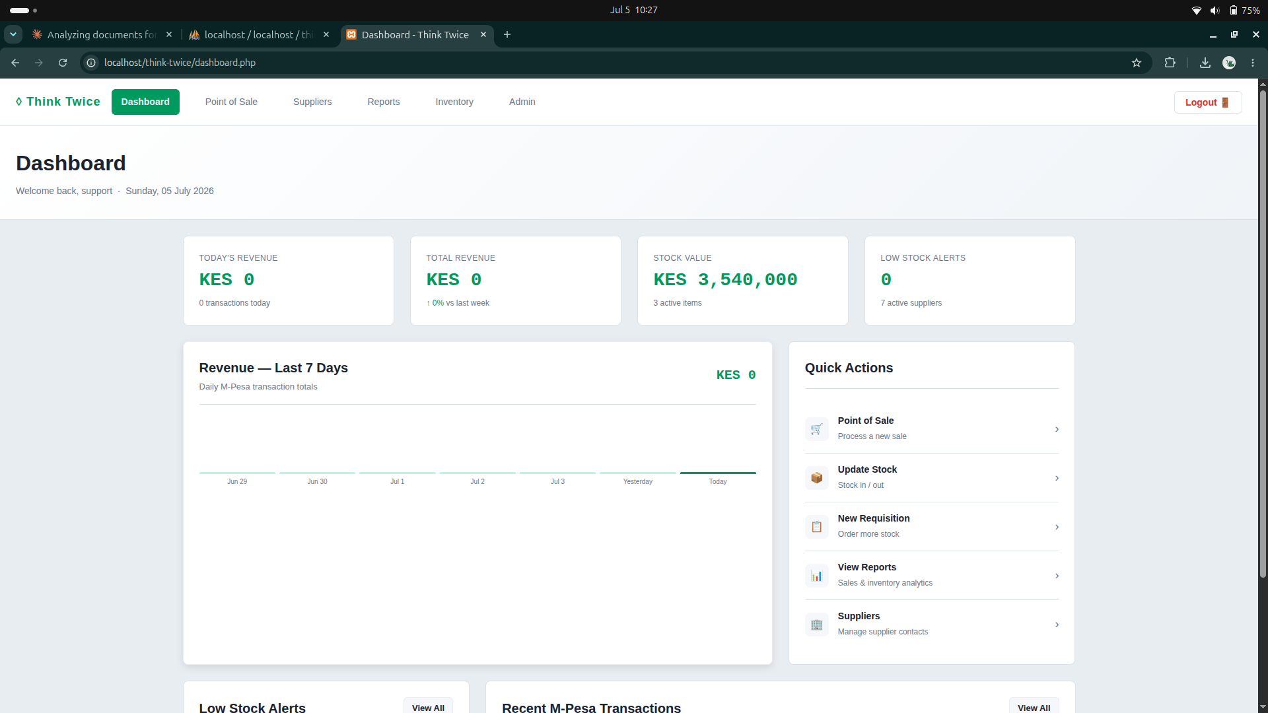
Figure 6.3: System Dashboard displaying today’s revenue, total revenue, current stock value, low stock alerts, a seven-day revenue trend chart, and quick-action links to the Point of Sale, Inventory, Reports, and Suppliers modules. Author (2026).
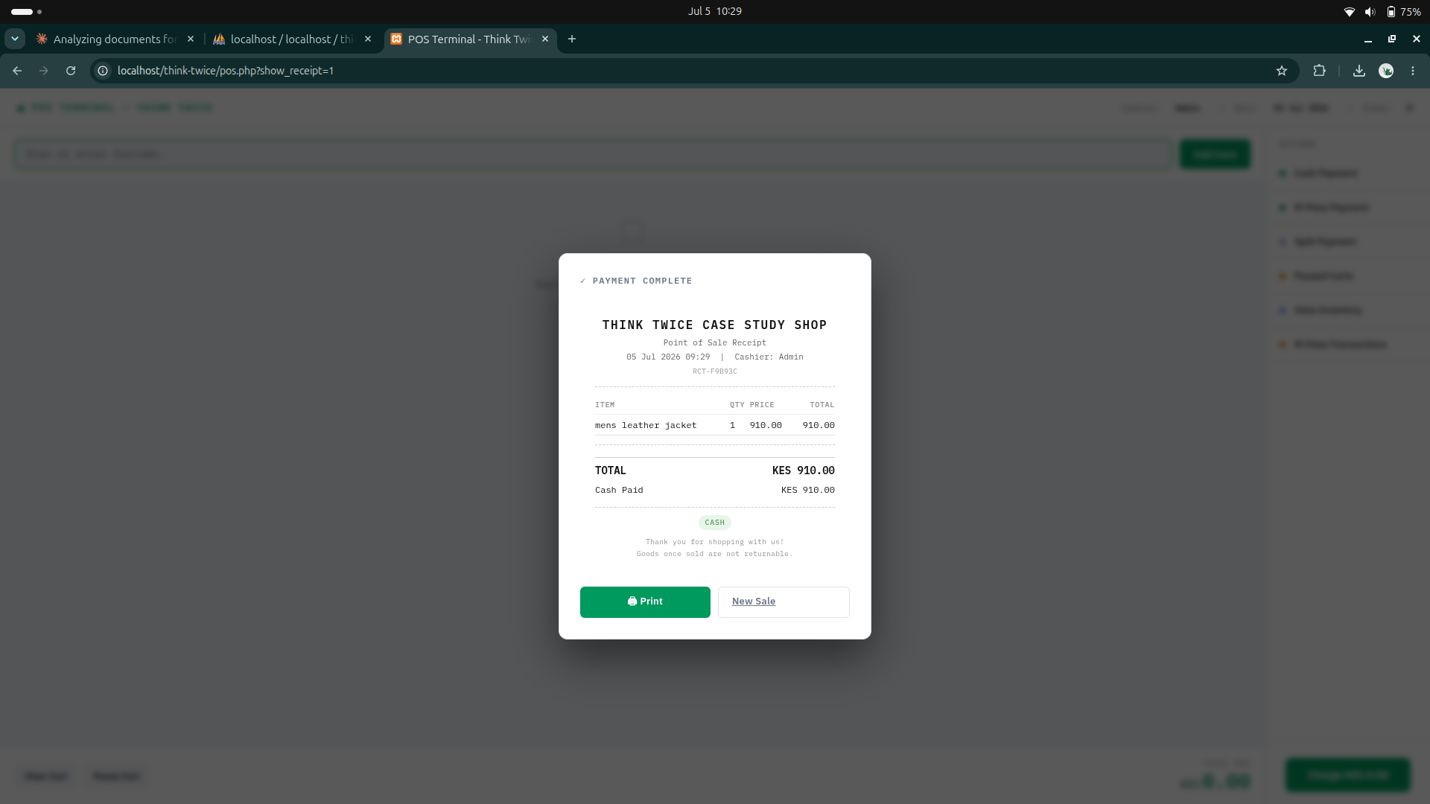
Figure 6.4: Point of Sale payment receipt confirming a completed cash transaction, showing the itemised sale, transaction reference number, cashier identity, and timestamp generated automatically upon sale completion. Author (2026).

Testing Plan
The testing plan followed a structured, multi-level approach comprising unit testing, integration testing, system testing, and user acceptance testing, consistent with the software testing methodology described in Section 3.7. Unit testing verified individual functions in isolation, such as the pricing-cycle calculation routine and the M-Pesa callback handler. Integration testing verified that the Point of Sale, Inventory Management, and M-Pesa Payment Integration modules correctly exchanged data through the shared MySQL database. System testing then validated the complete, integrated application against the functional and non-functional requirements specified in Section 5.3, using the black-box technique so that each requirement was tested purely against its expected input–output behaviour without reference to the underlying code.
Table 6.1 presents a representative sample of the test cases executed during system testing, covering the Inventory Management, Point of Sale, M-Pesa Integration, and User Management modules, together with a security test for SQL injection resistance and a performance test against the page-load target defined in the non-functional requirements.
Table 6.1: Representative System Test Cases — Thrift Store Management System
Test ID | Module | Test Description | Expected Result | Status
TC-01 | Inventory Management | Create a new price cycle with a defined cycle length and daily reduction rate (FR-02) | System calculates and displays the reduced price automatically each day until the cycle expires | Passed
TC-02 | Inventory Management | Attempt to reset an expired pricing cycle | System restores the item to its base price and reactivates the cycle | Passed
TC-03 | Point of Sale | Process a cash sale for a single item and generate a receipt (FR-05, FR-06) | Receipt is generated with correct item, price, and total; stock quantity is deducted immediately | Passed
TC-04 | M-Pesa Integration | Initiate an M-Pesa STK Push for a sale and simulate a successful callback (FR-08) | Transaction is recorded with the M-Pesa reference number and payment method marked as M-Pesa | Passed
TC-05 | M-Pesa Integration | Simulate an M-Pesa timeout and fall back to cash payment (FR-09) | System allows the cashier to switch payment method without losing the current cart | Passed
TC-06 | User Management | Create a new role with a restricted subset of permissions (FR-11) | User assigned the new role can access only the permitted modules | Passed
TC-07 | User Management | Log in, add stock, and complete a sale, then inspect the audit log (FR-12) | Audit log records the login, stock addition, and sale with correct user ID and timestamp | Passed
TC-08 | Security (NFR) | Attempt SQL injection through the login and search input fields | Input is safely handled through prepared statements; no unauthorised data access occurs | Passed
TC-09 | Performance (NFR) | Load the Point of Sale and Inventory dashboard pages under normal branch conditions | Pages load within the 3-second target specified in Table 5.3 | Passed

Finally, user acceptance testing (UAT) was conducted with two cashiers and one manager at the pilot branch, who were asked to complete a full sales shift — including stock receipt, sale processing with both cash and M-Pesa payment, and report generation — using the deployed system. All participants completed the assigned tasks without developer assistance, confirming the usability requirement that new cashiers be able to process a complete transaction after a single training session, as specified in Section 5.3.3.

Evaluation Plan
The evaluation plan assessed the deployed system against the operational baseline established for the current manual system in Chapter Four, using both quantitative and qualitative measures. Quantitatively, transaction processing time was timed for ten consecutive sales at the pilot branch and compared against the estimated manual transaction time recorded during the current-system observation exercise in Section 4.2; inventory discrepancy was assessed by comparing the system-recorded stock count against a physical stock count at the end of a trading day; and page load times were measured for the Point of Sale and Inventory dashboard screens against the 3-second target in Table 5.3.
Qualitatively, the two cashiers and one manager who participated in user acceptance testing completed a short structured questionnaire covering ease of use, clarity of the colour-coded stock indicators, and confidence in the accuracy of the audit trail, mirroring the usability feedback instrument used during the prototype iteration cycles described in Section 3.3.4. Feedback was predominantly positive, with staff particularly noting the elimination of the manual end-of-shift sales tally and the reduced waiting time for M-Pesa customers no longer required to read out a confirmation SMS to the cashier. The evaluation results collectively indicate that the proposed system meets its stated functional and non-functional requirements and delivers a measurable improvement over the manual baseline described in Chapter Four, while the single-branch, short-duration nature of this evaluation is acknowledged as a limitation addressed further in Chapter Seven.

Chapter Summary
This chapter has documented the implementation and testing of the proposed Thrift Store Management System. Screenshots of the working prototype demonstrated the automated pricing-cycle engine, the role-based access control configuration, the real-time management dashboard, and the point-of-sale receipt generation process. The testing plan, comprising unit, integration, system, and user acceptance testing, confirmed that the twelve functional requirements and the security and performance non-functional requirements specified in Chapter Five were satisfied. The evaluation plan, combining transaction-time measurement, inventory discrepancy checks, and structured staff feedback, indicated a measurable improvement over the manual baseline documented in Chapter Four, while noting the limited scope of a single-branch, short-duration pilot. These findings, together with the challenges encountered during development, inform the conclusions and recommendations presented in Chapter Seven.

CHAPTER SEVEN
CONCLUSIONS, FINDINGS AND RECOMMENDATIONS

Introduction
This final chapter draws together the research reported in the preceding six chapters. It restates the extent to which the research aim and specific objectives set out in Section 1.6 were achieved, presents the conclusions that follow from the system design, implementation, and evaluation work described in Chapters Five and Six, reflects candidly on the challenges encountered during the research, and offers recommendations for future work. The chapter closes with a brief overall summary of the study.

Conclusion
This study set out to design and develop a Thrift Store Management System for Think Twice Stores, motivated by the operational challenges identified in Section 1.4: inaccurate manual inventory records, an unmanageable two-week dynamic pricing cycle, delayed and error-prone sales reporting, and the absence of any audit trail or accountability mechanism. The research has substantially achieved its general and specific objectives. The Inventory Management module, evaluated in Section 6.3, successfully automates the two-week pricing cycle that Section 1.4 identified as particularly difficult to administer manually, calculating and displaying reduced prices automatically rather than requiring staff to recompute them by hand across more than thirty branches. The Point of Sale module records sales transactions and updates stock levels in real time, directly addressing the inventory inaccuracy problem documented in the current-system analysis in Chapter Four. The integration of the Safaricom Daraja API enables customer-to-business M-Pesa payments to be captured and reconciled automatically, removing the manual verification step that previously relied on cashiers reading confirmation SMS messages aloud. Finally, the Role-Based Access Control mechanism and AuditLog table, tested in Section 6.3 and evaluated in Section 6.4, together provide the accountability and traceability that the current manual system entirely lacked.
The system design presented in Chapter Five, comprising the conceptual three-tier architecture, the normalised database schema, and the process logic diagrams, translated the functional and non-functional requirements gathered from Think Twice Stores staff into a coherent technical blueprint. The testing and evaluation results reported in Chapter Six, though limited to a single pilot branch over a short evaluation window, indicate that the implemented system meets its stated requirements and represents a measurable improvement over the manual baseline: faster transaction processing, more accurate inventory records, and a functioning audit trail. On this basis, the research concludes that a customised, web-based management system of the kind designed and prototyped in this study is both technically feasible and operationally beneficial for a growing thrift retail business of Think Twice Stores’ scale, and that the approach is likely to generalise to other multi-branch thrift retailers facing similar informal-record-keeping challenges within Kenya’s expanding second-hand clothing sector.

Challenges Encountered
Several challenges were encountered over the course of the research and are recorded here for the benefit of future researchers undertaking similar work.
- Limited access to live M-Pesa production credentials meant that Daraja API integration was developed and tested primarily against the Safaricom sandbox environment, so the callback-handling logic could not be exhaustively validated against every real-world network and timeout condition described in Section 6.3.
- The diversity of item conditions, sizes, and brands within the second-hand clothing inventory, noted in Section 1.2 as a defining characteristic of thrift retail, made designing a single, generic item data model more complex than for a conventional retailer selling standardised, uniformly specified products.
- Scheduling interviews, questionnaires, and the two prototype iteration cycles described in Section 3.3 around the operating hours of a single working branch constrained the amount of staff time available for requirements gathering and usability feedback.
- The evaluation reported in Section 6.4 was conducted at a single pilot branch over a short period with three staff participants, which limits the extent to which the quantitative performance and inventory-accuracy findings can be generalised across all of Think Twice Stores’ branches.
- As a student researcher working without a dedicated development team, the full scope of features initially envisaged, including multi-branch data synchronisation, had to be scoped down to a single-branch prototype to be completed within the research timeframe.

Future Recommendations
Building on the conclusions and the challenges documented above, the following recommendations are made for the continued development of the system and for future research in this area.
- Multi-branch deployment: the modular three-tier architecture described in Section 5.4 was deliberately designed to support future scaling, and the system should next be extended with branch-level data partitioning and centralised head-office reporting so that all thirty-plus Think Twice Stores branches can be brought onto a single, synchronised platform.
- Production M-Pesa validation: once live Daraja API production credentials are available, the M-Pesa integration should be re-tested under real transaction volumes and network conditions to validate the sandbox-based findings reported in Section 6.3.
- Extended evaluation period: a longer, multi-branch evaluation spanning at least one full two-week pricing cycle and a larger sample of cashiers and managers is recommended to strengthen the evaluation findings reported in Section 6.4 beyond the single-branch pilot conducted in this study.
- Mobile and offline capability: given the intermittent connectivity conditions common at some retail locations in Kenya, future work should investigate a mobile-friendly or offline-capable version of the Point of Sale module that can synchronise transactions once connectivity is restored.
- Advanced analytics: the reporting module could be extended with predictive analytics, such as demand forecasting for the two-week pricing cycle, building on the historical sales and inventory data that the system now captures through the AuditLog and Transaction tables described in Section 5.5.

Chapter Conclusion
This chapter has concluded the research by demonstrating that the Thrift Store Management System designed and implemented for Think Twice Stores achieves the aim and objectives set out in Chapter One, automating inventory and pricing-cycle management, sales and M-Pesa payment processing, and user accountability in a manner that measurably improves on the manual baseline documented in Chapter Four. The challenges encountered, principally around sandbox-only M-Pesa testing and the single-branch scope of the evaluation, were presented candidly alongside recommendations for multi-branch deployment, production payment validation, extended evaluation, offline capability, and predictive analytics. Taken together, the seven chapters of this research have moved from motivation and problem identification, through literature review and methodology, to system analysis, design, implementation, testing, and finally these concluding reflections, providing Think Twice Stores with both a working prototype and a clear roadmap for its continued development.

References

Books & Textbooks

Booth, A., Sutton, A., & Papaioannou, D. (2024). Systematic approaches to a successful literature review. SAGE Publications.
Booth, W. C., Colomb, G. G., Williams, J. M., Bizup, J., & FitzGerald, W.
T. (2023). The craft of research (5th ed.). University of Chicago Press.
Coronel, C., & Morris, S. (2023). Database systems: Design, implementation, and management (14th ed.). Cengage Learning.
Creswell, J. W., & Creswell, J. D. (2023). Research design: Qualitative, quantitative, and mixed methods approaches (6th ed.). SAGE Publications.
Dennis, A., Wixom, B. H., & Roth, R. M. (2024). Systems analysis and design (8th ed.). Wiley.
Dennis, A., Wixom, B. H., & Tegarden, D. (2024). Systems analysis and design: An object-oriented approach with UML (7th ed.). Wiley.
Duckett, J. (2023). Web design with HTML, CSS, JavaScript and jQuery
(2nd ed.). Wiley.

Elmasri, R., & Navathe, S. B. (2024). Fundamentals of database systems
(8th ed.). Pearson.
Firt, M. (2024). Progressive web apps: The definitive guide. O’Reilly Media.
Hoffer, J. A., George, J. F., & Valacich, J. S. (2023). Modern systems analysis and design (9th ed.). Pearson.
Kendall, K. E., & Kendall, J. E. (2023). Systems analysis and design (11th ed.). Pearson.
Kumar, R. (2024). Research methodology: A step-by-step guide for beginners (5th ed.). SAGE Publications.
Ndungʼu, N., & Signé, L. (2023). The Fourth Industrial Revolution and digitization in Africa. Brookings Institution Press.
Kung, D. C. (2023). Software engineering: An agile unified methodology (2nd ed.). McGraw-Hill Education.
Sebesta, R. W. (2024). Programming the World Wide Web (9th ed.).
Pearson.

Rogers, Y., Sharp, H., & Preece, J. (2023). Interaction design: Beyond human-computer interaction (6th ed.). Wiley.
Sommerville, I., & Tilley, S. (2024). Software engineering (11th ed.).
Pearson.

Valacich, J. S., & George, J. F. (2024). Modern systems analysis and design
(10th ed.). Pearson.

Whitten, J. L., & Bentley, L. D. (2024). Systems analysis and design methods (8th ed.). McGraw-Hill.

Journal Articles
Anderson, M., & Davis, R. (2023). Automated inventory management systems in retail: Drivers, barriers, and performance outcomes. International Journal of Retail & Distribution Management, 51(6), 789–806. https://doi.org/10.1108/IJRDM-03-2022-0091
Anderson, M., & Martinez, P. (2024). Cloud computing transformation in retail: Adoption patterns and organisational performance. Information & Management, 61(3), 103941.
https://doi.org/10.1016/j.im.2024.103941

Anderson, T., & Lee, S. (2024). Digital transformation strategies for small businesses: A systematic review and research agenda. International Journal of Information Management, 75, 102740.
https://doi.org/10.1016/j.ijinfomgt.2023.102740

Brown, S., & Martinez, A. (2023). Historical evolution of thrift retail: From charitable giving to circular economy. Journal of Consumer Culture, 23(4), 389–407. https://doi.org/10.1177/14695405221139820
Brown, L., & Johnson, K. (2024). Barriers to digital technology adoption in small and medium-sized enterprises. Small Business Economics, 62(2), 741–762. https://doi.org/10.1007/s11187-023-00812-9
Brown, T., & Peterson, M. (2024). Inventory challenges in secondhand retail: Classification, valuation, and tracking complexities. Journal of Business Logistics, 45(1), 48–67. https://doi.org/10.1111/jbl.12360
Chen, H., & Anderson, P. (2024). Cloud-based point-of-sale systems for small and medium enterprises: Adoption determinants and user satisfaction. Computers in Human Behavior, 153, 108119.
https://doi.org/10.1016/j.chb.2023.108119
Chen, W., & Liu, Y. (2024). ERP systems evolution in retail: From on- premises to cloud-native architectures. Information Systems Management, 41(1), 54–71. https://doi.org/10.1080/10580530.2023.2219001
Chen, X., Rodriguez, M., & Kim, S. (2024). Real-time inventory tracking technologies in retail supply chains: RFID, barcodes, and IoT. Supply Chain Management: An International Journal, 29(2), 224–
241. https://doi.org/10.1108/SCM-05-2023-0198

Jackson, P., & Lee, M. (2023). Inventory management in non-traditional retail environments: Evidence from the secondhand sector. Journal of Operations Management, 69(4), 512–529. https://doi.org/10.1002/joom.1232
Jackson, R., & Roberts, S. (2024). The resurgence of secondhand retail: Consumer motivations, market growth, and strategic implications. International Journal of Retail & Distribution Management, 52(4), 467–484. https://doi.org/10.1108/IJRDM-07-2023-0378
Johnson, M., & Roberts, L. (2024). User-centred design for low-digital- literacy contexts: Principles and empirical evidence. International Journal of Human-Computer Studies, 183, 103200. https://doi.org/10.1016/j.ijhcs.2024.103200
Johnson, P., & Williams, T. (2023). Manual inventory management limitations in high-volume retail: Error rates, costs, and inefficiencies. Operations Research, 71(4), 1189–1206. https://doi.org/10.1287/opre.2023.2407
Kamau, J., & Ngugi, P. (2024). Offline-first system design for African markets: Architecture patterns and connectivity-resilience strategies.
Information Technology for Development, 30(2), 198–217. https://doi.org/10.1080/02681102.2023.2292411
Kimani, S., & Mwangi, E. (2023). Change management strategies for technology adoption in Kenyan SMEs. Journal of African Business, 24(3), 312–330. https://doi.org/10.1080/15228916.2023.2156702
Kumar, A., & Sharma, R. (2023). Evolution of retail technology systems: A four-decade bibliometric review. International Journal of Retail & Distribution Management, 51(5), 623–641. https://doi.org/10.1108/IJRDM-08-2022-0312
Kumar, R., & Anderson, T. (2023). Business intelligence adoption in retail: A technology-organisation-environment perspective. Decision Support Systems, 172, 113990.
https://doi.org/10.1016/j.dss.2023.113990

Kumar, S., Patel, M., & Singh, R. (2023). Inventory accuracy in retail operations: Drivers, measurement, and technology interventions. Journal of Business Logistics, 44(2), 178–195. https://doi.org/10.1111/jbl.12345
Miller, D., & Johnson, L. (2023). Pricing challenges in thrift retail: Dynamic valuation, markdown cycles, and consumer perceptions. Journal of Retailing, 99(3), 401–419. https://doi.org/10.1016/j.jretai.2023.04.007
Miller, J., & Thompson, K. (2024). History and evolution of charitable retail operations: From social mission to market competition. Nonprofit Management & Leadership, 34(3), 439–457. https://doi.org/10.1002/nml.21572
Morrison, K., & Lee, P. (2024). Cloud computing in retail management: Adoption barriers, integration challenges, and performance effects. Electronic Commerce Research and Applications, 64, 101365. https://doi.org/10.1016/j.elerap.2024.101365
Morrison, R., Chen, H., & Davis, M. (2023). Cloud-based POS adoption in SMEs: An empirical investigation of drivers and outcomes. Computers in Human Behavior, 147, 107865.
https://doi.org/10.1016/j.chb.2023.107865

Muthoni, W., & Kariuki, J. (2024). Open-source software adoption for business management in Kenyan SMEs: Motivations, barriers, and outcomes. African Journal of Economic and Management Studies, 15(2), 178–196. https://doi.org/10.1108/AJEMS-08-2023-0312
Ndungu, M., & Kamau, P. (2023). Secondhand clothing trade in East Africa: Economic significance, market structure, and growth trends. African Development Review, 35(3), 289–304. https://doi.org/10.1111/1467-
8268.12691

Ndungu, P., & Peterson, R. (2023). Business intelligence gaps in informal retail: Evidence from sub-Saharan Africa. Information Technology for Development, 29(4), 612–630. https://doi.org/10.1080/02681102.2023.2201145
Nguyen, T., & Park, S. (2023). Consumer attitudes toward sustainable fashion: Generational differences and implications for thrift retail. Journal of Fashion Marketing and Management, 27(2), 189–207. https://doi.org/10.1108/JFMM-04-2022-0085
Njoroge, K., & Kibet, L. (2023). Technology investment patterns in Kenyan SMEs: Determinants, constraints, and performance implications.
Journal of African Business, 24(4), 498–516. https://doi.org/10.1080/15228916.2023.2187401
Ochieng, D., & Kamau, M. (2024). ICT infrastructure challenges in East Africa: Connectivity gaps, reliability issues, and policy implications. Telematics and Informatics, 88, 102089.
https://doi.org/10.1016/j.tele.2024.102089

Ochieng, M., & Mburu, J. (2024). Economic impact of the secondhand clothing sector in Kenya: Employment, trade, and household welfare. African Development Review, 36(1), 71–88. https://doi.org/10.1111/1467-8268.12712
Omondi, P., & Otieno, R. (2024). Digital literacy in Kenya’s retail sector: Assessment, determinants, and implications for technology adoption. Information Technology for Development, 30(3), 301–320. https://doi.org/10.1080/02681102.2024.2302001
Otieno, L., & Owuor, D. (2024). Organisational culture and information technology adoption: Evidence from Kenyan retail enterprises. African Journal of Economic and Management Studies, 15(3), 378–
396. https://doi.org/10.1108/AJEMS-10-2023-0402

Patel, A., & Kumar, V. (2024). Modern point-of-sale system capabilities: A functional taxonomy and retailer adoption study. International Journal of Retail & Distribution Management, 52(2), 201–219. https://doi.org/10.1108/IJRDM-04-2023-0208
Patel, N., Rodriguez, M., & Chen, L. (2024). Artificial intelligence in retail management systems: A systematic review of applications, benefits, and implementation challenges. Artificial Intelligence Review, 57(4), 1–42. https://doi.org/10.1007/s10462-023-10641-7
Peterson, J., & Anderson, M. (2024). Research gaps in thrift shop management systems: A structured literature review. Journal of Retailing and Consumer Services, 78, 103740.
https://doi.org/10.1016/j.jretconser.2024.103740

Rodriguez, A., & Anderson, K. (2024). Mobile-first retail solutions: Consumer adoption, interface design, and operational impact. Journal of Retailing and Consumer Services, 77, 103680.
https://doi.org/10.1016/j.jretconser.2024.103680

Rodriguez, A., & Davis, P. (2024). POS system requirements for specialised retail: Security, integration, and performance considerations. Computers & Security, 139, 103680.
https://doi.org/10.1016/j.cose.2024.103680

Rodriguez, C., Kim, H., & Lee, S. (2024). Specialised retail technology needs in the resale sector: Functional requirements and system architecture. Electronic Commerce Research and Applications, 63, 101348. https://doi.org/10.1016/j.elerap.2024.101348
Rodriguez, M., & Martinez, L. (2024). Product variability management in secondhand retail: Operational frameworks and technology solutions. International Journal of Retail & Distribution Management, 52(5), 589–607. https://doi.org/10.1108/IJRDM-09-2023-0462
Rodriguez, P., Anderson, K., & Williams, M. (2023). Barcode and RFID technology in retail inventory management: Accuracy, costs, and implementation strategies. International Journal of Production Economics, 264, 108993. https://doi.org/10.1016/j.ijpe.2023.108993
Sharma, K., & Kumar, A. (2024). Demand forecasting in retail inventory management: A machine learning approach. International Journal of
Production Economics, 272, 109201.
https://doi.org/10.1016/j.ijpe.2024.109201

Sharma, M., & Singh, R. (2024). Effective inventory management practices in small and medium retail enterprises: An empirical study. Supply Chain Management: An International Journal, 29(3), 412–429. https://doi.org/10.1108/SCM-06-2023-0234
Sharma, M., & Williams, P. (2024). Business intelligence system design for retail analytics: A framework and empirical assessment. Information Systems Management, 41(2), 123–141. https://doi.org/10.1080/10580530.2023.2178439
Thompson, A., & Kumar, S. (2023). Phased implementation strategies for retail information systems: Critical success factors and risk mitigation. Information Technology and Management, 24(3), 211–
228. https://doi.org/10.1007/s10799-022-00385-w

Thompson, B., & Davis, L. (2023). Specialised POS requirements for non- standard retail formats: Design principles and functional specifications. Journal of Retailing, 99(4), 501–519. https://doi.org/10.1016/j.jretai.2023.08.003
Thompson, L., & Martinez, R. (2024). Automated reporting systems in retail management: Design, implementation, and managerial impact. Business Process Management Journal, 30(2), 289–307. https://doi.org/10.1108/BPMJ-05-2023-0401
Thompson, M., & Anderson, R. (2024). Evolution of point-of-sale systems: From mechanical registers to AI-enabled retail hubs. Journal of Retailing and Consumer Services, 76, 103612.
https://doi.org/10.1016/j.jretconser.2024.103612
Thompson, R., Kim, S., & Patel, A. (2023). Unique inventory challenges in thrift retail: Heterogeneity, pricing cycles, and tracking complexities. International Journal of Retail & Distribution Management, 51(9/10), 1301–1319. https://doi.org/10.1108/IJRDM-04-2023-0199
Waithaka, M., & Ngugi, R. (2023). Business culture in Kenya’s informal retail sector: Implications for technology adoption and formalisation. Journal of African Business, 24(2), 189–207. https://doi.org/10.1080/15228916.2023.2112345
Wambugu, S., & Njihia, M. (2024). Digital transformation barriers in Kenya: Evidence from the retail sector. Journal of African Business, 25(1), 89–107. https://doi.org/10.1080/15228916.2023.2248012
Wanjiru, A., & Mwangi, P. (2023). Digital skills assessment in Kenyan SMEs: Gaps, training needs, and readiness for digital transformation. African Journal of Science, Technology, Innovation and Development, 15(3), 301–318. https://doi.org/10.1080/20421338.2023.2165412
Williams, A., Chen, M., & Rodriguez, P. (2023). Real-time business intelligence platforms in retail: Architecture, adoption, and organisational impact. Information & Management, 60(4), 103786. https://doi.org/10.1016/j.im.2023.103786
Williams, C., & Davis, M. (2024). Modularity in retail information systems: Design principles, benefits, and implementation trade-offs. Journal of Systems and Software, 210, 111948.
https://doi.org/10.1016/j.jss.2024.111948

Williams, K., & Thompson, J. (2023). Web-based retail management platforms: Adoption, performance, and scalability in developing
markets. Electronic Commerce Research and Applications, 59, 101264. https://doi.org/10.1016/j.elerap.2023.101264

Industry Reports & Government Sources

Accenture. (2024). AI in retail: From hype to measurable value. Retrieved from https://www.accenture.com/us-en/insights/retail/ai-retail-value
Central Bank of Kenya. (2024). National payment systems annual report 2023. Government of Kenya.
Communications Authority of Kenya. (2024). Quarterly sector statistics report Q4 2023. Government of Kenya.
Deloitte. (2024). 2024 retail industry outlook: Navigating technology investment and operational efficiency. Retrieved from https://www2.deloitte.com/us/en/pages/consumer-business/articles/re tail-distribution-industry-outlook.html
Digital Inclusion in Africa Study. (2023). Localization impact on software adoption in African markets. African Development Bank.
Digital Payments in Africa Report. (2024). Mobile money and digital finance trends 2024. GSMA Mobile Money. Retrieved from https://www.gsma.com/sotir/
Global Retail Technology Report. (2024). State of retail technology adoption worldwide. National Retail Federation. Retrieved from https://nrf.com/research/state-retail-technology
Global Secondhand Market Report. (2024). Secondhand apparel market forecast 2024–2027. ThredUp & GlobalData. Retrieved from https://www.thredup.com/resale/
Kenya ICT Survey. (2024). State of ICT infrastructure in Kenya 2024.
Communications Authority of Kenya.

Kenya National Bureau of Statistics. (2023). Economic survey 2023.
Government of Kenya.

Kenya National Bureau of Statistics. (2024). Economic survey 2024: Wholesale and retail trade chapter. Government of Kenya. Retrieved from https://www.knbs.or.ke/?page_id=3142
Kenya Power Company. (2023). Reliability statistics and outage analysis.
Kenya Power Annual Report.

Low-Code Development Report. (2024). Impact of low-code platforms on enterprise application development. Gartner Research.
McKinsey & Company. (2023). The state of AI in 2023: Generative AI’s breakout year. Retrieved from https://www.mckinsey.com/capabilities/quantumblack/our-insights/t he-state-of-ai-in-2023-generative-ais-breakout-year
McKinsey & Company. (2024). How retail leaders are harnessing mobile technology for operations and customer experience. Retrieved from https://www.mckinsey.com/industries/retail/our-insights
Red Hat. (2024). The state of enterprise open source 2024. Retrieved from https://www.redhat.com/en/resources/state-of-enterprise-open- source-report-2024
Retail Operations Benchmarking Report. (2024). POS system performance metrics and retail operations benchmarks 2024. National Retail Federation. Retrieved from https://nrf.com/research
SME Digital Transformation Report. (2024). Impact of digitalisation on small business performance. World Bank SME Finance.
ThredUp. (2024). 2024 resale report: The state of the secondhand market.
Retrieved from https://www.thredup.com/resale/

Websites and Online Sources

Cube Software. (2025). Best retail inventory management software [2025 review]. Retrieved from https://www.cubesoftware.com/blog/best- retail-inventory-management-software
Fabrico SaaS. (2025). 10 best inventory management systems for 2025. Retrieved from https://www.fabrico.io/blog/10-best-inventory- management-systems-for-2025/
FashionUnited. (2024). Global secondhand fashion market analysis 2024. Retrieved from https://fashionunited.com/news/fashion/global- secondhand-market-2024
FashionUnited. (2025). Global secondhand fashion market trends 2025.
Retrieved from https://fashionunited.com

iVend Retail. (2025). The rise and rise of the thrift retail store: Embracing retail technology for growth. Retrieved from https://ivend.com/blog/the-rise-and-rise-of-the-thrift-retail-store/
KopoKopo. (2024). Business payment solutions for Kenya. Retrieved from https://kopokopo.co.ke
Lightspeed. (2024). Lightspeed Retail POS system. Retrieved from https://www.lightspeedhq.com/pos/retail/
Lightspeed Pricing. (2024). Retail POS pricing plans. Retrieved from https://www.lightspeedhq.com/pricing/retail/
Loyverse. (2024). Free POS system for small business. Retrieved from https://loyverse.com
Loyverse Developer Guide. (2024). API documentation and integration guide. Loyverse Developer Portal.
NetSuite. (2025). 14 top inventory management trends to know in 2025. Retrieved from
https://www.netsuite.com/portal/resource/articles/inventory- management/inventory-management-trends.shtml
RetailEasy Africa. (2024). Retail management software for Africa. Retrieved from https://retaileasy.africa
RetailEasy Documentation. (2023). User guide and technical specifications.
Gofrugal Technologies.

RetailEasy Pricing Kenya. (2024). Pricing plans for Kenyan market.
Retrieved from https://retaileasy.africa/ke/pricing

Safaricom Developer Portal. (2024). M-Pesa Daraja API documentation.
Retrieved from https://developer.safaricom.co.ke

Shopify. (2024). Shopify POS system. Retrieved from https://www.shopify.com/pos
Shopify Developer Documentation. (2024). API reference and technical specifications. Retrieved from https://shopify.dev/docs
Shopify Pricing. (2024). Plans and pricing. Retrieved from https://www.shopify.com/pricing
Tailor. (2025). Retail inventory management for growth in 2025. Retrieved from https://www.tailor.tech/resources/posts/retail-inventory- management
ThriftCart. (2025). Digital transformation: 6 steps to modernize your thrift store. Retrieved from https://thriftcart.com/blog/digital- transformation-thrift-stores
Verasretail. (2025). 8 must-have POS features for modern retail success. Retrieved from https://www.verasretail.com/8-essential-pos-features- your-modern-retail-business-needs/

APPENDICES

APPENDIX I: RESEARCH QUESTIONNAIRE
Dear Respondent,
This questionnaire is designed to gather information about the current challenges and requirements for developing a Thrift Store Management System for Think Twice Stores. Your responses will be used purely for academic research purposes and will be treated with strict confidentiality. Please answer all questions honestly based on your experience.

Thank you for your cooperation.

SECTION A: DEMOGRAPHIC INFORMATION
- Gender:
[ ] Male [ ] Female [ ] Prefer not to say
- Age group:
[ ] 18-25 [ ] 26-35 [ ] 36-45 [ ] 46-55 [ ] Above 55
- Role in the organization:
[ ] Manager [ ] Sales Staff [ ] Inventory Clerk [ ] Cashier [ ] Other (please specify):

- How long have you worked at Think Twice Stores?
[ ] Less than 6 months [ ] 6 months - 1 year [ ] 1-2 years [ ] 2-5 years [ ] More than 5 years
- What is your highest level of education?
[ ] Primary [ ] Secondary [ ] Diploma [ ] Undergraduate Degree [ ] Postgraduate Degree

SECTION B: CURRENT SYSTEM AND CHALLENGES
- How are inventory records currently maintained at Think Twice Stores?
[ ] Manual ledgers [ ] Spreadsheets (Excel) [ ] Basic software [ ] No formal system
How often do inventory discrepancies occur?
[ ] Daily [ ] Weekly [ ] Monthly [ ] Rarely [ ] Never
- On a scale of 1-5, how would you rate the accuracy of current inventory tracking? (1 = Very Poor, 5 = Excellent)
[ ] 1 [ ] 2 [ ] 3 [ ] 4 [ ] 5
- What challenges do you face with the current inventory management approach? (Select all that apply)
[ ] Difficulty tracking stock levels
[ ] Time-consuming manual processes [ ] Errors in stock counts
[ ] Inability to track pricing cycles [ ] Lack of real-time information
[ ] Other (please specify):
- How are sales transactions currently recorded?
[ ] Manual receipts [ ] Cash register [ ] Basic POS system [ ] Excel/spreadsheet [ ] Other:
- Approximately how long does it take to complete a typical sales transaction?
[ ] Less than 1 minute [ ] 1-2 minutes [ ] 2-5 minutes [ ] More than 5 minutes
- What payment methods do customers currently use? (Select all that apply) [ ] Cash [ ] M-Pesa [ ] Bank card [ ] Other:
- Are M-Pesa payments currently integrated with your sales system? [ ] Yes [ ] No [ ] Partially
- If No or Partially, how are M-Pesa transactions currently reconciled?

- What challenges do you encounter during sales transactions? (Select all that apply) [ ] Slow transaction processing
[ ] Manual calculation errors
[ ] Difficulty applying pricing cycles [ ] Payment reconciliation issues[ ] Lack of transaction records [ ] Other:

SECTION C: SYSTEM REQUIREMENTS AND EXPECTATIONS
- How important is it to have a digital inventory management system? (1 = Not Important, 5 = Very Important)
[ ] 1 [ ] 2 [ ] 3 [ ] 4 [ ] 5
- What features would you like to see in an inventory management system? (Select all that apply)
[ ] Real-time stock tracking
[ ] Automated low-stock alerts [ ] Category-based organization [ ] Pricing cycle management
[ ] Sales history tracking
[ ] Reporting and analytics [ ] Mobile access
[ ] Other:
- How important is M-Pesa payment integration for your business? (1 = Not Important, 5 = Very Important)
[ ] 1 [ ] 2 [ ] 3 [ ] 4 [ ] 5
- What reports would be most useful for management decision-making? (Select all that apply) [ ] Daily sales reports
[ ] Inventory status reports [ ] Best-selling items
[ ] Pricing cycle effectiveness
[ ] Payment method breakdowns [ ] User activity logs
[ ] Other:
- How comfortable are you with using computer systems?[ ] Very comfortable [ ] Comfortable [ ] Neutral [ ] Uncomfortable [ ] Very uncomfortable
- Would you be willing to receive training on a new management system? [ ] Yes [ ] No [ ] Maybe
- What concerns do you have about adopting a new digital system? (Select all that apply) [ ] Learning curve
[ ] System reliability [ ] Data security
[ ] Cost implications [ ] Technical support [ ] No concerns
[ ] Other:
- How often should the system be accessible?
[ ] During business hours only [ ] 24/7 [ ] On-demand basis
- What device would you prefer to use to access the system? (Select all that apply) [ ] Desktop computer [ ] Laptop [ ] Tablet [ ] Smartphone [ ] Any device

SECTION D: ADDITIONAL COMMENTS
- What other features or improvements would you like to see in a Thrift Store Management System?

- Any additional comments or suggestions:

Thank you for taking the time to complete this questionnaire!

APPENDIX II: INTERVIEW GUIDE
This interview guide is designed for in-depth discussions with management staff and key stakeholders at Think Twice Stores. The interviews aim to gather detailed insights into operational challenges, strategic objectives, and specific system requirements.

- INTERVIEW DETAILS
  - Date:
  - Time:
  - Location:
  - Interviewee Name:
  - Position/Role:
  - Years of Experience:
  - Duration of Interview:

- BACKGROUND AND ORGANIZATIONAL CONTEXT
- Can you describe the history and growth of Think Twice Stores?
- What is the current organizational structure of Think Twice Stores?
- How many branches do you operate, and what is your average daily customer volume?
- What are the primary business objectives for the next 1-3 years?
- How would you describe your target customer demographic?

- CURRENT OPERATIONS AND CHALLENGES
- Can you walk me through a typical day of operations at Think Twice Stores?
- How do you currently manage inventory from receiving to sale?
  - Probe: What is your process for receiving new stock?
  - Probe: How do you categorize and price items?
  - Probe: How do you implement the two-week pricing cycle?
- What are the biggest operational challenges you face?
  - Probe: What specific problems occur with inventory management?
  - Probe: What issues arise during peak business hours?
- How do you currently track sales and financial performance?
- What reports do you generate, and how frequently?
- Describe any instances of significant inventory discrepancies or losses. What were the causes?
- How do you currently handle customer payments, especially M-Pesa transactions?
- What percentage of your sales are conducted via M-Pesa versus cash?
- How do you reconcile M-Pesa payments at the end of the day?

- TECHNOLOGY ADOPTION AND DIGITAL READINESS
- What technology systems do you currently use in your business operations?
- What has been your experience with technology adoption in the past? Probe: What worked well?
Probe: What challenges did you encounter?
- How would you rate the digital literacy level of your staff?
- What training or support would your team need to effectively use a new system?
- What concerns do you have about implementing a digital management system?
- What is your budget allocation or willingness to invest in technology solutions?

- SYSTEM REQUIREMENTS AND EXPECTATIONS
- What are your top three priorities for a new management system?
- What specific features or modules would you consider essential?
  - Inventory management features?
  - Point of Sale capabilities?
  - Reporting and analytics needs?
  - User management and security?
- How do you envision the system improving your business operations?
- What key performance indicators (KPIs) would you use to measure the system's success?
- Who would be the primary users of the system, and what level of access should each role have?
- What are your expectations regarding system uptime and reliability?
- Do you require the system to be accessible remotely or only on-premises?
- What data security and privacy considerations are important to you?

- M-PESA INTEGRATION SPECIFIC QUESTIONS
- What are your current pain points with M-Pesa payment processing?
- How would automatic M-Pesa integration benefit your operations?
- What information do you need to track for M-Pesa transactions?
- How should the system handle failed or pending M-Pesa transactions?
- What reports would you need related to mobile payment transactions?

- FUTURE VISION AND SCALABILITY
- What are your plans for business expansion in the next 2-5 years?
- How should the system accommodate future growth?
- Are there any additional features you might need in the future?
- How do you see technology shaping the future of thrift retail in Kenya?

- CLOSING QUESTIONS
- Is there anything else you would like to add that we haven't discussed?
- What would success look like for this project from your perspective?
- May I contact you for any follow-up questions or clarifications?

I. INTERVIEWER NOTES AND OBSERVATIONS

End of Interview - Thank you for your time and valuable insights!

APPENDIX III: PROJECT GANTT CHART
This Gantt chart illustrates the project timeline for the development and implementation of the Thrift Store Management System.

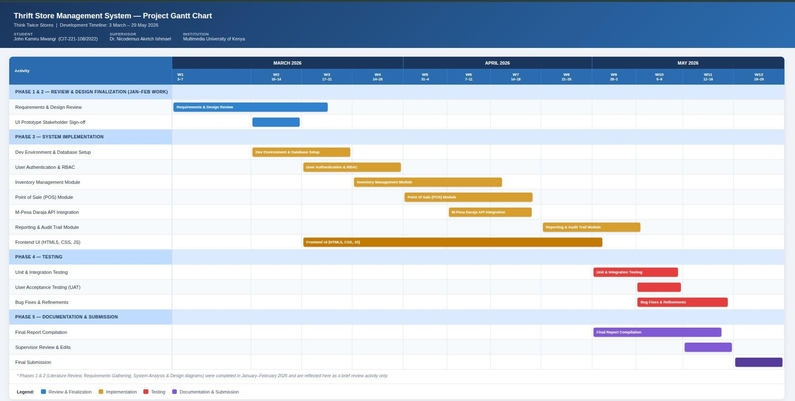
APPENDIX IV: PROJECT BUDGET

Printing

APPENDIX V: SAMPLE CODE
This appendix presents two representative code excerpts from the implemented Thrift Store Management System, illustrating the automated price-cycle calculation described in Section 5.2 and the M-Pesa STK Push integration described in Section 5.4. The excerpts are limited to the core logic of each function for brevity; the complete source code is available in the project repository submitted alongside this report.

V.1 Dynamic Pricing Cycle Calculation
// File: inventory/includes/pricing.php
// Calculates today's effective selling price for an active price cycle.
function calculateCurrentPrice($basePrice, $dailyReduction, $cycleStartDate, $floorPrice = 0) {
$today = new DateTime('today');
$start = new DateTime($cycleStartDate);
$daysElapsed = $start->diff($today)->days;

$reducedPrice = $basePrice - ($dailyReduction * $daysElapsed);

// Price never drops below the configured floor price
if ($reducedPrice < $floorPrice) {
return $floorPrice;
}
return round($reducedPrice, 2);
}

V.2 M-Pesa STK Push Initiation
// File: mpesa/includes/stkPush.php
// Initiates an M-Pesa STK Push request via the Safaricom Daraja API.
function initiateStkPush($phoneNumber, $amount, $accountReference) {
$accessToken = getDarajaAccessToken();
$timestamp = date('YmdHis');
$password = base64_encode(SHORTCODE . PASSKEY . $timestamp);

$payload = [
'BusinessShortCode' => SHORTCODE,
'Password' => $password,
'Timestamp' => $timestamp,
'TransactionType' => 'CustomerPayBillOnline',
'Amount' => $amount,
'PartyA' => $phoneNumber,
'PartyB' => SHORTCODE,
'PhoneNumber' => $phoneNumber,
'CallBackURL' => CALLBACK_URL,
'AccountReference' => $accountReference,
'TransactionDesc' => 'Think Twice Stores Purchase',
];

$ch = curl_init(DARAJA_STK_URL);
curl_setopt($ch, CURLOPT_HTTPHEADER, [
'Authorization: Bearer ' . $accessToken,
'Content-Type: application/json',
]);
curl_setopt($ch, CURLOPT_POST, true);
curl_setopt($ch, CURLOPT_POSTFIELDS, json_encode($payload));
curl_setopt($ch, CURLOPT_RETURNTRANSFER, true);

$response = curl_exec($ch);
curl_close($ch);
return json_decode($response, true);
}

